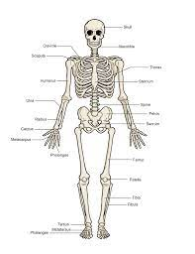

**Music**

Our Music unit this term is ‘Ostinato’. In this unit the children learn about music based on a rhythmic ostinato by studying Ravel’s Boléro.

**English**

Fiction – We will be continuing with the classic picture book ‘Owl Babies’ which we started during ‘roll up week’ to retell and write stories in the present tense. We will then be learning about adjectives as we write setting descriptions. After this, we will use ‘Arabian Nights’ to help us write character descriptions and recounts based on the story of ‘Aladdin and the magic lamp’.

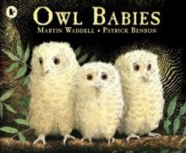

SPAG – During these lessons we will be ensuring that capital letters and full stops are being used consistently and correctly.

**Computing and Digital Citizenship**

* We will be learning about a range of multimedia’s and word processors to present our work.
* We will be learning about privacy and security.

**PSHE**

We will be learning about Health and Wellbeing inspired by the leading question, ‘What helps us stay safe?’ During the sequence of lessons we will learn about recognising risk, keeping safe and acknowledging rules.

**Maths**

Place value:

* Sort, count and represent objects and numbers.
* Count, read and write numbers forwards and backwards.
* Count one more and one less.
* Represent numbers as tens and ones.
* Compare groups and numbers.
* Order numbers.
* Count in 2s, 3s, 5s and 10s.

Addition and subtraction:

* Addition and subtraction bonds within 20.
* Bonds to 100 (tens).
* Add three 1-digit numbers.
* Add and subtract across 10.
* Add and subtract two 2-digit numbers.

Visit

Fieldwork around Shouldham for our Geography unit.



**DT**

We will be making, decorating and evaluating gingerbread in DT this half term. Exact dates will be communicated closer to the time.

**Science**

This half term we will be learning about The Human Body. During our lessons we will be learning all about some systems that operate in our bodies, including:

* The skeletal system
* The muscular system
* The digestive system
* The circulatory system
* How to prevent illnesses through understanding germs and diseases.

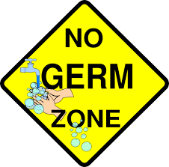

**Timetables**

This terms timetable focus is the 2s and 10s.

**Physical Education**

We will be learning about **Ball skills**. During our sequence of lessons we will be mastering our skills for running, jumping, throwing and catching, developing balance, agility and co-ordination.

**Religious Education**

* Our unit is called ‘What is a human being?). This unit focuses on Christianity and the book of Genesis which contains a story about why the world exists and what human beings are.

Investigators

Autumn Term 1

Spatial Sense

**Geography** – Spatial Sense

This half term we will learn the following:

* Maps show us information about a location.
* To recognise and locate human and physical features.
* To use maps to plan routes.
* To identify locations on a globe or world map.

**Art and Design** – Colour and shape

We will be using the artwork; Kandinsky’s Square with Concentric circles, Delaunay’s Electric Prisms and Monet’s the Beach at Trouville. We will be practising colour-mixing and brushwork skills. We will be using natural objects to make different shapes inspired by the works of Picasso and the mobile-like sculptures of Calder.

