Be a regular reader!  Investigators Homework Grid  Autumn 1  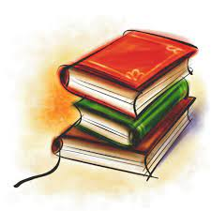  Please read to an adult daily and get your reading record book signed so I can see all the super reading you are doing!  Before changing your book, you will need to read it three times at home first to ensure fluency and comprehension. When you are reading your book with an adult discuss your book with them. What was your favourite part of the story? What did you learn from the book? Who was your favourite character? | Be a word wiz!  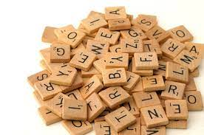  We will be having a spelling test every Friday which will include your year 1 common exception words that you should know and your new year 2 common exception words. Please practice these at home throughout the week. You will receive the spellings for the whole half term at the beginning of each term.  Step for depth: Put your spellings into a sentence. | Be a number wiz!    Please practice the 2 and 10 times tables every week. You can practice these however you would like!  You could write them, say them, or practice them online.  Useful resources for timetables include:  - Hit the Button  - TimesTable Rockstars (your logins are stuck in the back of your reading records)  - Complete Maths Tutor (your logins are stuck in the back of your reading records)
Be a super storyteller!    This half term we are using oral rehearsal to retell events in a story and write character descriptions.  Could you retell a story you have read to someone else?  Maybe you could retell the story from a character’s point of view and even dress up to really get in the role of the character! Please evidence this using pictures or videos for me to see via Dojo. | Be a smart survivor!  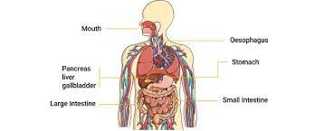  In science we are learning about the human body. The human body can do amazing things. but sometimes it can be difficult to tell the difference between things we normally do and what our body needs to survive.  Create a poster showing the things our body needs to do to survive, e.g. eat. | Be a maths marvel!  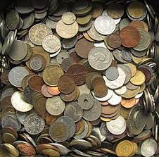  In class, we will be looking at how we can represent numbers in different ways. Find and make as many numbers as you can using objects you find around the house! Could you use pasta, pegs, stones or Lego?  Challenge: Can you try and make numbers to 100 using a variety of different coins? E.g. 50p, 20p, 20p & 10p.
Christian Value of Friendship    Write 3 sentences showing how you should treat your friends.  Going deeper: Last Autumn our Christian value was thankfulness – Write three thingd you are thankful for. | Be a clever cartographer!  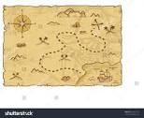  We will be looking at maps in our learning about ‘Spatial Sense’ in Geography, now it is your chance to make your own!  It could be a map of a real place like your village or an imaginary land. Maybe it could even be a pirate map showing the way to some hidden treasure! Whatever you choose, don’t forget to include a key!  Challenge: Try and visit ‘Castle Rising’ in King’s Lynn (PE31 6AH) and create your own map, showing the tower and all the many corridors! | Be an out of this world artist!  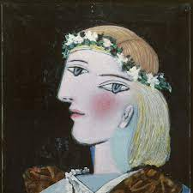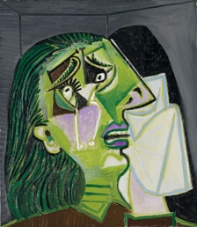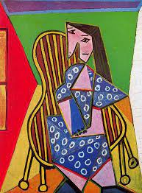  You will be learning about a variety of different artists in Art lessons, now it is your turn to create your own piece of art inspired by Picasso of yourself or a member of your family.

This homework grid gives a range of tasks that you can do with your child this half term. The top three boxes that are marked with a star are tasks that should be completed weekly. These can have significant impact across all your child’s learning.
Remember to love your homework books as much as you love your class books, so presentation rules and expectations still apply!
.

Key vocabulary for our Geography and Science unit this half term can be seen below.
Please help your child to learn and remember these words.

