Spring 1 Neptune Homework Grid Anglo-Saxons, Scots & Vikings Hand in date: w/c Monday 2^{3rd} February 2026
BE A REGULAR READER  Please read every day. Read a range of  different types of books, including poems  and non-fiction. Make sure you read aloud too as this is a different skill and you can practise making it interesting for the listener. Make a note of what you read under each day in your Reading Record and write a comment to note your thoughts about what you have read. Make sure you have your Reading Record in school every day! | BE A WORD WHIZZ  Practise the spellings we send home as often as you can. Try writing the word in different styles and colours, looking for letter patterns or making up a mnemonic to help you.  e.g. Big Elephants Can Always Understand Small  Elephants = because.  There will be a test of the week’s words on Friday.  As we always revisit prior learning, it is vitally important that all Year 3 pupils are able to spell the Key Stage 1 words shared on the next page. Please revisit and practice these to ensure they are fully consolidated into your long-term memory. | BE A MATHEMATICIAN  Log on to TIMES TABLE ROCK STARS and answer a minimum of 100 questions a week. We will check this on a Friday along with your average accuracy score. We will be looking for this to be above 90%. If you have trouble accessing TTRockstars at home, you can use an iPad at break or lunch times.  In line with our multiplication bonds policy, our focus this term will be the 8x and 9x table. Children in Y3 have previously learned their 2s, 5s and 10s, and as they progress towards the end of Year 4, they will complete the government MTC, which is an important statutory assessment. Daily times table practice will help ensure their success with this assessment and is therefore vital..
Be a write of the past!  Imagine you are an Anglo-Saxon. You have just been to battle. Write a recount telling all about your day. What happened? Who was involved? Were you victorious? Don’t forget to say how you’re feeling! Remember a diary is like talking to your best friend. You could even create stained paper using a teabag to make it look authentic! | Be an Anglo-Saxon warrior!  The Saxons used round shields as part of their armour to protect themselves during battle. Can you design and create a shield? Think about the colours, shapes, patterns and detail. Maybe you could include your initials or a logo! Your shield must be strong, so consider your material wisely! | Be a game inventor!  Anglo-Saxons were famous for making their own games. Can you make an Anglo-Saxon board game based on invasion?  Who will you invade? Who are your characters? Who will win?  Bring it into school and we could play it together!
Be an Anglo-Saxon chef!  The Anglo-Saxons loved eating and drinking and would have huge feasts with cooked fish, bread and vegetables. A favourite would have been vegetable soup. Can you make your own Saxon-style soup?  You could even write instructions for a friend. Take a picture and bring it into school! | Be a researcher!  Carry out your own research on the Anglo-Saxons. You could either create a non-chronological report using your findings, or a quiz for a friend. Ask in school for some resources if you need them. Remember, for a quiz you must also have the answers! | Be a geographer!  Complete some local research, and find out which rivers flow through Norfolk and where do they go to?  Can you make a fact file about each river and bring it into school to share?
Be a designer!  Design and make a 3D model of a river, from source to mouth. Can you label it with its different features to e.g. source, mouth, and meander? | Be an intercontinental comparer!  What are the seven continents on Earth? Find the longest rivers in each continent, and show where they are located on a map of the world. Which one is the longest? Which one is the widest? Which one runs through the most countries? Do any run through more than one continent? | Be spiritual!  Start a gratitude journal. Each day, write or draw something you are grateful for. This practice inspires mindfulness and helps you to appreciate the blessings in your life. It's a simple yet powerful way to begin to become more spiritual.  
- Starred activities are compulsory and must be done every week. +
- You need to complete at least one activity from each of the coloured columns by the end of the half term.
- Activities must be done in your homework book. Drawings or photos of models should be stuck in with a title to explain what the work is.
- All homework books are to be returned into school on Monday 2^{3rd} February 2026

History Vocabulary Geography Vocabulary
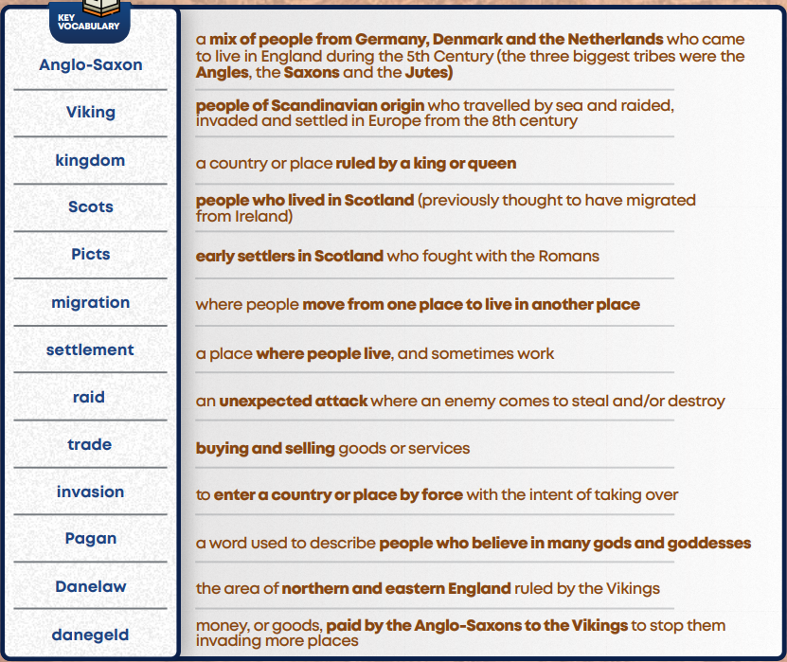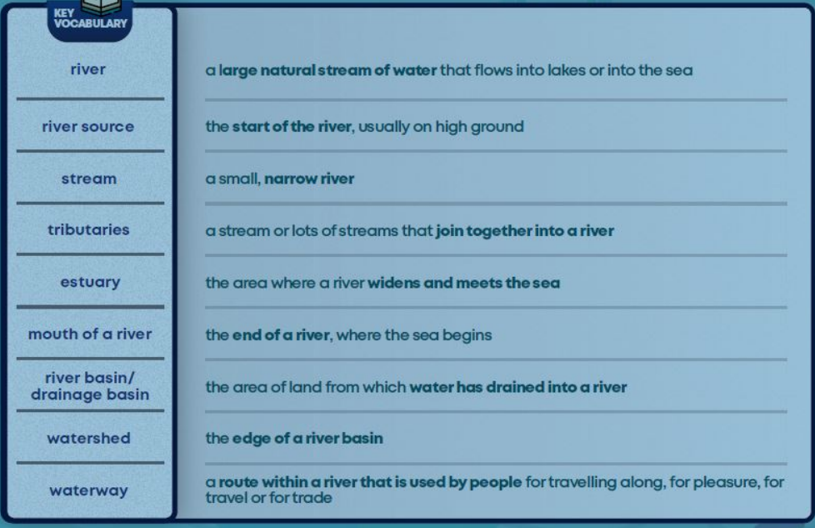
Key Stage 1 Spellings (prior learning)

