2026 Summer 2 ‘Stories from the past’ Homework Grid
Personal, Social and Emotional Development  Read the story: The Magic Porridge Pot. If you had a magic pot, what food would you like it to make? Draw a picture of your favourite food. Ask your friends and family about their favourite food too. What would they like the magic pot to make them? | English  - Can you make up your own story and write it for an adult? Does it have a beginning, middle and end?  - Can you read fairy tales at home with a grown up? Can you order the sequence of events of the story by retelling the story in your own words?  - Can you research a Greek myth and draw a story board of the myth?  - We will send out homework for phonics and reading separately, please look out for this in book bags and on Dojo. | Maths  - Play Hit the Button https://www.topmarks.co.uk/maths-games/hit-the-button and practise your doubles to 10. How many can you get correct? Can you beat your score?  - Can you make a map of your house and garden? Can you hide some treasure in your garden and mark it on your map? Give your map to someone else to see if they can find your treasure.  - Can you weigh ingredients to make some gingerbread men? Here is a recipe idea: Gingerbread men recipe | BBC Good Food
Understanding the World  - Can you build a bridge for the Billy Goats gruff to get across? You could make this out of Lego or lollypop sticks.  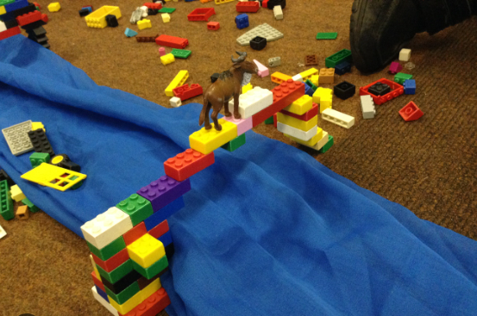  - Go on a hunt to rescue a princess (go for a walk in the local environment). Can you record what natural features you see on your walk? | Value - Trust   Can you show you are listening when someone is talking to you?  Can you play a game fairly - saying your score outloud and congratulating the winner. | Communication and Language  Tell a grown-up the story of The Three Little Pigs. Remember to use different voices for the characters. You could even act it out together!  Little Red Riding Hood stopped to talk to the Big Bad Wolf. Do you think this was a good idea? Talk to a grown-up at home about what she should have done.
Physical Development  - Can you follow the yoga poses in this fairy tale themed cosmic yoga Goldilocks & The Three Bears | Yoga Adventures | Cosmic Kids?  - Can you make up your own game that gets you moving? Can you write down the rules for your game? | Show and Tell  This half term please try to focus on what your child shares to reflect our topic. These opportunities enrich communication, listening and attention skills. Please also share on Dojo and we will share this with the class on our interactive whiteboard. | Expressive Arts and Design  Make a story box of your favourite fairy tale. Can you remember the parts of the story to act it out?  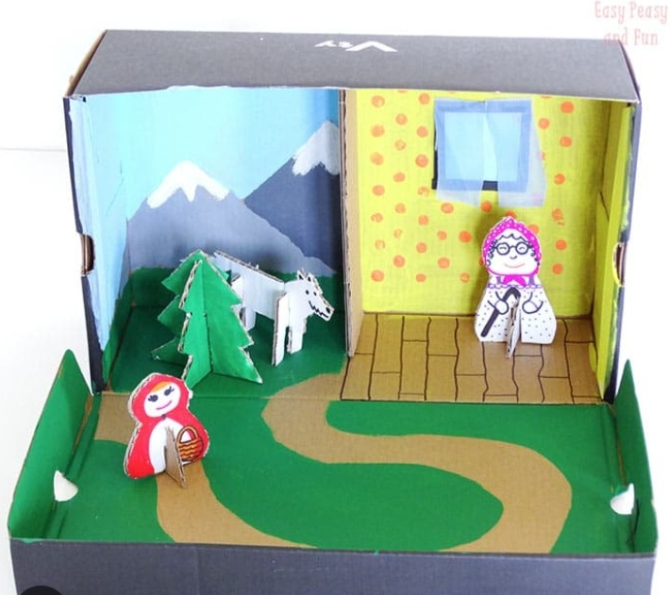
Please continue to share as much as possible on Dojo.
Key vocabulary for the half term | Exciting books for topic  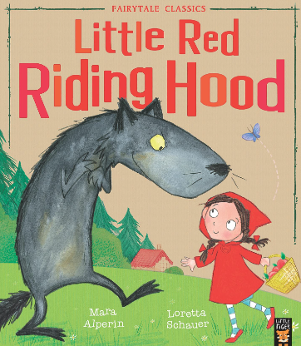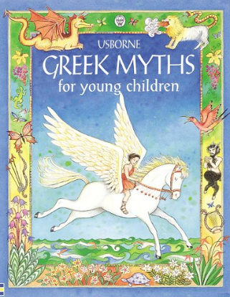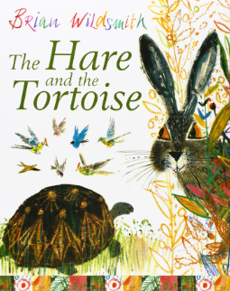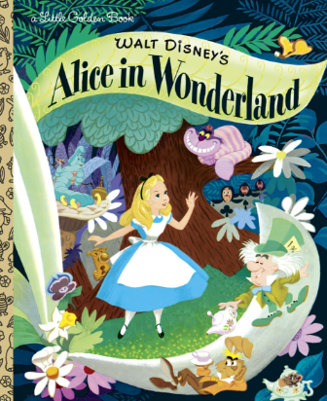  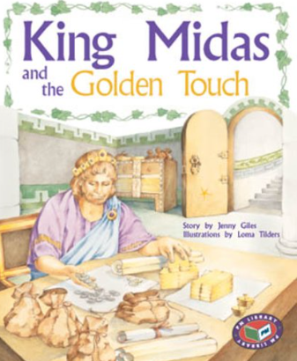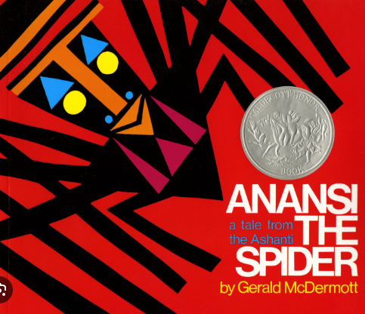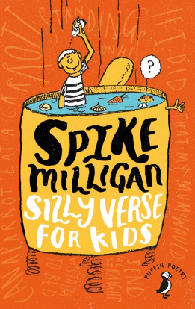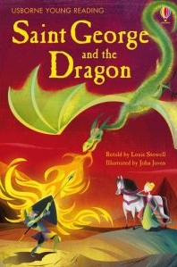
  Fairytale | Stories with imaginary characters who often live in magical lands.
  Legend | Stories from a long time ago, sometimes with a little bit of truth.
  myth | An imaginary story that helps to explain the world around us.
  fable | A story that teaches us a lesson.
  Folk tale | Stories from different cultures.

