eSpace Event Scheduler
Event Request User Guide

Version Control

Version | Date | Detail | Completed by | Reviewed
.01 | 02/05/2025 | Original Document | Margie Schmitz
1.0 | 02/07/2025 | Draft Completed & Published | Margie Schmitz | Y
1.1 | 2/19/2025 | Updated based on feedback from testing and remediation | Margie Schmitz | Y
2.0 | 2/19/2025 | Document updates from testing and remediation validated; published | Margie Schmitz | Y

Table of Contents
1. Event Request Form 1
2. Selecting Spaces for Events 3
3. Review Process 9
4. Request Approved or Declined 10
5. Canceling an Event 10
6. Important Information 10

Event Request Form
This is the Event Request Form. Users needing to request space for a meeting or event must submit a request a minimum of 7 calendar days prior to the event.
A few things of note with the new form:
- Fields with an * are required.
  - Even though your phone number is not a required field (a hard coded setting within the software tool), please provide it so we can contact you with any questions about your request.
- If your event/meeting requires time to set up and clean up, please note those in the fields provided. Please note: eSpace programming allows for a MAXIMUM of 60 minutes (1 hour) for set up prior to an event and a MAXIMUM of 60 minutes (1 hour) for clean up after an event.
- If your event is recurring, in the Recurrence field, click on the drop-down button to expand the options and select from one of the following:
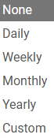, then complete the rest of the fields based on your selection.
- There are 3 locations from which to choose where your event will take place.
  - St. Margaret of York Church – all conference rooms and worship spaces in the church building.
  - St. Margaret of York Parish Grounds – all outdoor spaces (e.g., parking lot, Mary Garden, etc.)
  - St. Margaret of York School – all spaces in the school building, including the Gym and MPR.
- If you want to have your event displayed on the PUBLIC calendar, check the Public box. For Youth events, these are typically not displayed to the public for safety and security purposes.
- Click on the Category field to display the various categories/ministries from which to choose.
- Enter the number of people expected to attend your event. If you’re not sure, provide a reasonable estimate.
- Indicate if the event is an Adult Activity, a Family Activity (adults and youth) or a Youth Activity. If it’s an activity for youth, provide the names of the Safe Environment Adults who will be with the children.
- Enter the Real Person Verification code in the field provided then press Next.
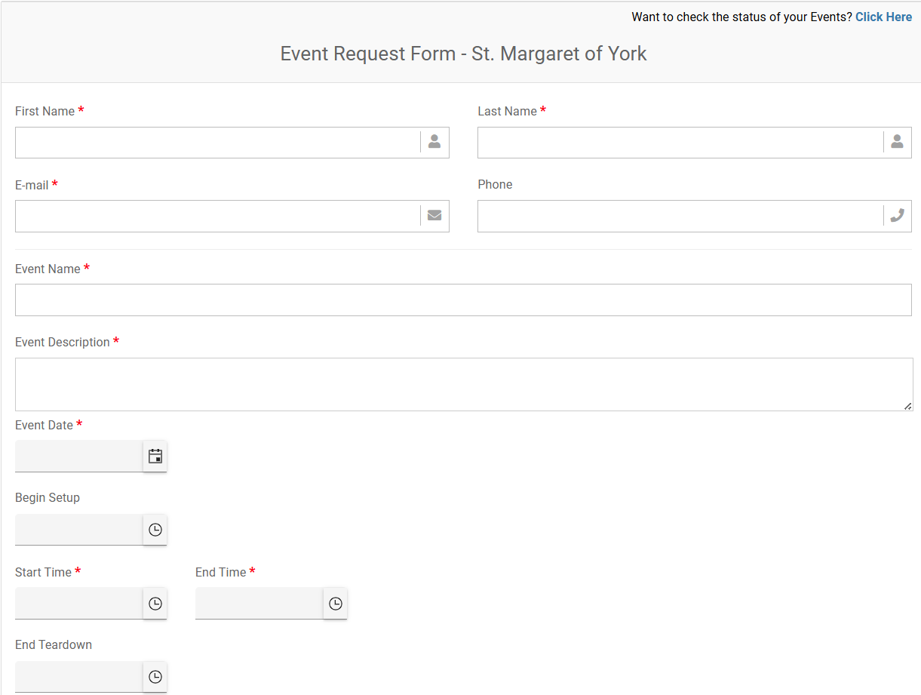
Schedule availability 6 am – 10 pm, exceptions being when Mass is scheduled, or sacraments are being administered.
2
2
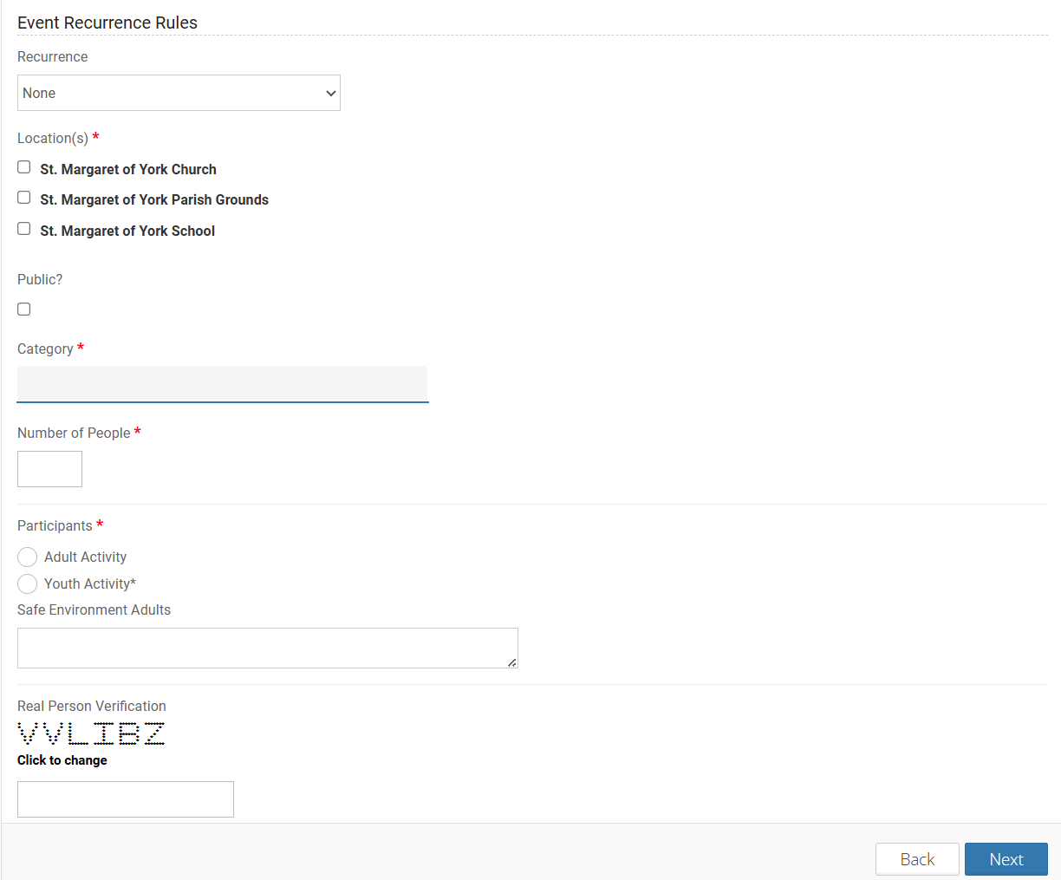
9
8
7
5
62
42
3
Figure 1 - Event Request Form Template

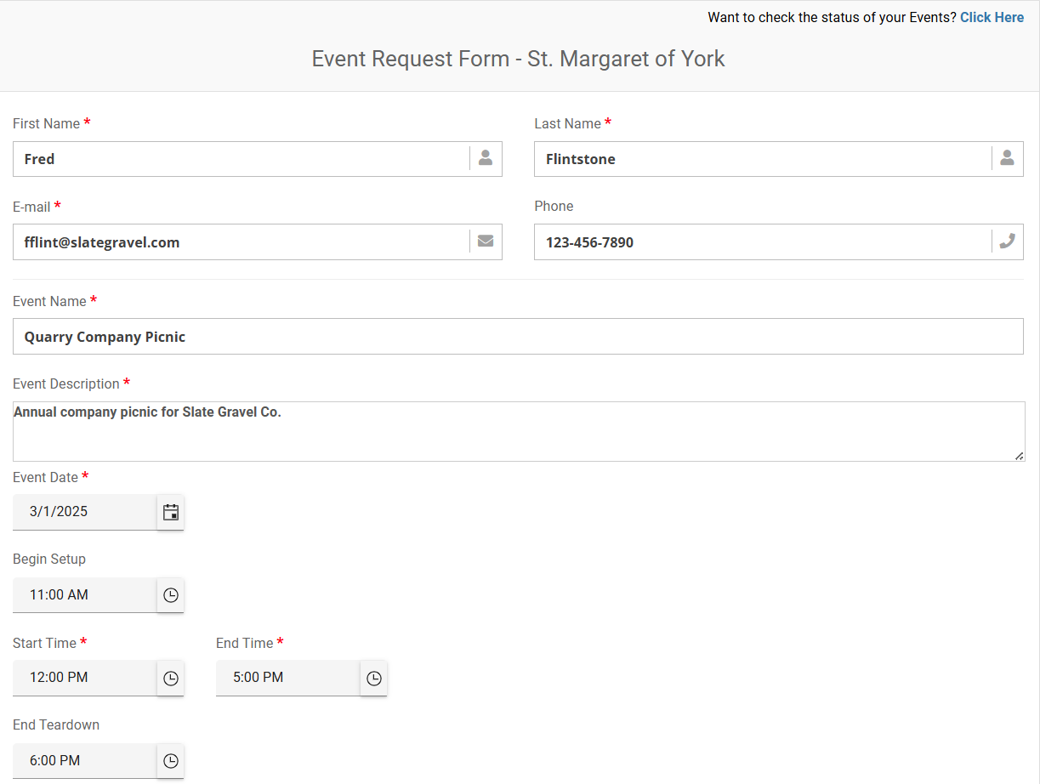
This is an example of a completed Event Request Form.
When you press Next, if there are errors, they will appear in a red box like this: 
Correct the error, enter in the new Real Person Verification code and press Next again.

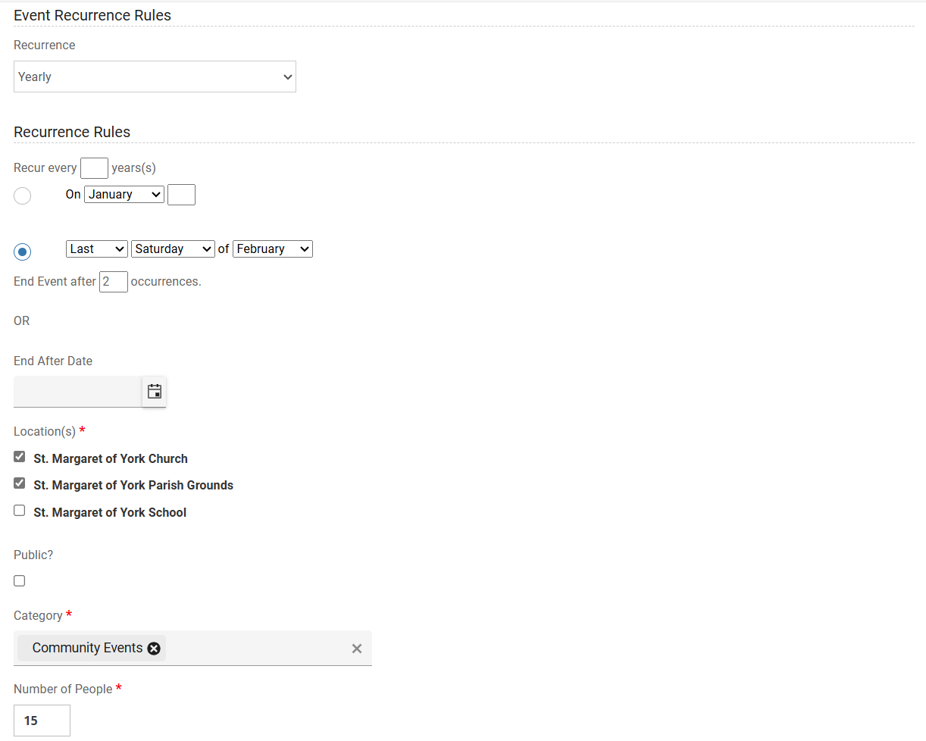
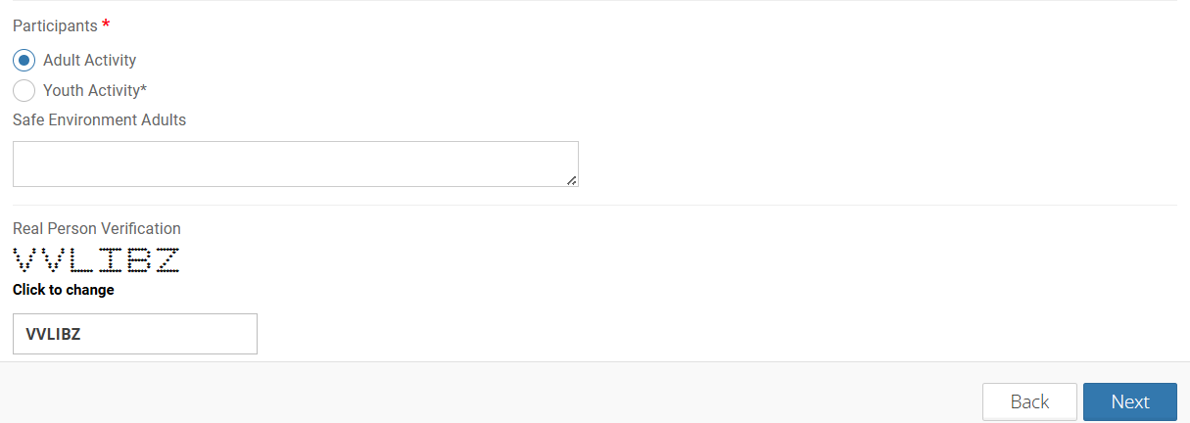
Figure 2 - Example of Completed Event Request Form

Selecting Spaces for Events
The information entered in the Event Request Form is displayed in a new window giving you the opportunity to review what was submitted. If any changes are needed, click on the Edit General Information button. This will take you back to the Event Request Form. Once your changes are made, scroll down to the bottom of the form and click Next.
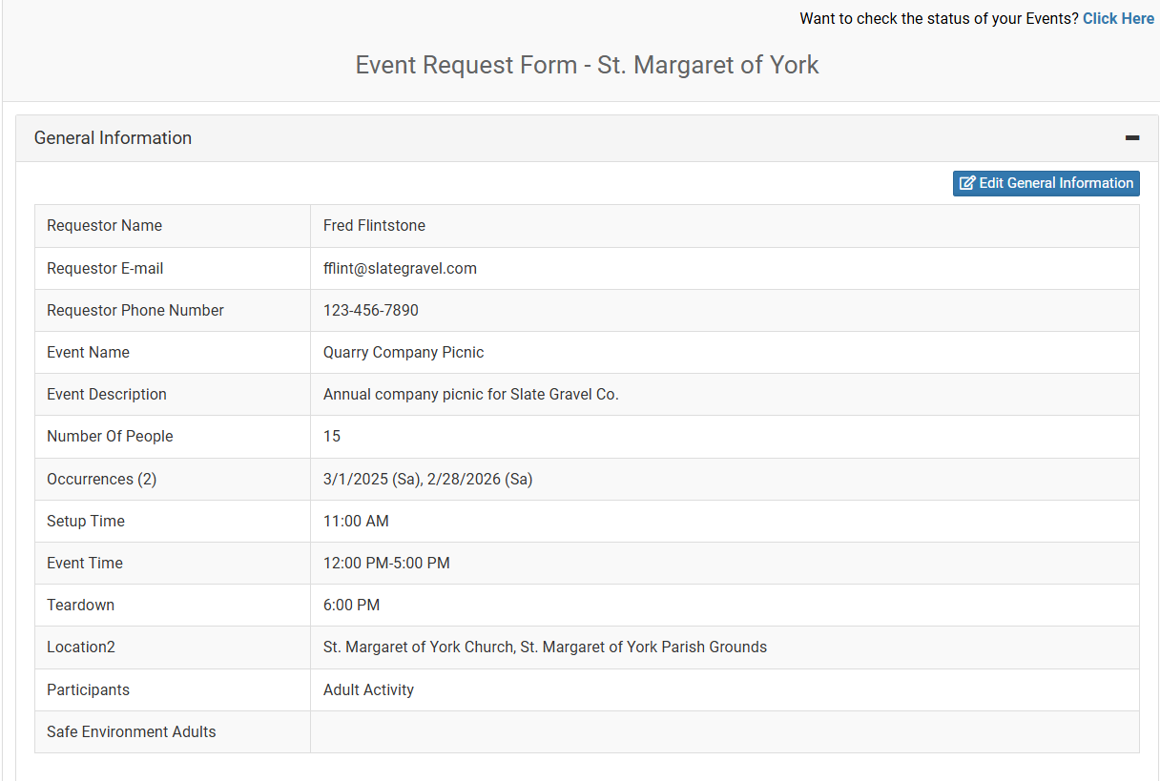
Figure 3 – Example of information entered in Event Request Form
Below the Event Request Form is a listing of the spaces available for selection for the location(s) you selected. In this example, you’ll notice that no space at the school (classrooms, Gym, MPR, etc.) are shown. This is because St. Margaret of York School was not one of the locations selected when completing the Event Request Form.

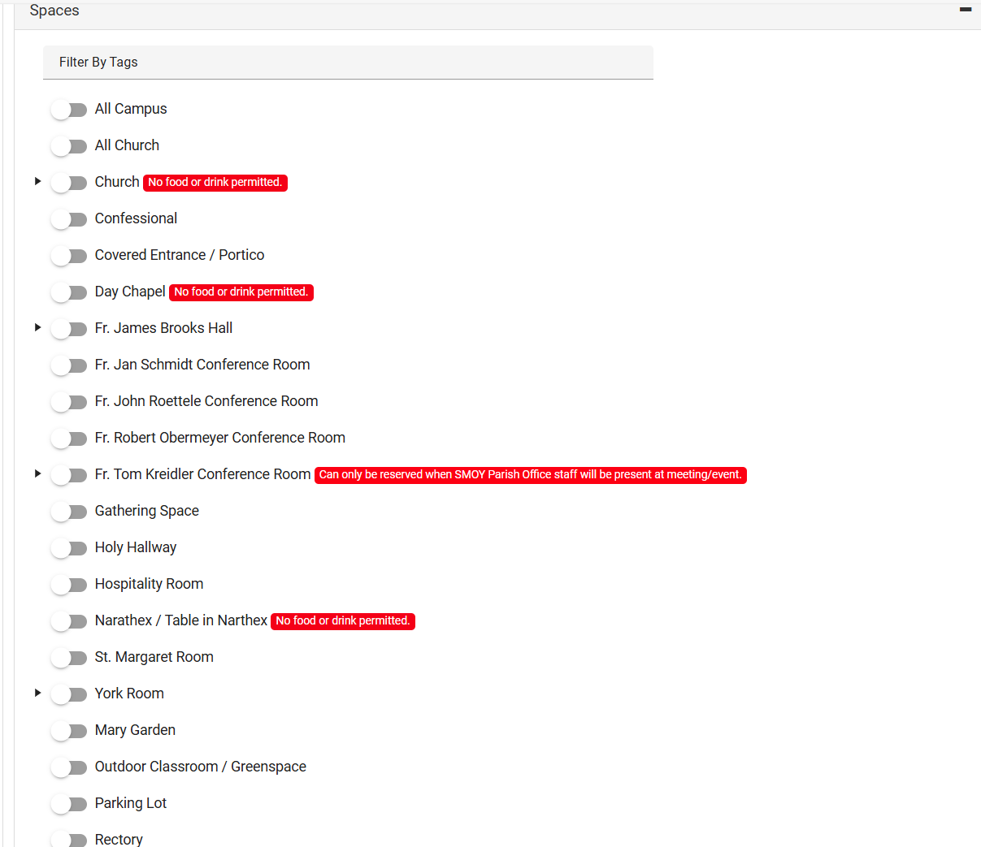
Figure 4 - Spaces Available for Event – Collapsed View
- Spaces with a have two options from which to choose. Click on the to expand the list.
- Once the list is expanded, select only one option (either the setup with tables/chairs or without tables/chairs), not both.
- Do not select the Parent space (the one without any tables/chairs detail) as that will select both of the Child options (the ones with tables/chairs detail).

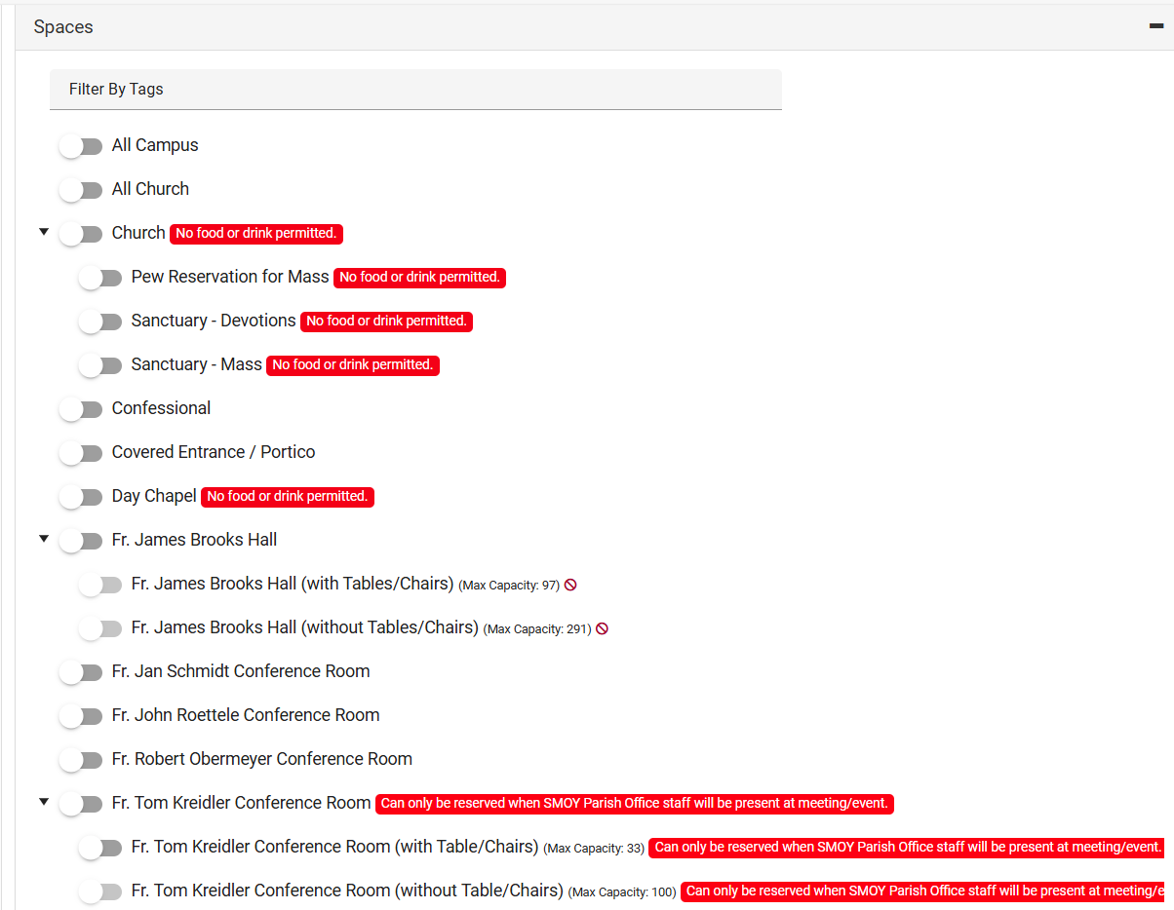
Child Spaces
Parent Space
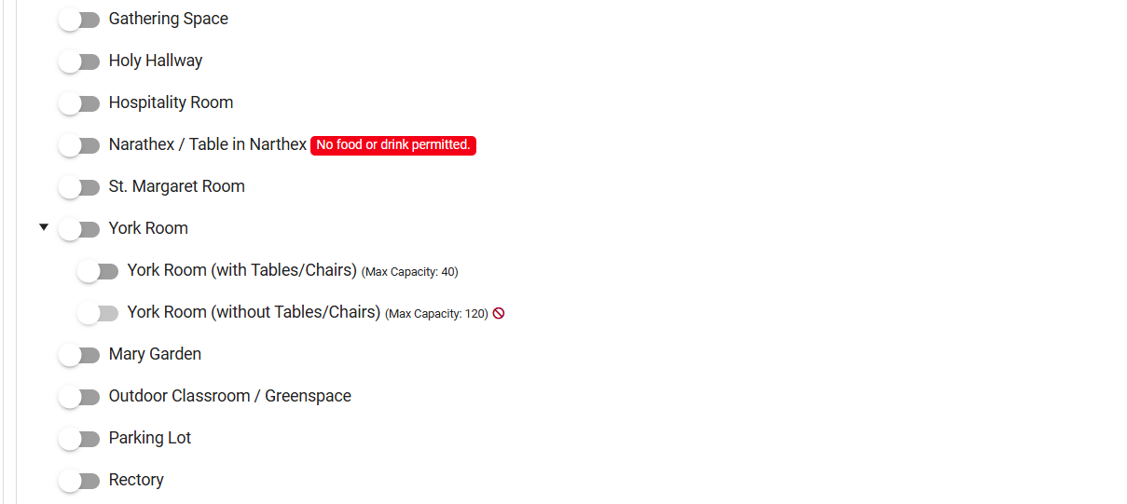
Figure 5 - Spaces Available for Event – Expanded View
- Items of Note Regarding Requesting Space
There are five (5) spaces that have been measured by Deerfield Township Fire Rescue to provide maximum occupancy permitted with tables and chairs and without tables and chairs. The spaces measured out and their occupancy limits are listed below:
Space | Occupancy Max with Tables & Chairs | Occupancy Max without Tables & Chairs
Fr. James Brooks Hall | 97 | 291
Fr. Tom Kreidler Conference Room | 33 | 100
Gym | 344 | 1,034
MPR | 240 | 720
York Room | 40 | 120

To reserve any of these spaces, a minimum of 25% of the occupancy maximum for either of the configurations listed above is required. This is to ensure that the larger spaces are available for larger events and groups needing the space.
If your event doesn’t meet the minimum attendance requirement, there will be a little icon () by the space(s) not available.
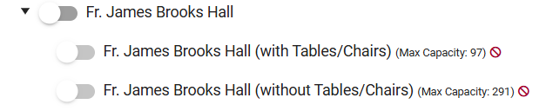
Figure 6 - Example of Unavailable Spaces
Click on the icon a pop-up window will be displayed explaining the reason a space is unavailable.
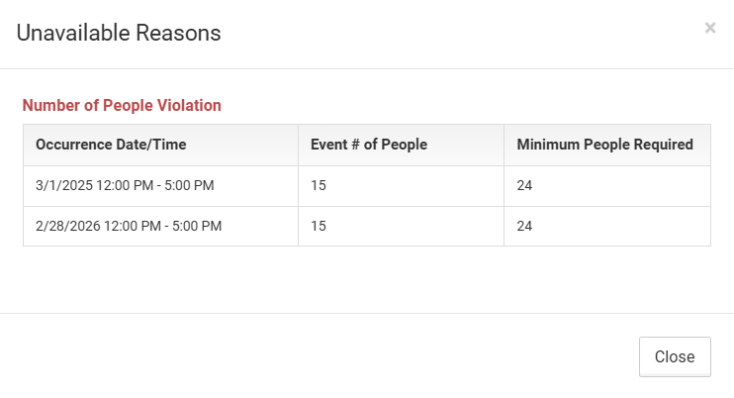
Figure 7 - Pop Up Window Showing Unavailable Spaces / Explanation
To select your space(s), click on the slide bar. If you need to remove one, you can click on the slide bar or scroll to the top and click on the trash can icon to delete your choice.
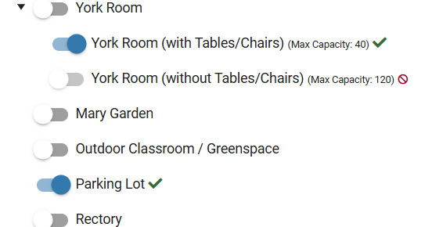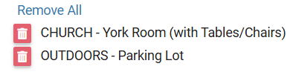
Figure 8 - Selecting and removing event space selections
When St. Margaret of York Church is selected as an Event Location, you will be presented with an option to indicate whether the Services of clergy (a priest or deacon) are needed. If they are, click on the slide bar to indicate this, then click Submit Event.
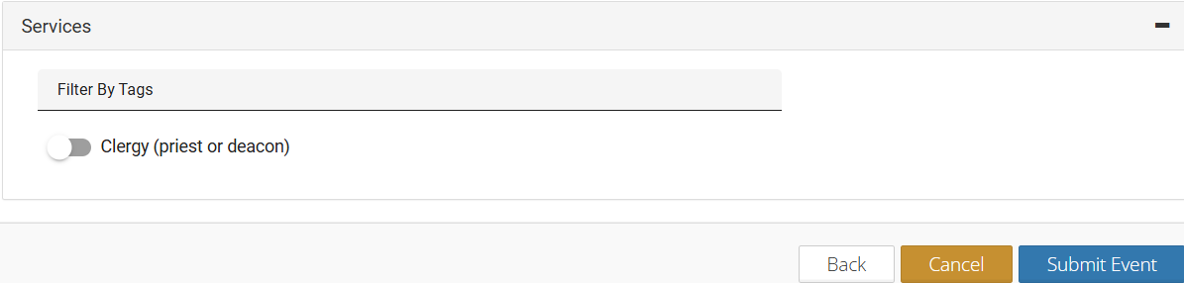
Figure 9 - Services Option
After clicking Submit Event, you’ll be presented with a pop-up window, giving you one last chance to review your request. Choose Yes or No.
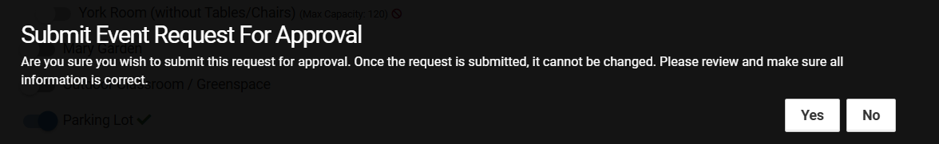
Figure 10- Submit Event Request for Approval Pop-Up
Once your event is submitted, you’ll get a message like the one below. This is confirmation that your event request has been submitted and is in review.
If you need to submit an additional request, click on the Submit New Request button. To check the status of your request, click on the Check Your Requests button.
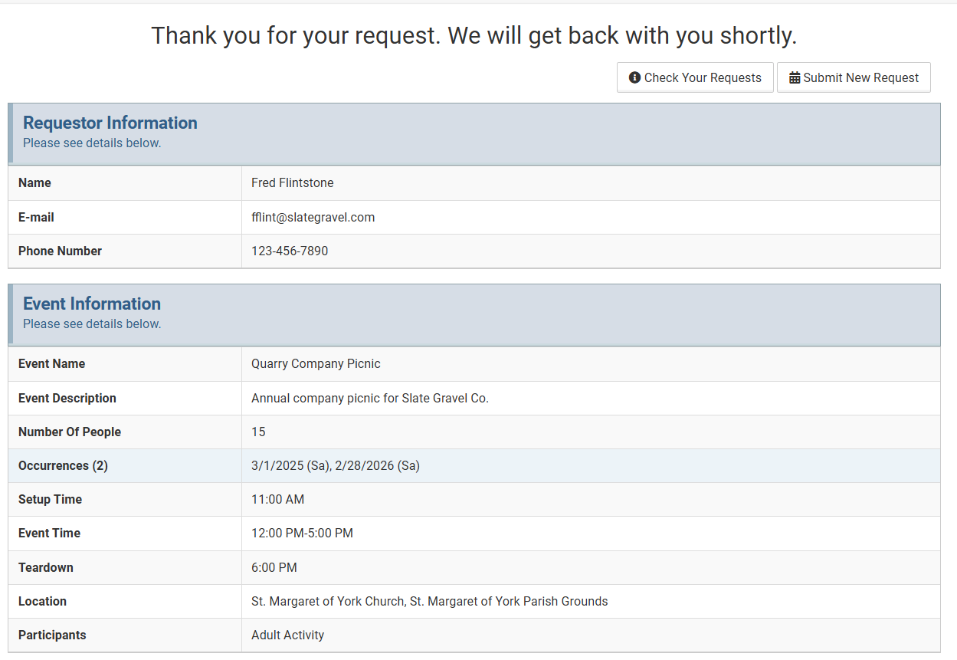
Figure 11- Event Request Confirmation
After clicking on the Submit New Request button, your first and last name and email address auto populate. The phone number field, since it’s not required, does not auto populate, but, it’s requested so we can get in touch with you if we have questions about your request.
Clicking on the Check Your Requests button will open a window that will display all the requests you’ve submitted and the status of each.
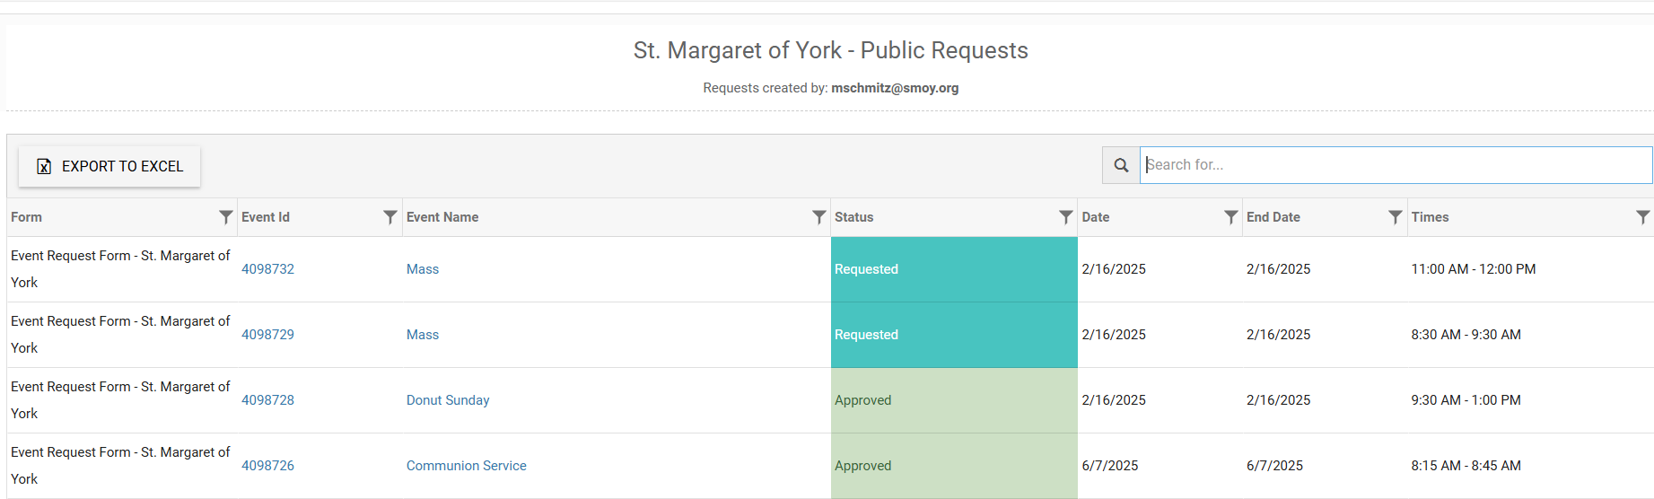
Figure 12 - Event Request Status Window

After submitting the request, you’ll receive an email from eSpace (mailer@espace.cool) with a subject line reading [St. Margaret of York] Event Request Created. The body of the email will have the details of your event request. **HELPFUL HINT** If you don’t receive the email in your inbox, check your Spam folder and then update your email preferences to have items from eSpace not marked as Spam.
After submitting your request, your event will show as Pending (tan box with brown lettering) on the calendar. (See Figure 8 below for an example.)

Review Process
After submitting your event request, it enters the eSpace workflow where it goes through review process.
and approval. The hierarchy of priority for reserving spaces is:
- Mass (to include weddings and funerals)
- Sacraments
- Faith Formation / Religious Education
- Ministries
  - Faith based (e.g., Scouts, Father’s Team, Devotions)
  - Service based
  - Social
If there’s a conflict with the date/time/space requested for an event, the Administrator will contact the requestor to work to get a different date/time/space.

Request Approved or Declined
After your event request has been reviewed, it will be either approved or declined.
- If your event request has been approved, you will receive an email from eSpace (mailer@espace.cool) with a subject line reading [St. Margaret of York] Event Approved: <Your Event>. Once an event is approved and if it you selected the Public option when entering your request, it will show on the public calendar.
- If your event request has been declined (not approved), you will receive an email from eSpace (mailer@espace.cool) with a subject line reading [St. Margaret of York] Event Request Declined. In the body of the email, there will be details about your request and an explanation of why the event was declined.
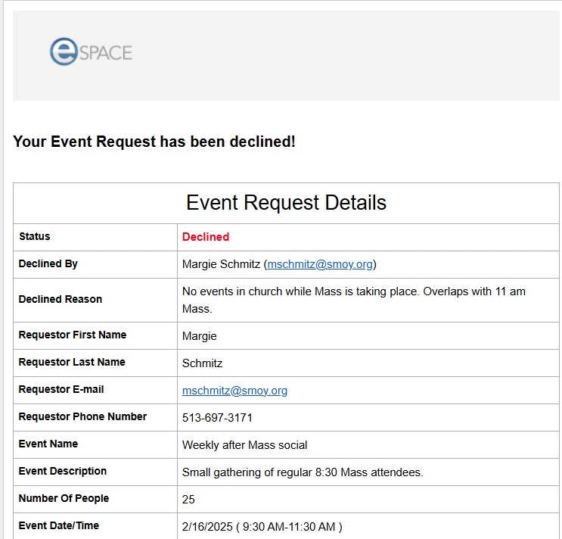
Figure 13 - Example of Declined Event Notification

Canceling an Event
If an approved event (one-time or recurring) needs to be canceled, an email is sent to calendar@smoy.org to cancel an event (or a particular date of the event).

Important Information
  - Link to submit calendar request - https://app.espace.cool/Public/PublicEventRequest/16959/1587
  - Link to public calendar - https://app.espace.cool/ClientApi/FullMonth/16959?calendarId=2004
  - Copy of eSpace Event Management Workflow

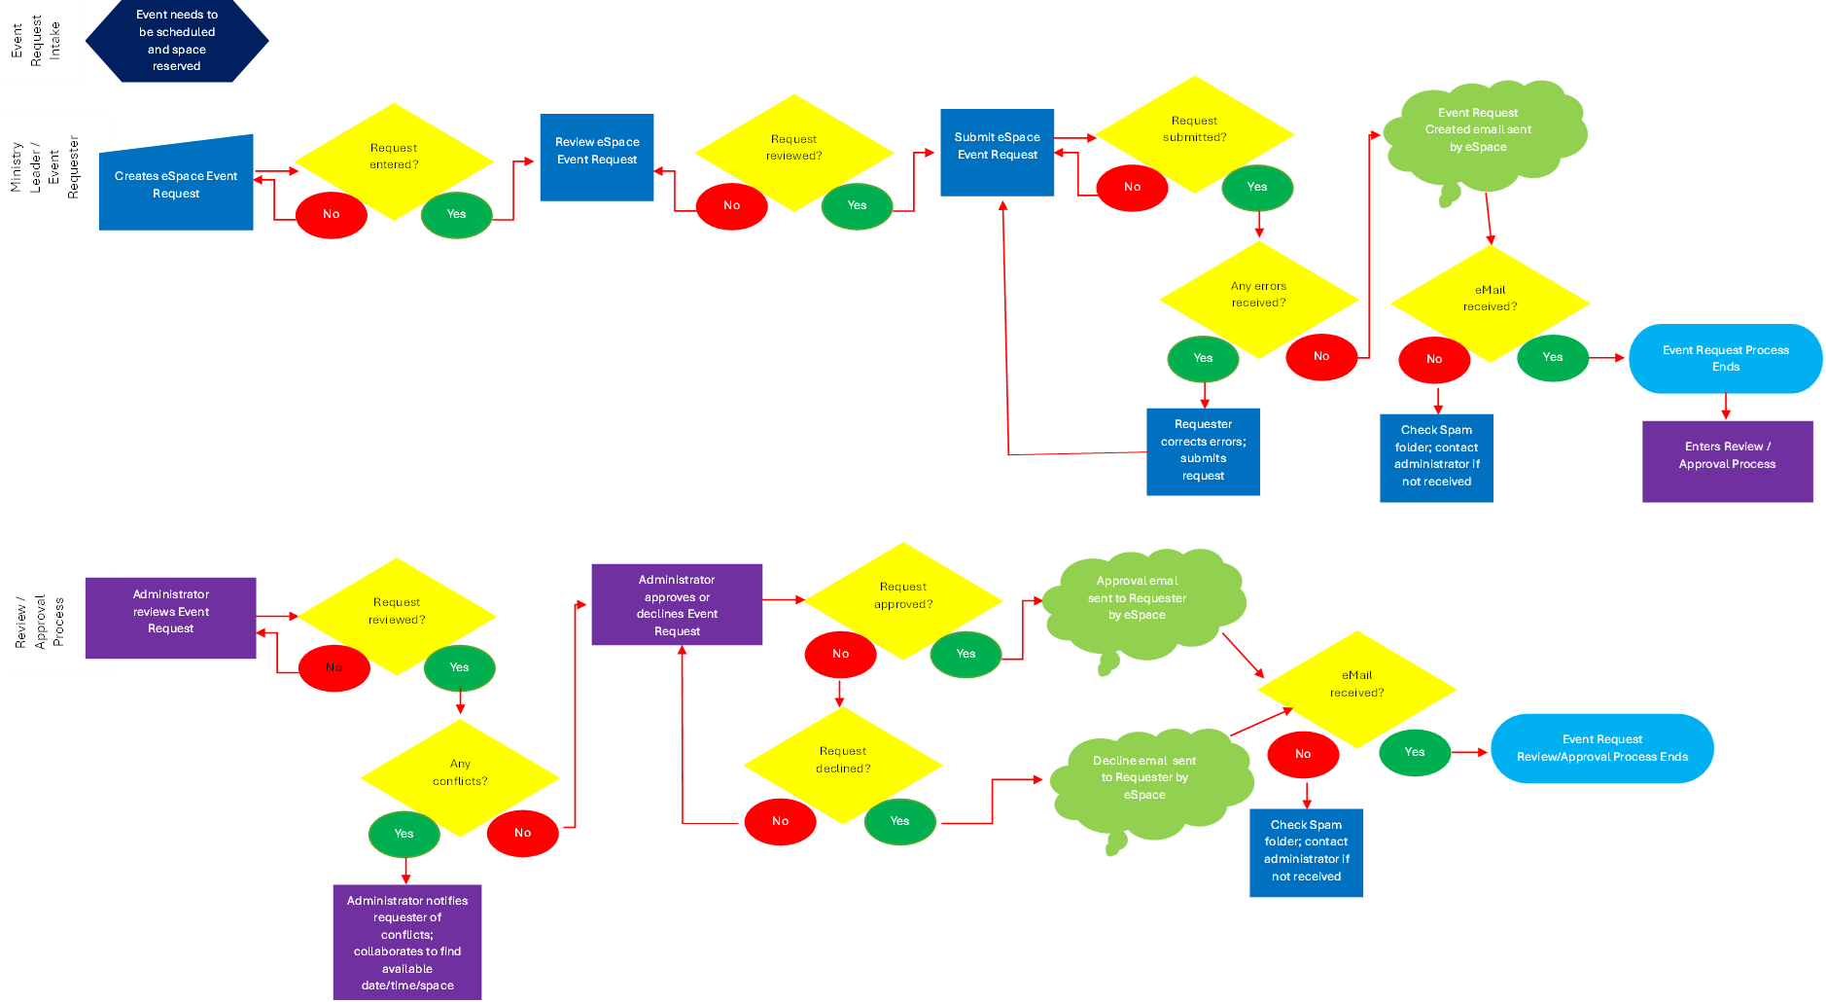
Figure 14 – eSpace Event Management Workflow

