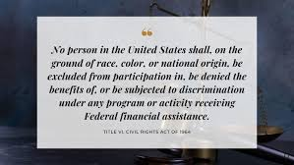 |  |  | Title VI Program  Check-Up
 | 1. Program Updates Every Three Years  Your updated Title VI Program should be fully prepared and approved by your governing Board BEFORE the expiration date, which is 3 years from your prior Board Approval Date. |  |  |  | 2. When is Your Update Due?  Current Board Approval Date: ____________________  My next Program Update is due: (three years from the date above): __________________________________
 | 3. What Languages Meet the Threshold?  What year(s) of data did you use? _________________ |  |  |  | 4. Did you designate Vital Documents?  If yes, what documents?
 | 5. If you have Threshold languages, are ALL the Vital Documents you listed translated into ALL the languages? If not, did you explain why? |  |  |  | (more space for Vital Docs info)
 | 6. Title VI Notice to the Public:  Does it contain all 3 elements  1-We don’t discriminate on race, color, or national origin. 2-For more information, contact… 3-To file a discrimination complaint contact….  Is contact info current? |  |  |  | 7. Where is your Notice Posted?  Is it everywhere you named in your plan? On website?  On buses? In transit center?
 | 8. Do you have all 4 Factors in your Analysis?  1-Number of LEP Persons in your Service Area (census)  2-Frequency of Contact (internal data/observations)  3-Nature & Importance of your Program  4-Langauge Assistance Resources Available & Costs |  |  |  | 9. Do you have a specific Language Assistance Plan?  Do you know what to do if someone needs help in another language? Do all your public-facing employees know? Have all relevant staff been trained?

