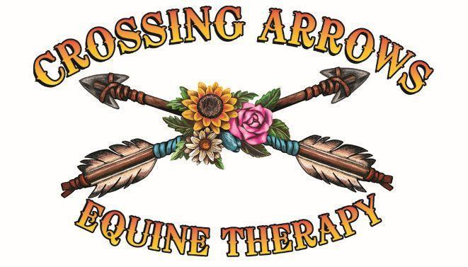

Crossing Arrows Ranch

2026 Applications & Available Spots
We are committed to making equine therapy accessible while also protecting the sustainability of our ranch, our animals, and our family. To maintain fairness, all reduced-fee and veteran/first responder clients must apply during open application periods and provide required documentation. All clients must agree to the 24-hour cancellation policy.

Application Periods
• January 1–15, 2026 (for Spring/Summer sessions)
• July 1–15, 2026 (for Fall/Winter sessions)
Applications outside these dates will be considered only if spots remain open.

Available Spots for 2026
• Tier 1 (30% fee): 2 clients – Sponsor or volunteer service required
• Tier 2 (50% fee): 3 clients – Sponsor or volunteer service required
• Tier 3 (75% fee): 4–5 clients – Sponsor or volunteer service required
• Tier 4 (Full fee): Unlimited – No sponsor or volunteer required
• Veterans & First Responders (Special Tier): 10 participants (80 total sessions) – Receive up to 8 free sessions, must provide proof of service, sponsor or volunteer service required. After 8 sessions, may continue through sliding scale or sponsorship.

Important Notes
• All reduced-fee tiers (1–3) and veterans/first responders must either complete a volunteer agreement or secure a sponsorship to help offset the full cost of services.
• Veterans and first responders must provide documentation of service (e.g., DD-214, service ID, or other verification).
• After completing 8 free sessions, veterans/first responders may continue services by applying through the sliding scale or sponsorship program.
• The 24-hour cancellation policy applies to all clients.

How to Apply
1. Download and complete the appropriate application form.
2. Submit required documentation during the open application period.
3. Await confirmation of acceptance based on available spots and funding.
4. Approved applicants must sign an agreement acknowledging requirements, including sponsorship/volunteer obligations and cancellation policy.

Sliding Scale Fee Information and Application Form

Sliding Scale Fee Information

Full Fee:

Service: Natural Lifemanship Trauma Focused Therapy

- Individual equine therapy sessions

- Includes mental health health professional and Equine professional
Price: $200 per session

Sliding Scale Tiers :

Tier 1: Income below $20,000 – Pay 30% of the full fee ($60 per session) Sponsorship required

Tier 2: Income $20,000 - $40,000 – Pay 50% of the full fee ($100 per session) Sponsorship required

Tier 3: Income $40,000 - $60,000 – Pay 75% of the full fee ($150 per session)

Tier 4: Income above $60,000 – Pay 100% of the full fee ($200 per session)

Service: Equine therapy sessions with an equine professional

Price: $100 per session

Sliding Scale Tiers:

Tier 1: Income below $20,000 – Pay 30% of the full fee ($30 per session) Sponsorship Required

Tier 2: Income $20,000 - $40,000 – Pay 50% of the full fee ($50 per session) Sponsorship Required

Tier 3: Income $40,000 - $60,000 – Pay 75% of the full fee ($75 per session)

Tier 4: Income above $60,000 – Pay 100% of the full fee ($100 per session)

Explanation: Our sliding scale fee system is designed to make therapy accessible based on your financial situation. Please complete the application form below to determine your sliding scale rate.

Rider Name: _______________________________________________________ Phone: _________________________

Address: ____________________________________________City: __________________State: _______ ZIP: _______

Parent/Legal Guardian: _______________________________________________ Phone: _________________________

Email: _______________________________________________________________

Please attach a copy of the first page of your most recent Federal Income Tax return, last 3 months pay stubs, proof of other income, and any other details you would like us to consider. All information will be kept in strictest confidence.

I certify that the above information is accurate and complete to the best of my knowledge. I give Crossing Arrows Ranch permission to verify all of the above information. I understand that any incorrect information will result in immediate termination of this request.

Rider/Parent/Legal Guardian: _________________________________________________ Date: ___________________ __________________________________________________________________________________________________
Crossing Arrows Ranch, Equine Therapy

Trudi Perkins CSW 435-230-4175
Spencer Smith EP 435-225-6941
Crossingarrowsranch@gmail.com

