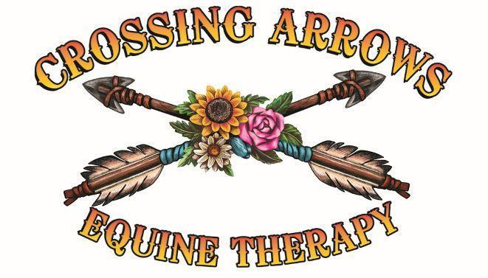

Crossing Arrows Ranch

2026 Applications & Available Spots
We are committed to making equine therapy accessible while also protecting the sustainability of our ranch, our animals, and our family. To maintain fairness, all reduced-fee and veteran/first responder clients must apply during open application periods and provide required documentation. All clients must agree to the 24-hour cancellation policy.

Application Periods
• January 1–15, 2026 (for Spring/Summer sessions)
• July 1–15, 2026 (for Fall/Winter sessions)
Applications outside these dates will be considered only if spots remain open.

Available Spots for 2026
• Tier 1 (30% fee): 2 clients – Sponsor or volunteer service required
• Tier 2 (50% fee): 3 clients – Sponsor or volunteer service required
• Tier 3 (75% fee): 4–5 clients – Sponsor or volunteer service required
• Tier 4 (Full fee): Unlimited – No sponsor or volunteer required
• Veterans & First Responders (Special Tier): 10 participants (80 total sessions) – Receive up to 8 free sessions, must provide proof of service, sponsor or volunteer service required. After 8 sessions, may continue through sliding scale or sponsorship.

Important Notes
• All reduced-fee tiers (1–3) and veterans/first responders must either complete a volunteer agreement or secure a sponsorship to help offset the full cost of services.
• Veterans and first responders must provide documentation of service (e.g., DD-214, service ID, or other verification). See Veteran application under “forms”
• After completing 8 free sessions, veterans/first responders may continue services by applying through the sliding scale or sponsorship program.
• The 24-hour cancellation policy applies to all clients.

How to Apply
- Download and complete the appropriate application form.
2. Submit required documentation during the open application period.
3. Download and fill out sponsorship form under “forms” on the Crossing Arrows Ranch website
- Await confirmation of acceptance based on available spots and funding
- Approved applicants must sign an agreement acknowledging requirements, including sponsorship/volunteer obligations and cancellation policy.

Sliding Scale Fee Information and Application Form

Explanation: Our sliding scale fee system is designed to make therapy accessible based on your financial situation. Please complete the application form below to determine your sliding scale rate.

Rider Name: _______________________________________________________ Phone: _________________________

Address: ____________________________________________City: __________________State: _______ ZIP: _______

Parent/Legal Guardian: _______________________________________________ Phone: _________________________

Email: _______________________________________________________________

Please attach a copy of the first page of your most recent Federal Income Tax return, last 3 months pay stubs, proof of other income, and any other details you would like us to consider. All information will be kept in strictest confidence.

I certify that the above information is accurate and complete to the best of my knowledge. I give Crossing Arrows Ranch permission to verify all the above information. I understand that any incorrect information will result in immediate termination of this request.

Rider/Parent/Legal Guardian: _________________________________________________ Date: ___________________ __________________________________________________________________________________________________
Crossing Arrows Ranch, Equine Therapy

Trudi Perkins CSW 435-230-4175
Spencer Smith EP 435-225-6941
Crossingarrowsranch@gmail.com

Crossing Arrows Ranch

Sliding Scale & Scholarship Policy with Reference Guide

Purpose
Crossing Arrows Ranch is committed to making trauma-focused equine therapy accessible to individuals and families regardless of financial situation. Our sliding scale fee system adjusts costs based on income, family size, and need. A limited number of reduced-fee and scholarship sessions are available each year to ensure fairness and sustainability.

Standard Session Fees
• Natural Lifemanship Trauma-Focused Equine Therapy (Therapist + Equine Professional): $200/session
• Equine Professional–Led Sessions: $100/session

Sliding Scale Tiers (Adjusted for Family Size)
Fees are based on annual household income and family size, using federal poverty guidelines as a reference.
• Tier 1 (≤150% of poverty level): Pay 30% of the full fee ($60 therapy / $30 equine only)
- Sponsor required OR Volunteer agreement required to cover the remainder
• Tier 2 (150–250% of poverty level): Pay 50% of the full fee ($100 therapy / $50 equine only) Sponsor required OR Volunteer agreement required to cover the remainder
• Tier 3 (250–350% of poverty level): Pay 75% of the full fee ($150 therapy / $75 equine only) - Sponsor or volunteer contribution encouraged
- Standard reduced fee; no sponsor required
• Tier 4 (≥350% of poverty level): Pay 100% of the full fee ($200 therapy / $100 equine only)
Note: Household size includes all people supported by the reported income (children, dependents, spouse/partner).

2025 Federal Poverty Guidelines (Reference)
Household Size | 100% Poverty Level | 150% | 250% | 350%
1 | $15,060 | $22,590 | $37,650 | $52,710
2 | $20,440 | $30,660 | $51,100 | $71,540
3 | $25,820 | $38,730 | $64,550 | $90,370
4 | $31,200 | $46,800 | $78,000 | $109,200
5 | $36,580 | $54,870 | $91,450 | $128,030
6 | $41,960 | $62,940 | $104,900 | $146,860
For each additional person, add ~$5,380 at 100% poverty level.

Family Member Discounts
• If two or more members of the same household participate in services, a 10–20% discount may apply to the second (and additional) family member(s).
• Each family member must still complete a consent form and sliding scale application.

Scholarship / Pro Bono Slots
• A limited number of scholarship sessions are reserved each year for individuals experiencing severe financial hardship (e.g., unemployment, housing insecurity).
• These may include reduced flat monthly fees, volunteer exchange, or sponsorship through community donations.
• Scholarship sessions are capped each year to protect the sustainability of the ranch.

Volunteer & Sponsorship Options
• Volunteer Agreement: Clients (or family members) may contribute volunteer hours at Crossing Arrows Ranch (help with stalls, animal care, maintenance, events) in exchange for reduced fees.
• Sponsorship Program: Community donors may sponsor a client’s therapy sessions to offset costs.

Required Documentation
To apply for the sliding scale or scholarship, please submit:
• The first page of the most recent Federal Income Tax return (1040)
• Pay stubs or unemployment/benefits statement (last 3 months)
• Documentation of family size (dependents listed on tax return or other legal forms)
• Sponsorship application

Cancellation Policy
• All clients, regardless of tier or scholarship status, are required to give at least 24 hours’ notice for cancellations or rescheduling.
• Cancellations with less than 24 hours’ notice, or missed appointments, will be billed at the full agreed-upon session rate (sliding scale or scholarship rate).
• Exceptions may be made only in cases of documented emergencies.

Agreement
• Sliding scale rates are reviewed annually. Clients must reapply each year.
• Providing false or misleading information may result in termination of services.
• By signing below, I acknowledge that I have read and understand the sliding scale policy, reference guidelines, and the 24-hour cancellation requirement.
Client/Parent/Guardian Signature: ______________________________ Date: _____________

