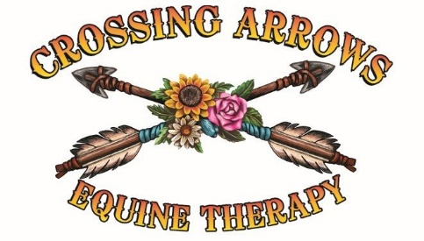

Crossing Arrows Ranch Sponsorship Application:

Rider Name: _______________________________________________________ Phone: _________________________

Address: ____________________________________________City: __________________State: _______ ZIP: _______

Parent/LegalGuardian: _______________________________ Phone: _________________________

Email: _______________________________________________________________

Sponsorships are limited and are offered to Crossing Arrows Ranch riders throughout the year, however, you will be asked to reapply each year:

• January 1–15, 2026 (for Spring/Summer sessions)
• July 1–15, 2026 (for Fall/Winter sessions)
Applications outside these dates will be considered only if spots remain open.
You may continue in the riding program using a different payment resource. Decisions are based on a combination of factors including financial need, anticipated benefits to the rider’s needs, the commitment to attending sessions, and available funds.

Required: Please attach sliding scale application along with any required documentation and proof of income.

Parent/Legal Guardian: ______________________________________________Date: __________
Crossing Arrows Ranch, Equine Therapy
Trudi Perkins CSW, TF-EAP 435-230-4175
Spencer Smith: EP 435-225-6941 Crossingarrowsranch@gmail.com

Letter to Sponsor: Please write a short summary of at least 3 reasons Therapeutic Riding would benefit this rider:

_____________________________________________________________________________________
_____________________________________________________________________________________
____________________________________________________________________________________

____________________________________________________________________________________

_____________________________________________________________________________________
_____________________________________________________________________________________
____________________________________________________________________________________

____________________________________________________________________________________

_____________________________________________________________________________________
____________________________________________________________________________________

____________________________________________________________________________________

_____________________________________________________________________________________

_____________________________________________

