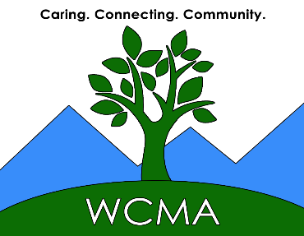

2026 Member Sponsor Grant Application
Due on or before September 25, 2026

WCMA Sponsor Information

- WCMA Sponsor Name:
- Sponsor Postal Address:
- Sponsor Email Address:
- Sponsor Phone Number:
- Describe your active involvement with this charity:
- Number of hours you donate per week or per year to this charity:
- Tell us why you chose to get involved with this charity:
- Have you reviewed the most recent WCMA guidelines and Sponsor Roles and Responsibilities on the WCMA website?
- Does the proposed project/program meet the current WCMA guidelines for funding?

Organization Information

- Organization Name:
- Organization Contact Name:
- Organization Contact Email:

This application is to be completed by the WCMA member who wishes to sponsor the charity at which they volunteer. A sponsor application must be submitted in order for a nonprofit organization’s application to be considered. In addition, the WCMA member is responsible for providing additional information as may be needed by the Grant Review Committee during the review process.

The above application questions can be downloaded or copy and pasted into a word processing document and should be submitted by email as an attachment using this link: grants@walnutcovemembers.com. Attachments can be emailed in the form of a Word File, Mac Pages file or a PDF.

