Dear Coaches and Managers,

We are seeking your assistance to identify a player that may be the recipient of the Toby Martin Cricket Scholarship.

This is not a performance-based scholarship. This is about providing an opportunity to a boy or girl that might not otherwise be available to them.

The criteria is simple.

- The player must have a deep love of the game.
- The player should demonstrate the qualities of courage, strength and perseverance.
- The player would benefit from resources that might not be available to them if it wasn’t for the scholarship.

In the first year, we would like to select a player from within the club to receive the scholarship and present it to them at our Junior presentation evening.

It is proposed that the scholarship will include:-

- Registration fees limited to the value of the active kids voucher.
- Playing kit.
- Attendance at a school holiday cricket clinic.

I would appreciate it if you could think about the players and families from within your team and provide any nominations to me at your earliest convenience.

About Toby
Toby Martin was a Kincumber Junior that passed away in July 2020 after a being diagnosed with leukaemia in October 2018.

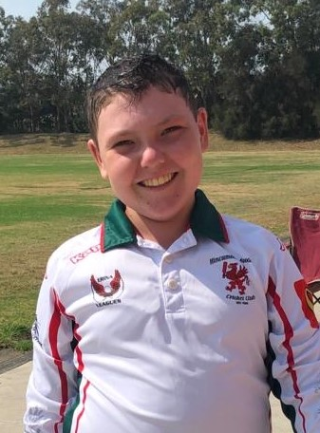

Toby’s love of cricket was immense, as was his courage, strength and perseverance. To learn more about Toby watch the A Current Affair story at the link below. You’ll see how much he loved cricket.

https://9now.nine.com.au/a-current-affair/toby-martins-kindness-and-charity-leaves-lasting-impact-on-central-coast-kids-in-need/22af165b-7887-44fc-907a-09bb244639ee

Toby’s family have generously agreed to provide a scholarship to a boy or girl that would benefit from the support.

I can’t say I’ve ever met anyone like Toby and his family. They are so gracious, generous, strong, kind and loving. Toby played just one game for the griffins prior to his diagnosis and I’ll never forget it. It was round three of the 2018/2019 season. The first two rounds had been washed out so it was essentially the first game of the season.

It was a 2 day 50 over match against our arch rivals Narara in the under 13A’s. Toby was new to the Central Coast and new to the club. What happened next demonstrates to me how quickly Toby had an impact on his team mates and how well liked he had become with boys he had only met for the first time just a few weeks earlier.

Toby came into bat in the 50th over with just three balls remaining in the innings. As he strode to the crease his team mates were cheering him on but no one can really remember why. The previous wicket was a runout so Toby was at the non-strikers end before Zac Gregory hit a three to put Toby on strike with two balls remaining. Angus Jack, Narara’s best bowler and probably the quickest on the coast, had the ball in hand and steamed in from the Renwick Street end of Alan Davidson Oval. Toby got bat on ball and past the man at square leg. An almighty roar came from a bunch of 12 and 13 year old boys beneath the treeline as Toby scampered through for a single. Honestly, you’d have thought young Toby had won the game but this was just the first day of a two day match. He finished 1 not out from 1 ball and came off the field with a grin from ear to ear. I don’t know why the boys carried on the way they did that day but in hindsight, I’m so glad they did.

After that game Toby was in and out of hospital and in and out of the team, mostly out. Over the next 18 months toby played when he was able. Toby played 6 games in the 14A’s and his last innings came in December 2019. Toby finished on 2 not out after facing 17 balls in 23 minutes. The photo above is after that innings and he was exhausted but beaming.

Toby’s younger brother Archer played in our 14B’s this season and his dad Chris manages the team.

This scholarship should be bestowed on a player that encompasses Toby’s perseverance, courage and strength as well as his love of cricket. We would really appreciate your assistance to identify the recipient.

Don’t hesitate to give me a call if you have any questions or suggestions.

Many thanks,

Stephen.

