Bulletin announcements (4) for medical debt ministry 2026

For Sunday, September 27, 2026
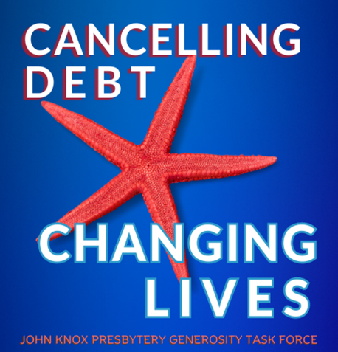
Our congregation is participating in a presbytery-wide fundraising ministry to cancel medical debt. It’s called “The Starfish Campaign”. Too many families suffer hardship trying to pay their medical bills. Medical debt can turn a family’s life upside down. Their physical and mental health can be affected. Every dollar contributed to the Starfish Campaign will cancel at least $100 of medical debt and that’s amazing! Donate through our Sunday offering or mail your gift to the church. Please make your check out to our church and mark it “The Starfish Campaign”. Contributions can be made through October 18. Together, we make a difference!
If you prefer, you may use the QR code to donate online.



For Sunday, October 4, 2026
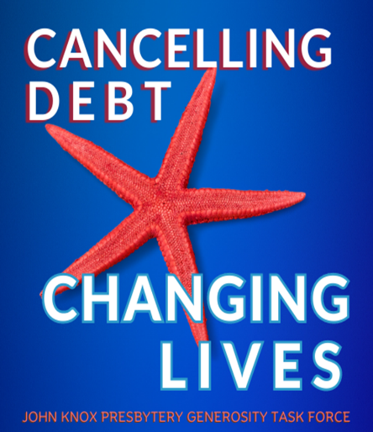
How is your gift to the Starfish Campaign multiplied? John Knox Presbytery partners with an organization called Undue Medical Debt to purchase and cancel medical debt on a grand scale. Because Undue Medical Debt understands the medical debt industry, every dollar the Presbytery raises will remove at least $100 of medical debt for a family. That changes people’s lives! There are two ways to contribute to this ministry. Give through October 18 through our Sunday offering. You may also mail your gift to the church. Please make your check out to our church and be sure to mark it “The Starfish Campaign”. Help lift a burden on struggling families. Others can live because we give!
If you prefer, you may use the QR code to donate online.

For Sunday, October 11, 2026
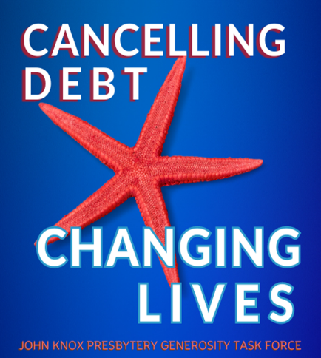
John Knox Presbytery is again participating in a fundraising ministry to remove the burden of medical debt for families. All of the churches in our presbytery have been invited to contribute. Together, we have accomplished amazing results. In the first four years, contributions presbytery-wide have been able to cancel $15,973,326 of medical debt for 14,530 families. We are making a huge impact! Through October 18, contributions can be made through our regular Sunday offering or you can mail your gift to the church. Make your check out to our church and mark it “The Starfish Campaign”. Together, we can unleash the power of hope!
If you prefer, you my use the QR code to donate online.

For Sunday, October 18, 2026
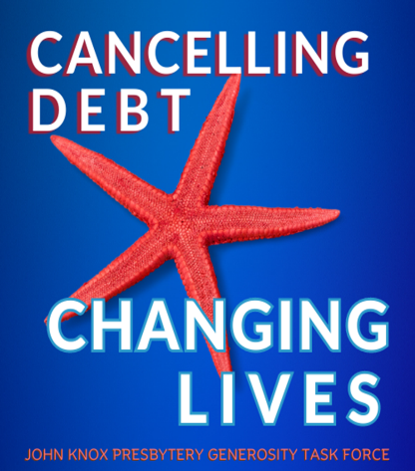
John Knox Presbytery’s ministry to purchase and cancel medical debt concludes today. Those who are carrying medical debt are three times more likely to struggle with depression and/or anxiety. Due to the expertise of the Presbytery’s mission partner, Undue Medical Debt, every dollar you contribute goes on to wipe out at least $100 of debt for the families we are helping. The results are amazing!
There is still time to contribute through our regular offering this morning. Please make your check out to our church and mark it “The Starfish Campaign”. Thank you for your generosity. God accepts what we offer and makes it amazing!
If you prefer, you may use the QR code to donate online.

Minute for Mission—September 27, 2026
John Knox Presbytery’s ministry to cancel medical debt is called “The Starfish Campaign”. In addition to adverse health effects like high blood pressure, stress and poor nutrition, those struggling with medical debt can face bankruptcy and homelessness. Many are less likely to seek medical care for preventative services or treatment. They want to pay the debt but, by the time they provide the basic needs for their families, there just isn’t anything left.
There is an estimated $225 billion of medical debt in the United States. That’s a huge number. We won’t be able to help everyone. But in the last four years alone, “The Starfish Campaign” has helped thousands of families! Our entire Presbytery has been invited to raise money to eliminate medical debt. Every dollar raised will be sent to an organization called Undue Medical Debt, a leader in the purchase and removal of medical debt. They are able to buy large bundles of debt from collection agencies for pennies on the dollar. They understand the medical debt industry, which allows what we contribute to go much further. In fact, one hundred times further! A five dollar contribution will remove at least $500 of medical debt for someone struggling to pay their bills. $20 will cancel $2,000!
“The Starfish Campaign” is a ministry of hope. It’s an important ministry and we want to be a part of it. We ask you to be generous because God will grow our dollars many times over. To paraphrase the prayer of St Francis of Assisi, “Where there is despair, may we bring hope.” The need is great but, because God accepts what we offer and makes it amazing, our congregation can make a difference and bring hope to many. “The Starfish Campaign” will conclude on Sunday, October 18. Contributions can be made anytime. Make your check out to our church and mark it “The Starfish Campaign”. You can also contribute online through the presbytery’s website, jknox.org.

Minute for Mission—October 4, 2026
The prophet Micah has told us what the Lord requires of us—to do justice, to love kindness and to walk humbly with God. Through contributions to “The Starfish Campaign”, our congregation has joined other churches in John Knox Presbytery. We will abolish medical debt for thousands of families. In only four years, the presbytery has been able to cancel almost $16 million and changed the lives of 14,530 families. How is it possible to eliminate so much? Because medical debt is handled differently than other kinds of debt. John Knox Presbytery has partnered with a non-profit organization, Undue Medical Debt, to grow the impact of our ministry. Undue Medical Debt purchases large bundles of medical debt from collection agencies and hospitals for only pennies on the dollar. They rely on contributions like ours to cancel the debt. Every dollar we can send them will wipe out at least $100. That means every contribution will make a difference in the lives of the families we serve.
Having their medical debt cancelled means the world to those we are helping. The burden of trying to balance two things, providing for their family and paying the debt, causes stress and anxiety. When the debt shows up on their credit report, new problems are added. Good luck trying to take out a loan or rent an apartment. Almost half of those carrying medical debt live in despair. They don’t ever expect to be able to pay it off. The Starfish Campaign gives us a resource to free families from the prison of medical debt and give them hope.
(Last year, our congregation generously contributed $_______ and made a difference to many families.) The culmination of this year’s fundraising effort will take place on Sunday, October 18. Gifts can be made anytime between now and October 18 by placing them in the offering plates. Checks should be made out to our church and please mark your offering “The Starfish Campaign”. Gifts can also be made online on the Presbytery’s website, jknox.org. Together, and with God’s help, we will change lives!

Minute for Mission—October 11, 2026
Christians are called to live lives of gratitude. As we give thanks for all that God has given us, the same spirit of thankfulness encourages us to help others. Churches in John Knox Presbytery are again participating in a ministry to eliminate medical debt. Our congregation wants to share in this ministry so we’re raising money to help as many families as we can escape the burden of medical debt. Those who struggle with this type of debt can have their credit rating destroyed. Many suffer the physical effects of stress and worry. Some families have even become homeless trying to pay their medical bills. Almost half of those carrying medical debt don’t think they’ll ever be able to pay it off. Dr. Martin Luther King Jr. said, “If you lose hope, somehow you lose the vitality that keeps moving, you lose that courage to be, that quality that helps you go on in spite of it all. And so today I still have a dream.”
Our church and the other churches in John Knox Presbytery have a dream as well…a dream that God has revealed to us. We want to help thousands of families in Iowa, Minnesota and Wisconsin rebound from the burden of medical debt and have hope for the future. All financial gifts will be sent to an organization called Undue Medical Debt, a leader in the area of medical debt removal. In just the first four years of “The Starfish Campaign”, John Knox Presbytery has been able to wipe out close to $16 million of debt and has changed the lives of 14,530 families. When the families we help open a letter from Undue Medical Debt announcing their debt is gone, they experience many emotions…relief, joy and gratitude. In her thank-you letter to Undue Medical Debt, a single mother and teacher in Florida confessed, “This debt was especially stressful because I’ve spent the last three years working to rebuild my credit in hopes of buying a home. I knew this bill could hurt my credit and that fear added to the pressure. This is an enormous relief. You’ve already made our summer brighter. Thank you.” Your contribution can be placed in the offering plates through next Sunday. Please make your check out to our church and mark it “The Starfish Campaign”. Gifts can also be made online by going to the Presbytery’s website, jknox.org. Together, we can bring hope to many!

Minute for Mission—October 18, 2026
In the movie “The Shawshank Redemption”, inmate Andy Dufresne tells one of his fellow inmates, “Remember hope is a good thing, maybe the best of things, and no good thing ever dies.” When families are struggling to pay their medical bills, they suffer financially, physically and emotionally. Their lives get turned upside down and about half of these families lose hope. They don’t expect to ever be able to pay the bills.
“The Starfish Campaign” helps families who are burdened by medical debt. Our ministry is many things but, above all, it is a ministry of hope. There is an estimated $225 billion of medical debt in the united States. We won’t be able to cancel all of it. But, in only four years, “The Starfish Campaign” has cancelled almost $16 million dollars for 14,530 families. We have renewed their hope. Your financial gifts to “The Starfish Campaign” will grow through the skill of our mission partner, Undue Medical Debt. They understand the medical debt industry forwards and backwards and can make every dollar we send them abolish at least $100 of debt. Our ministry is living proof of something Paul wrote to the church at Ephesus a long time ago: “Now to him who by the power at work within us is able to accomplish abundantly far more than all we can ask or imagine, to him be glory in the church and in Christ Jesus to all generations, forever and ever. Amen.
Today is the final day gifts can be placed in the plates. Thank you for your generosity! Please make your check out to our church and mark it “The Starfish Campaign”. That name reminds us we are unable to help every family who bears the burden of medical debt, but we can help many and make a huge difference in their lives. By participating in this ministry, we will be helping families reestablish a better credit score, giving them a chance to get a new start. Together, we can change lives and provide hope!

(Use this newsletter article if your congregation has not
yet donated to the Starfish Campaign.)

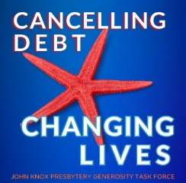
A Ministry of Hope
Whether as individuals or as a community of faith, we are called to serve those in need…not only to notice their need but also to do something about it. Our congregation is going to have the opportunity to help those who are suffering under the weight of medical debt through donations to the Starfish Campaign.
Medical debt is all too easy to accumulate. All it takes is getting sick or being involved in an accident or receiving a cancer diagnosis. The burden of medical debt turns people’s lives upside down. Home foreclosures and bankruptcies are common. A tarnished credit rating makes it next to impossible to take out a loan or rent an apartment. In too many cases, trying to pay a medical bill can deplete a person’s savings. Some have even become homeless. Even worse, a lot of people carrying medical debt do not pursue the care they need or buy medications that will keep them healthy.
October 18 is the culmination of this year’s Starfish Campaign. Every dollar received will be sent to an organization called Undue Medical Debt. They are able to buy large bundles of medical debt for pennies on the dollar. They then use the money we donate to eliminate as much medical debt as possible. Every dollar they receive will be able to wipe out at least $100 of medical debt for someone. Talk about bang for your buck!
Donating to this ministry is easy. You may contribute through your regular Sunday offering by placing your gift in the offering plate during worship. Please make your check out to our church and mark it “The Starfish Campaign”. Together, we can impact a lot of families! With their debts cancelled and their credit rating improved, it's absolutely good news to the families we’re helping. Truly God accepts what we offer and makes it amazing!

If you prefer, you may use the QR code to donate online.
(Use this newsletter article if your congregation has
donated to the Starfish Campaign in the past.)

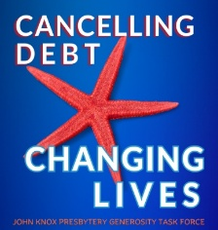

Removing Medical Debt in 2026
Once again this year, (YOUR CHURCH NAME) will raise money to support a Presbytery-wide ministry to cancel medical debt. John Knox Presbytery’s mission partner, Undue Medical Debt, is able to buy large bundles of medical debt from collection agencies and hospitals for pennies on the dollar. This allows every dollar we contribute to do the work of at least $100 and greatly increases the impact of our ministry!
It’s called The Starfish Campaign because, even though we cannot help every family carrying medical debt, we can still help thousands. In only four years, this ministry has cancelled close to $16 million of medical debt for 14,530 families. To those we are able to help, our ministry means the world. They receive a letter in the mail from Undue Medical Debt announcing the good news. A recent letter received by Undue Medical Debt tells the story. Cheryl, a nurse from South Dakota shared, “I’ve spent my life taking care of the people I love. Having this debt erased felt like someone finally taking care of me.”
Families struggle under the weight of medical debt for years. It’s a constant source of anxiety and stress as they try unsuccessfully to balance providing basic needs and paying their debt. When that debt is removed, everything changes. Lives are turned around. Hope is restored where no hope previously existed. Tears of joy flow freely. This is what our participation in the Starfish Campaign accomplishes.
Please give generously. Even a small gift will have a huge impact. A $10 contribution will cancel $1,000. This year’s fundraising efforts will culminate on Sunday, October 18 but donations can be made at any time. Simply mark your gift “The Starfish Campaign

If you prefer, you may use the QR code to donate online.

(This is a newsletter article that can be used after the Presbytery
announces the total received, how much medical debt was
removed and how many families were helped)

Removing medical debt…✓
“Now to him, who by the power at work within us is able to accomplish abundantly far more than all we can ask or imagine, to him be glory in the church and in Christ Jesus to all generations, forever and ever. Amen.” --Ephesians 3:20-21

Again this year, the churches in John Knox Presbytery were invited to participate in a ministry to remove the burden of medical debt for as many people as possible. The totals are now in and, altogether, $________ was raised. Our congregation generously contributed $__________. The entire amount was sent to Undue Medical Debt, a nonprofit organization whose mission is to buy medical debt from collection agencies for pennies on the dollar and uses donations like ours to cancel it.
Ready for the total amount of debt our ministry purchased and abolished? $_______! That is astonishing! The lives of _____ people and their families have indeed been blessed by the ministry God has called us to. The quote above is from the apostle Paul’s letter to the church at Ephesus. It was written close to 2,000 years ago but the words still ring true. God is able to accomplish a great deal more than we can imagine, even in our wildest dreams. Thank you, church, for this miracle that God has performed in our midst. It’s proof positive that God accepts what we offer and makes it amazing!

(This is a sample press release, inviting your church’s community to contribute)
Press release (Month, Day, Year) (your town) CAMPAIGN TO REMOVE MEDICAL DEBT
For immediate release
Church name and logo
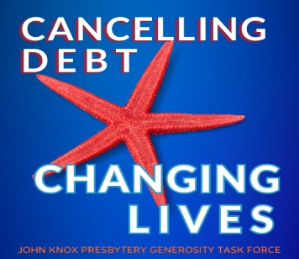
A major survey suggests people in the United States owe more than $225 billion in medical debt. Those struggling to pay their medical debt often suffer adverse health effects such as high blood pressure, anxiety and poor nutrition. They can also face bankruptcy and homelessness. Many are less likely to seek medical care for preventative services or treatment. Removing the burden of medical debt changes people’s lives and gives them renewed hope. Their credit rating improves. They are able to rent an apartment or apply for a car loan. And, as they receive a second chance, their mental and physical health improve too.
(Your church) of (your community) is participating in a fundraising effort with a nonprofit organization that purchases medical debt and cancels it. In the last four years alone, working with an organization called Undue Medical Debt, the congregations in John Knox Presbytery have raised over $131,000 and retired close to $16 million dollars in medical debt for 14,530 families. Members of the (Your church) congregation were so impressed, they are raising money again and inviting others in the community to join them. (your church) is committed to helping families struggling under the weight of medical debt by cancelling the debt and providing hope for the future. They are excited to be able to raise money to buy medical debt for just pennies on the dollar and make it disappear. Every dollar we receive will cancel at least $100 for a family struggling with medical debt. (Name of local church official) calls it, "Tremendous bang for the buck."
(your church)’s efforts are targeted to conclude October 18. Contributions from the (your city) community may be sent at any time to (your church name and mailing address). Checks should be made out to (your church) and donors are asked to mark their contribution “The Starfish Campaign”.
More information on Undue Medical Debt can be found at https://unduemedicaldebt.org.
Media contact:
Name
Email address
Contact phone number
Website address:

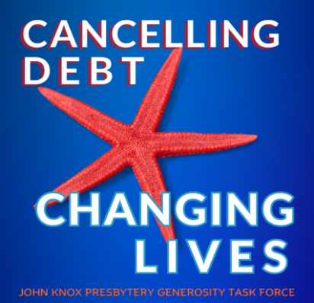

The Generosity Task Force chose the starfish logo to remind us that every fundraising effort is valuable. We undertake ministry even if we cannot help everyone, which is almost always the case anyway. The ministry we do changes people’s lives. It means the world to every family we help.
The starfish story is a familiar one. A man was walking along the beach. From a short distance, he saw a young boy pick something up and toss it into the water. When the man was able to catch up, he saw what the boy was doing…picking up starfish and throwing them back into the ocean. The boy explained that, if the starfish remained on the beach, they would die.
The man tried to reason with the boy and told him, “There must be thousands of starfish on this beach. You can’t save them all. What difference can you make?” The boy had found another starfish. As he picked it up and nimbly sent it into life-giving water, he smiled and told the man, “I made a difference to that one!”
With medical debt in the United States at more than $225 billion, no one person or group can help everyone. By partnering with Undue Medical Debt though, each dollar contributed will do the work of at least $100. You will make a difference to many people, renewing their hope and changing their lives!

