Bulletin announcements (4) for medical debt ministry 2025

For Sunday, September 28, 2025
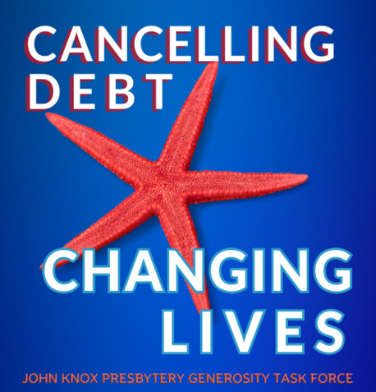
The Starfish Campaign raises money to cancel medical debt. Our congregation will be participating in this Presbytery-wide fundraising ministry. Too many families suffer great hardship trying to pay their medical bills. Unfortunately, medical debt can turn a family’s life upside down. Their physical and mental health can be affected. Every dollar contributed to the Starfish Campaign will cancel at least $100 of medical debt. Donate through our Sunday offering or mail your gift to the church. Please make your check out to our church and mark it “The Starfish Campaign”. Contributions can be made through October 19. Together, we make a big difference!

If you would prefer to donate online, the above QR code will take you directly to a secure portal on the Presbytery’s website.

For Sunday, October 5, 2025
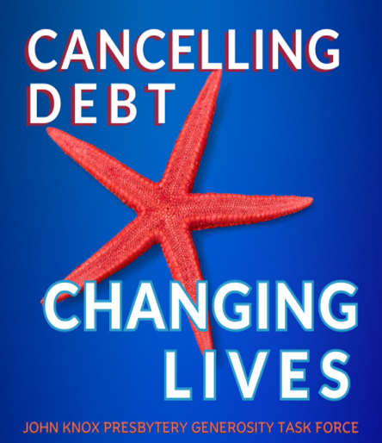
How is your gift to the Starfish Campaign multiplied? John Knox Presbytery partners with an organization called Undue Medical Debt to purchase and cancel medical debt on a grand scale. Because Undue Medical Debt understands the medical debt industry, every dollar the Presbytery raises will remove at least $100 of medical debt for a family. That changes people’s lives! There are two ways to contribute to this ministry. Give through October 19 in our Sunday offering, or you may mail your gift to the church. Please make your check out to our church and be sure to mark it “The Starfish Campaign”. Help lift a burden on struggling families. Others can live because we give!

If you would prefer to donate online, the above QR code will take you directly to a secure portal on the Presbytery’s website.

For Sunday, October 12, 2025
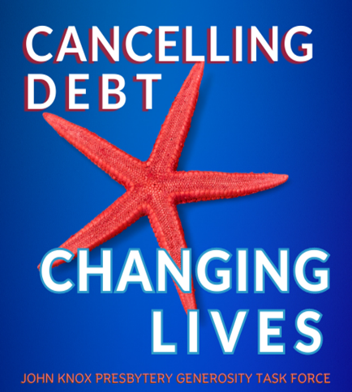
John Knox Presbytery is again participating in a ministry to remove the burden of medical debt for families. All 55 churches in our Presbytery have been invited to contribute to this ministry. Together, we have accomplished amazing results. In only three years, contributions Presbytery-wide have been able to cancel $11,138,677 of medical debt for 9,487 families. We are making a huge impact! Through October 19, contributions can be made through our regular Sunday offering or you can mail your gift to the church. Make your check out to our church and mark it “The Starfish Campaign”. Together, we can unleash the power of hope!
If you would prefer to donate online, the above QR code will take you directly to a secure portal on the Presbytery’s website.

For Sunday, October 19, 2025
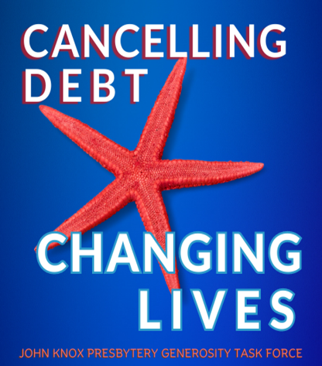
John Knox Presbytery’s ministry to purchase and cancel medical debt concludes today. Those who are carrying medical debt are three times more likely to struggle with depression and/or anxiety. Due to the expertise of the Presbytery’s mission partner, Undue Medical Debt, every dollar you contribute goes on to wipe out at least $100 of debt for the families we are helping.
There is still time to contribute through our regular offering this morning. Please make your check out to our church and mark it “The Starfish Campaign”. Thank you for your generosity. God accepts what we offer and makes it amazing!
If you would prefer to donate online, the above QR code will take you directly to a secure portal on the Presbytery’s website.

Minute for Mission—September 28, 2025
John Knox Presbytery’s ministry to cancel medical debt is called “The Starfish Campaign”. Here’s why. As the story goes, a man was walking along the beach. From a short distance, he saw a young boy pick something up and toss it into the water. When the man was able to catch up, he saw what the boy was doing. He was picking up starfish and throwing them back into the ocean. The boy explained that, if the starfish remained on the beach, they would die.
The man tried to reason with the boy and told him, “There must be thousands of starfish on this beach. You can’t save them all. What difference can you make?” The boy had found another starfish. As he picked it up and nimbly sent it into life-giving water, he smiled and told the man, “I made a difference to that one!”
Besides adverse health effects like high blood pressure, stress and poor nutrition, those struggling with medical debt can face bankruptcy and homelessness. Many are less likely to seek medical care for preventative services or treatment. There is an estimated $220 billion of medical debt in the United States. That’s a huge number. We won’t be able to help everyone. But…there is hope! On October 19, our entire Presbytery has been invited to raise money to eliminate medical debt. Every dollar raised will be sent to an organization called Undue Medical Debt, a leader in the purchase and removal of medical debt. They are able to buy large bundles of debt that have gone to a collection agency for pennies on the dollar. Their understanding of the medical debt industry allows what we contribute to go much further. Five dollars will remove at least $500 of medical debt for someone struggling to pay their bills. $20 will cancel $2,000!
This is an important ministry and we want to be a part of it. We ask you to be generous because God will grow our dollars many times over. The need is great but, because God accepts what we offer and makes it amazing, our congregation can make a difference and bring hope to many.

Minute for Mission—October 5, 2025
Our congregation has joined other churches in John Knox Presbytery to cancel medical debt for as many families as we can through the Starfish Campaign. In only three years, the presbytery has been able to cancel over $11 million and give hope to almost 9,500 families. How is it possible to eliminate so much? Because medical debt is handled differently that credit card or other kinds of debt. John Knox Presbytery has partnered with a non-profit organization, Undue Medical Debt, to grow the impact of our ministry. Undue Medical Debt purchases large bundles of medical debt from collection agencies and hospitals for only pennies on the dollar. They rely on contributions like ours to cancel the debt. Every dollar we can send them will wipe out at least $100.
Having their medical debt cancelled means the world to those we are helping. The burden of trying to balance providing for their family and paying the debt causes a lot of stress and anxiety. When the debt shows up on their credit report, new problems are added. Good luck trying to take out a loan or rent an apartment. Almost half of those carrying medical debt live in despair. They don’t ever expect to be able to pay it off. (Last year, our congregation generously contributed $_______ and made a difference to many families.) The Starfish Campaign gives us a resource to free families from the prison of medical debt. The culmination of this fundraising effort will take place on October 19. Gifts can be made anytime between now and October 19 by placing them in the offering plates. Checks should be made out to our church and please mark your offering “The Starfish Campaign”. Gifts can also be mailed to the church or made online on the Presbytery’s website, jknox.org. Together, and with God’s help, we will change peoples’ lives!

Minute for Mission—October 12, 2025
Christians are called to live lives of gratitude. As we give thanks for all that God has given us, the same spirit of thankfulness encourages us to help others. Churches in John Knox Presbytery are again participating in a ministry to purchase and eliminate medical debt. Our congregation wants to share in this ministry so we’re raising money to help as many families as we can escape the burden of medical debt. Those who struggle with this type of debt can have their credit rating destroyed. Many suffer the physical effects of stress and worry. Some families have even become homeless trying to pay their medical bills. Almost half of those carrying medical debt don’t think they’ll ever be able to pay it off.
Our donations and those of other churches in John Knox Presbytery will be sent to an organization called Undue Medical Debt, a leader in the area of medical debt removal. In just three years, the Presbytery has sent $87,527 to Undue Medical Debt where it has been able to wipe out over $11 million of debt for 9,487 families. That’s a lot of bang for the buck! Those whose debts have been significantly reduced or cancelled altogether receive a yellow envelope in the mail containing that good news. As you can imagine, those folks experience many emotions when they open the envelope to discover what has happened…relief, joy and gratitude. Here’s one woman’s story. Raquel is a single mom. She teaches a middle school history class in Florida. She underwent an emergency c-section several years ago and accumulated medical debt she was unable to pay off. When she received word that her debt had been cancelled, she wrote a letter to Undue Medical Debt. In it, she said, “This debt was especially stressful because I’ve spent the last three years working to rebuild my credit in hopes of buying a home. I knew this bill could hurt my credit and that fear added to the pressure. This is an enormous relief. You’ve already made our summer brighter. Thank you.” Your contribution can be placed in the offering plates through next Sunday. Please make your check out to our church and mark it “The Starfish Campaign”. Gifts can be mailed to the church and can also be made online by going to the Presbytery’s website, jknox.org. Let’s help send out a lot more of those yellow envelopes and give hope to as many families as we can!

Minute for Mission—October 19, 2025
Maya Angelou said, “Hope and fear cannot occupy the same space. Invite one to stay.” For many Americans drowning in medical debt, hope is only a memory. The troubles stem from the medical debt they’re carrying. Medical bills leave too many Americans overwhelmed and devastated. Their recovery from debt is often deferred…and it’s rarely a choice. Getting sick or diagnosed with cancer or being involved in an accident can start a family down the road to homelessness, bankruptcy and a loss of hope. Our congregation is joining other churches in John Knox Presbytery in a ministry of hope…a ministry to provide hope. We’re raising money to remove medical debt for as many people as possible. We can eliminate fear and bring hope to families struggling under the burden of medical debt.
Every dollar received will remove at least $100 in medical debt. To give you an idea what our ministry means to those we help, listen to words of gratitude from a woman in New Jersey. She expressed her gratitude in a letter to Undue Medical Debt. “Having all these unpaid medical bills weighed heavy on my mind. When I received the notice that my medical debt was no longer owed, I cried tears of joy. Thank you.”
Offerings can be placed in the plates this morning. Please make your check out to our church and mark it “The Starfish Campaign”. That name reminds us we are unable to help every family who bears the burden of medical debt, but we can help many and make a huge difference in their lives. By participating in this ministry, we will be helping families reestablish a better credit score and give them a chance to get a new start. Together, we can change lives and provide hope!

(Use this newsletter article if your congregation has not
yet donated to the Starfish Campaign.)

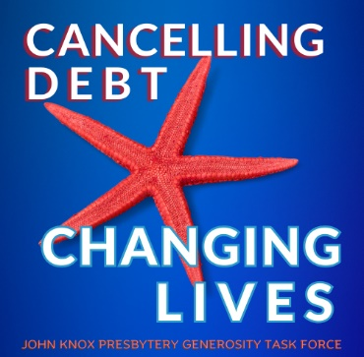
A Ministry of Hope
Whether as individuals or as a community of faith, we are called to serve those in need…not only to notice their need but also to do something about it. Our congregation is going to have the opportunity to help those who are suffering under the weight of medical debt through donations to the Starfish Campaign.
Medical debt is all too easy to accumulate. All it takes is getting sick or being involved in an accident or receiving a cancer diagnosis. The burden of medical debt turns people’s lives upside down. Home foreclosures and bankruptcies are common. A tarnished credit rating makes it next to impossible to take out a loan or rent an apartment. In too many cases, trying to pay a medical bill can deplete a person’s savings. Some have even become homeless. Even worse, a lot of people carrying medical debt do not pursue the care they need or buy medications that will keep them healthy.
October 19 is the culmination of this year’s Starfish Campaign. Every dollar received will be sent to an organization called Undue Medical Debt. They are able to buy large bundles of medical debt for pennies on the dollar. They then use the money we donate to eliminate as much medical debt as possible. Every dollar they receive will be able to wipe out at least $100 of medical debt for someone. Talk about bang for your buck!
Donating to this ministry is easy. You may contribute through your regular Sunday offering by placing your gift in the plate during worship. Please make your check out to our church and mark it “The Starfish Campaign”. Together, we can impact a lot of families! With their debts cancelled and their credit rating improved, it's absolutely good news to the families we’re helping. Truly God accepts what we offer and makes it amazing!
If you would prefer to donate online, the above QR code will take you directly to a secure portal on the Presbytery’s website.

(Use this newsletter article if your congregation has
donated to the Starfish Campaign in the past.)

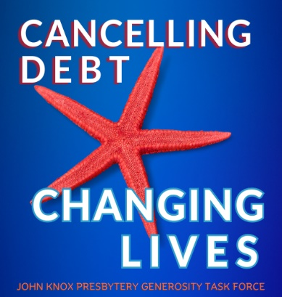

Removing Medical Debt in 2025
Once again this year, (YOUR CHURCH NAME) will raise money to support a Presbytery-wide ministry to cancel medical debt. John Knox Presbytery’s mission partner, Undue Medical Debt, is able to buy large bundles of medical debt from collection agencies and hospitals for pennies on the dollar. This allows every dollar we contribute to do the work of at least $100 and greatly increases the impact of our ministry!
It’s called The Starfish Campaign because we know we cannot help every family carrying medical debt. But we can still help many people. In only three years, this ministry has cancelled more than $11 million of medical debt for close to 9,500 families. To the families we are able to help, our ministry means the world. They receive a letter in the mail from Undue Medical Debt announcing the good news. A recent letter received by Undue Medical Debt tells the story. Vicki from Ohio shared, “This was an unexpected surprise. I’m retired, on oxygen and Social Security. It’s hard to manage unexpected costs like this hospital bill. I’m so grateful for what you do. I will treasure this letter forever.”
Families struggle under the weight of medical debt for years. It’s a constant source of anxiety and stress as they try unsuccessfully to balance providing basic needs and paying their debt. When that debt is removed, everything changes. Lives are turned around. Hope is restored where no hope preciously existed. Tears of joy flow freely. This is what our participation in the Starfish Campaign accomplishes.
Please give generously. Even a small gift will have a huge impact. A $10 contribution will cancel $1,000. This year’s fundraising efforts will culminate on Sunday, October 19 but donations can be made at any time. Simply mark your gift “The Starfish Campaign”.
If you would prefer to donate online, the above QR code will take you directly to a secure portal on the Presbytery’s website.

(This is a newsletter article that can be used after the Presbytery
announces the total received, how much medical debt was
removed and how many families were helped)

Removing medical debt…✓
“Now to him, who by the power at work within us is able to accomplish abundantly far more than all we can ask or imagine, to him be glory in the church and in Christ Jesus to all generations, forever and ever. Amen.” --Ephesians 3:20-21

On October 19, all the churches in John Knox Presbytery were invited to participate in a ministry to remove the burden of medical debt for as many people as possible. The totals are now in and, altogether, $________ was raised. Our congregation generously contributed $__________. The entire amount was sent to Undue Medical Debt, a nonprofit organization whose mission is to buy medical debt from collection agencies for pennies on the dollar and cancel it.
Ready for the total amount of debt our ministry purchased and forgave? $_______! That is astonishing! The lives of _____ people and their families have indeed been blessed by the ministry God has called us to. The quote above is from the apostle Paul’s letter to the church at Ephesus. It was written close to 2,000 years ago but the words still ring true. God is able to accomplish a great deal more than we can imagine, even in our wildest dreams. Thank you, church, for this miracle that God has performed in our midst. It’s proof positive that God accepts what we offer and makes it amazing!

(This is a sample press release, inviting your church’s community to contribute)
Press release (Month, Day, Year) (your town) CAMPAIGN TO REMOVE MEDICAL DEBT
For immediate release
Church name and logo
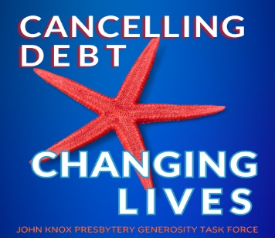
A major survey suggests people in the United States owe more than $220 billion in medical debt. Those struggling to pay their medical debt often suffer adverse health effects such as high blood pressure, anxiety and poor nutrition. They can also face bankruptcy and homelessness. Many are less likely to seek medical care for preventative services or treatment. Removing the burden of medical debt changes people’s lives and gives them renewed hope. Their credit rating improves. They are able to rent an apartment or apply for a loan. And, as they receive a second chance, their mental and physical health improve.
(Your church) of (your community) is participating in a fundraising effort with a nonprofit organization that purchases medical debt and cancels it. In the last three years alone, working with an organization called Undue Medical Debt, the congregations in John Knox Presbytery have raised over $87,000 and retired just over $11.1 million dollars in medical debt for 9,487 families. Members of the (Your church) congregation were so impressed, they are raising money again and inviting others in the community to join them. (your church) is committed to helping families struggling under the weight of medical debt by providing hope for the future. They are excited to be able to raise money to buy medical debt for just pennies on the dollar and make it disappear. (Name of local church official) calls it, "Tremendous bang for the buck."
(your church)’s efforts are targeted to conclude October 19. Contributions from the (your city) community may be sent at any time to (your church name and mailing address). Donors are asked to mark their contribution “The Starfish Campaign”.
More information on Undue Medical Debt can be found at https://unduemedicaldebt.org. Their guarantee is that, for every $1 donated, at least $100 in medical debt will be forgiven.

Media contact:
Name
Email address
Contact phone number
Website address:

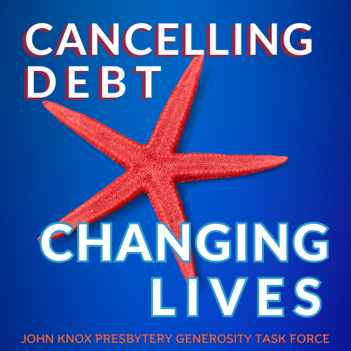



This is the QR code which will take folks directly to the Presbytery’s website and secure online portal to contribute.

