Easy Oven Mitt
Thursday, November 20th
12:30pm – 3:30pm or 5pm – 8pm
Class fee - $15, kit fee - $8

Make a quilted oven mitt with the help of the AccuQuilt Oven Mitt die. This is a perfect gift for the holiday season. Add a few wooden kitchen utensils or stitch a coordinating hot pad for a lovely gift.

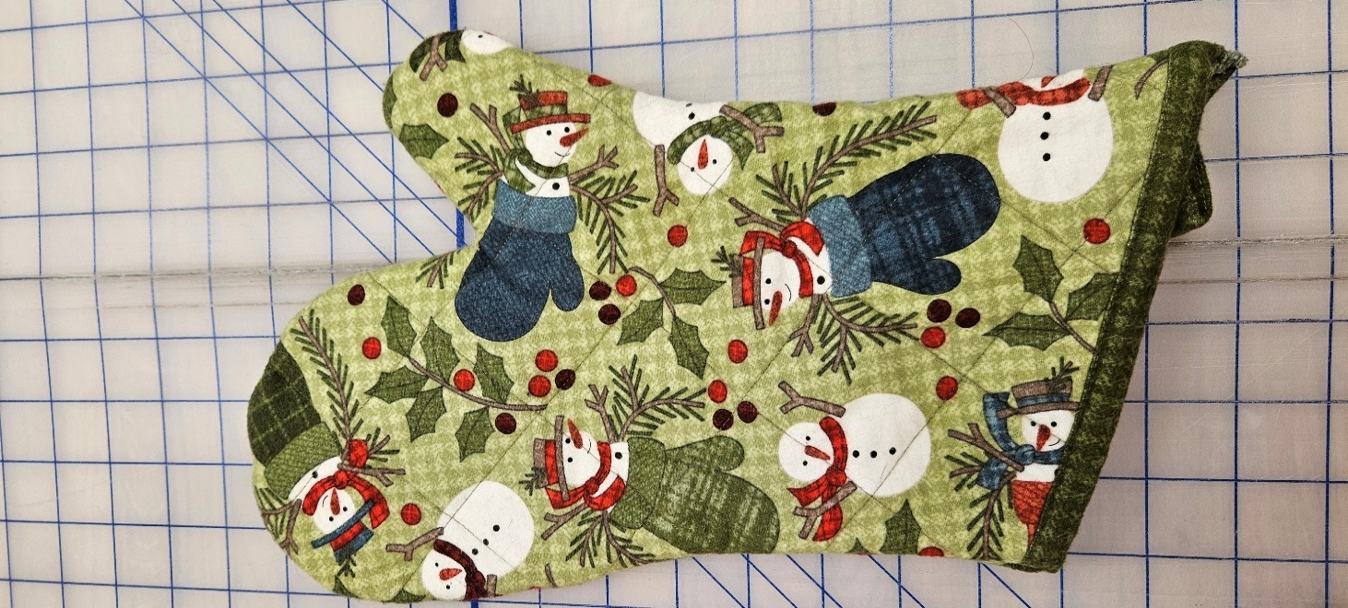
After quilting the layers together, the AccuQuilt Oven Mitt die quickly and accurately cuts the front and back pieces!

Skill level – beginner, but please be familiar with the threading of your sewing machine.

Supplies needed –
Sewing machine in good working order.
Standard zig-zag foot and a quarter inch foot.
Outer fabric – 12”x width of fabric.
Lining fabric, binding & loop – 12”x width of fabric.
Thread that complements the outer fabric.
Temporary marking pen that will show against outer fabric.
Basic sewing supplies – scissors, pins/clips, seam ripper, extra needles, etc.

Your kit will include –
Directions, Insul Bright and cotton batting.

Class Registration Policy - Class and kit fees are due at time of registration. Please register at least 72 hours prior to the class date. Your seat is not reserved until you register. You will receive a discount on supplies purchased in the store.

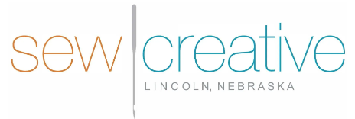
5143 South 48th Street
Lincoln, NE 68516
402-489-6262
sewcreative-ne.com

