Hot Pad
Monday, March 2nd
1 – 4pm or 5-8pm
Class fee -$20, Kit fee $5

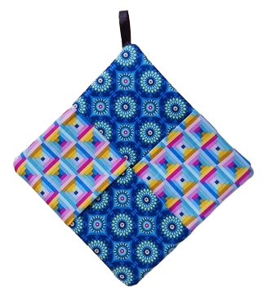
This class is appropriate for a beginner, but please be familiar with threading and bobbin winding on your sewing machine.

What to bring to class:
- Sewing machine in good working order,
- 80/12 Universal needles,
- 90/14 Quilting needles,
- Standard sewing foot <or> ¼-inch foot with guide,
- Walking foot (optional),
- Fabric – 2 or 3 Fat Quarters,
- Insulbrite – 9” square,
- Thread: 1 spool Mettler Metrosene to match fabric,
- Small ruler – 2”x18” recommended,
- Basic sewing supplies – pins, sharp scissors, seam ripper, point turner, marking pen/pencil.

Your kit will include cotton batting and ribbon.

Please feel free to bring a beverage, snacks, etc.

Class Registration Policy - Class fee is due at time of registration. Please register at least 72 hours prior to the class date. Once registered, you will receive a discount on supplies purchased in the store. We would love to help you pick out your fabrics and supplies!
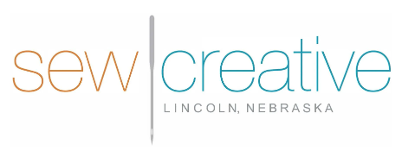
5143 South 48th Street
Lincoln, NE 68516
402-489-6262
sewcreative-ne.com

