Get to Know Your Sewing Machine
Saturday, February 7th
10am – 2:30pm
Class fee - $20, kit fee - $15

If you would like to become more familiar with your sewing machine – basic operation, stitches and basic sewing techniques, this is the class for you! We will provide a variety of fabric samples for practice stitching and information sheets for you to attach finished samples. The information sheet/samples can act as a reference guide when you go home.

Although THIS IS A BEGINNER CLASS, we do ask that you be familiar with how to thread and wind a bobbin on your sewing machine. If you need help with threading/bobbin winding, please let us know and we will assist you prior to class.

This class is open to all brands and all levels of sewing machines.

Skill level – beginner.

Supplies needed –
Sewing machine in good working order.
Bobbins and feet that came with your sewing machine.
Scissors or thread snips.
Pen or pencil.

Your kit will include –
Metrosene thread, a variety of fabric samples and needles.

Class Registration Policy - Class and kit fees are due at time of registration. Please register at least 72 hours prior to the class date. Your seat is not reserved until you register. You will receive a discount on supplies purchased in the store.

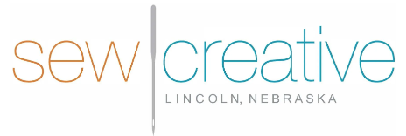
5143 South 48th Street
Lincoln, NE 68516
402-489-6262
sewcreative-ne.com

