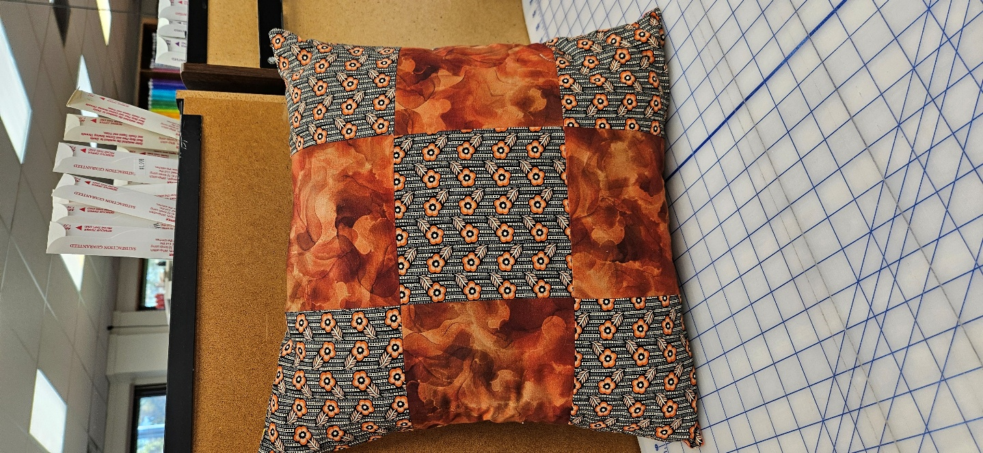
Beginning Sewing
9 Patch Pillow
Saturday, December 6th
10am – 3pm
Class fee - $40

Learn sewing basics while constructing a pillow. Safe cutting technique, proper pressing technique, accurate seams, zipper insertion and much more! We’ll review machine and basic sewing vocabulary to help you become familiar with common terminology and phrases.

Skill level – beginner, but please be familiar with threading and bobbin winding. If you are unfamiliar with your machine, please stop by the store and we will help you with threading and bobbin winding.

Supplies needed –
Sewing machine in good working order, including zipper foot,
Overcasting foot (optional, but helpful),
1/4 yard of two fabrics,
1 fat quarter for the back of the pillow,
12-14 inch invisible zipper,
Fabric marking pen/pencil (air or water erasable),
Thread to coordinate with fabrics,
Basic sewing supplies (pins/clips, scissors, seam ripper, etc.),
18” pillow form.

Class Registration Policy - Class fee is due at time of registration. Please register at least 72 hours prior to the class date. Your seat is not reserved until you register. You will receive a discount on supplies purchased in the store.

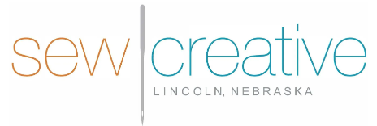
5143 South 48th Street
Lincoln, NE 68516
402-489-6262
sewcreative-ne.com

