Beginning Quilting 4-Patch Quilt
Finished size approximately 40”x40”
Saturday, February 14th & 28th
10am – 4pm, $80

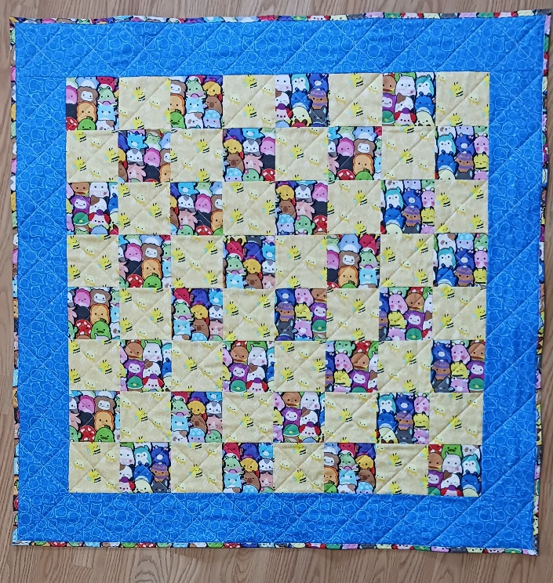
What to bring to class:

- Sewing machine in good working order,
- 80/12 Universal needles,
- 90/14 Quilting needles,
- Standard sewing foot <or> ¼-inch foot with guide,
- Walking foot (required),

- Fabric
  - Blocks – Dark – 5/8 yard
  - Blocks – Light – 5/8 yard
  - Borders – 5/8 yard
  - Binding – 1/3 yard
  - Backing – 1 ¼ yard
- Batting: 45” x 45” square,
- Thread: 1 spool Madeira cotton OR 2 spools Mettler Metrosene to match fabric,

- 6” x 24” acrylic ruler,
- Rotary cutter (45 mm),
- Fabric Marker (blue water soluble, or chalk wheel, whichever can be seen best on your fabric),
- Straight pins for quilting or clips,
- Quilt basting pins (safety pins), about 120,
- Scissors,
- Seam ripper.

Please feel free to bring a beverage, snacks, lunch etc.

Class Registration Policy - Class fee is due at time of registration. Please register at least 72 hours prior to the class date. Your seat is not reserved until you register. You will receive a discount on supplies purchased in the store. We would love to help you pick out your fabrics and supplies!
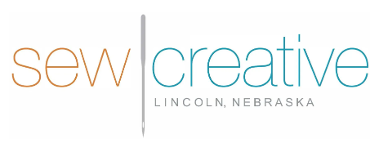
5143 South 48th Street
Lincoln, NE 68516
402-489-6262
sewcreative-ne.com

