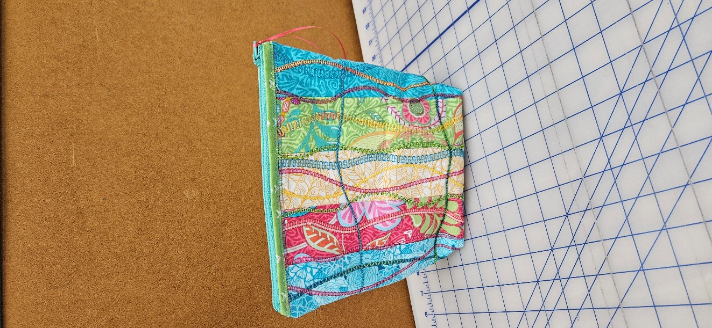
Applaud Zipper Bag
Saturday, November 8th
10am – 3pm
Class fee - $40, kit fee - $15

Use your Baby Lock serger to make a simple, yet eye-catching bag. You will have the opportunity to use the Baby Lock Applaud Decorative Cover/Chain Stitch to embellish your fabric!

Skill level – beginner, but please be familiar with the threading of your Baby Lock serger.

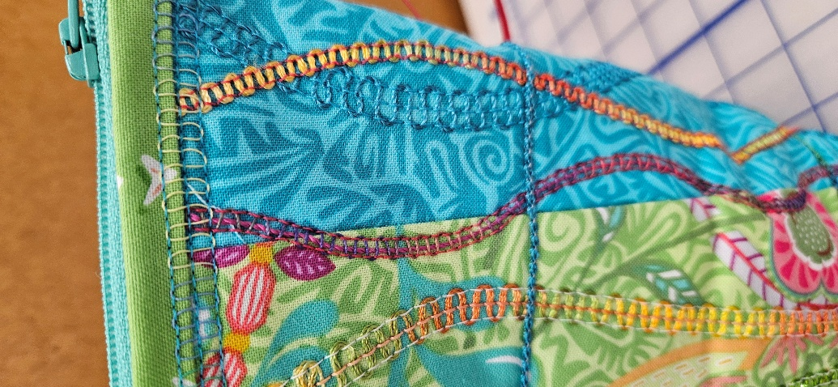
Supplies needed –
Baby Lock serger or serger/coverstitch combination.
4 cones of neutral colored serger thread.
Basic serger/sewing supplies – scissors, pins/clips, seam ripper, extra needles, etc.

Optional Supplies –
Decorative zipper pull,
Iron, pressing cloth and ironing mat.

Your kit will include –
Fabric, outside and lining.
Batting,
Zipper,
Fusible tape,
Decorative thread, yarn, ribbons, etc. for embellishment using the Applaud.

Class Registration Policy - Class and kit fees are due at time of registration. Please register at least 72 hours prior to the class date. Your seat is not reserved until you register. You will receive a discount on supplies purchased in the store.

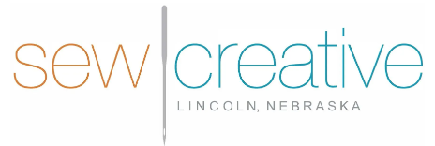

5143 South 48th Street
Lincoln, NE 68516
402-489-6262
sewcreative-ne.com

