Increased Creativity
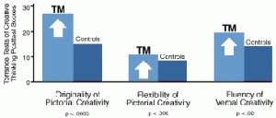This study used the Torrance Tests of Creative Thinking to measure figural and verbal creativity in a control group and in a group that subsequently learned the Transcendental Meditation technique.
On the posttest 5 months later, the Transcendental Meditation group scored significantly higher on figural originality and flexibility and on verbal fluency.
*Reference I: The TM technique and creativity: A longitudinal study of Cornell University undergraduates, Journal of Creative Behavior 13: 169-190, 1979. Reference II: A psychological investigation into the source of the effect of the Transcendental Meditation technique, (Ph.D. dissertation, York University) Dissertations Abstracts International 38, 7-B: 33723373, 1978.

Lower Blood Pressure
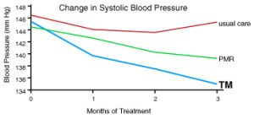In a clinical experiment with elderly African Americans (mean age 66) dwelling in an inner-city community, Transcendental Meditation was compared with the most widely used method of producing physiological relaxation.
Subjects who had moderately elevated blood pressure levels were randomly assigned Transcendental Meditation, Progressive Muscle Relaxation (PMR), or usual care.
Over a 3-month interval, systolic and diastolic blood pressure dropped by 10.6 and 5.9 mm Hg, respectively, in the Transcendental Meditation group, and 4.0 and 2.1. mm Hg in the PMR group, with virtually no change in the usual care group.
A second random assignment study with the elderly conducted at Harvard found similar blood pressure changes produced by Transcendental Meditation over 3 months (11 mm Hg for systolic blood pressure).
*Reference I: In search of an optimal behavioral treatment for hypertension: A review and focus on Transcendental Meditation, chapter in Personality, Elevated Blood Pressure, and Essential Hypertension (Washington, D.C., Hemisphere Publishing, 1992). Reference II: Transcendental Meditation, mindfulness, and longevity: An experimental study with the elderly, Journal of Personality and Social Psychology 57(6): 950 964, 1989.

Reduced Anxiety
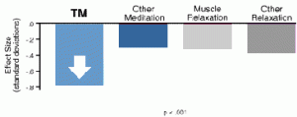A statistical meta-analysis conducted at Stanford University of all available studies-146 independent outcomes-indicated that the effect of the Transcendental Meditation programme on reducing anxiety as a character trait was much greater than that of all other meditation and relaxation techniques, including muscle relaxation.
This analysis also showed that the positive Transcendental Meditation result could not be attributed to subject expectation, experimenter bias, or quality of research design.
*Reference: Differential effects of relaxation techniques on trait anxiety: A meta-analysis, Journal of Clinical Psychology 45: 957974, 1989.

Decreased Stress
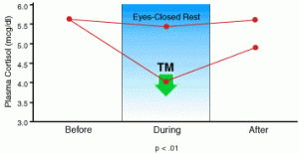Increased levels of the hormone cortisol in the circulation are well established correlates of both acute and chronic stress.
The study shows that plasma cortisol decreased during Transcendental Meditation, whereas it did not change significantly in control subjects during ordinary relaxation.
Sources: The transcendental meditation technique, adrenocortical activity, and implications for stress, Experientia 34(5): 618-619, 1978. Adrenocortical activity during meditation, Hormones and Behavior 10(1): 5460, 1978.

