
Rev. Dr. Willie P. Stallworth, Sr.

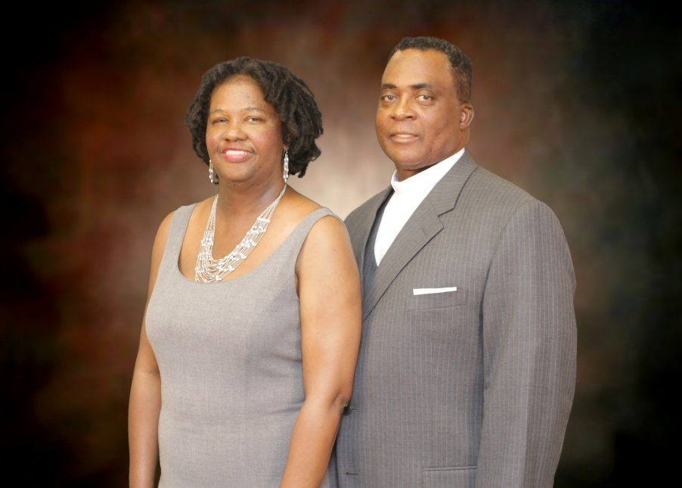

Dr. Willie P. Stallworth, Sr., is the third son of Mr. Clifford Stallworth, Sr., and the late Mrs. Virgia M. McIntosh Stallworth of Chestnut Corner, Alabama. He has three sisters, the late Alberta Murphy, Virginia Browder, and Brunetta (Michael) Blackshear. He has three brothers, the late Clifford Stallworth, Jr., Reverend Benjamin F. (LaDonya) Stallworth, and the late Frederick D. Stallworth.

Dr. Stallworth is a fourth generation Lutheran from the mission work of the Lutheran Church Missouri Synod on the Alabama Field in the early 1900’s. He is a Lutheran Pastor from the descendants of his great-grandmother, the late Ella McCant, who was instrumental in starting the fourth Lutheran Church on the Alabama Field, St. James Lutheran Church, Buena Vista, Alabama, and the fifth Lutheran Pastor from his extended family of the McCant, Montgomery, and Stallworth.

Dr. Willie P. Stallworth served as principal of St. Matthew Lutheran School, St. Louis, Missouri for fifteen years. Under his leadership, the student body grew from 90 students to 190. His objective was to prepare children spiritually, academically and socially for life in the 21st century and beyond; to lead by example; promote realistic goals; and establish a clear vision for setting and achieving goals.
Dr. Stallworth received his undergraduate degrees from Concordia College, Selma, Alabama - (A.A.), and Concordia Teacher's College in Seward, Nebraska - (B.S.). He received his Master's in School Administration from Concordia University, River Forest, Illinois. He also holds a degree in Urban Teachers Education from C.U.T.E., Rock Hurst College, Kansas City, Missouri.

Dr. Stallworth served on the Board for Black Ministry Services for six years as chairperson for Education and Recruitment before accepting the position as Director of Education Resources/ Family Life. In 2003, Dr. Stallworth became the Associate Executive Director for the Board for Black Ministry Services.

Dr. Stallworth is the founder of BLAST (Black-Ministry’s Lutheran Advisory School Team) and the Schools in Black Ministry Teacher’s Conference. He served on the School Cabinet and SSAC for School Ministry-LCMS, and was a consultant for Early Childhood Ministry-LCMS.

Dr. Stallworth was awarded the “Outstanding Leadership Award” by BLAST at the 2002 Black Ministry Family Convocation. He was recognized for his outgoing schools in Black Ministry leadership.

On May 7, 2005, Dr. Stallworth received his Doctor of Letters Degree from Concordia University in Seward, Nebraska.

In May 2005, Dr. Stallworth, co-founded Great Commission Lutheran Church, Saint Louis, Missouri.

Dr. Stallworth, currently serves on the Board of Lutheran Child and Family Servers of Illinois.

As a hobby, Dr. Stallworth enjoys working with his hands restoring antique cars and renovating, remolding, and repairing houses.

Dr. Stallworth is married to First Lady, Claudia Lenise Lewis Stallworth, and their household is blessed with six sons, Clifford (Christine), Willie, Jonathan (Katrina), George, Bryant and Virgil. Dr. Stallworth and First Lady Claudia have two grandchildren, ZiJohn and Zorah Stallworth, who are the new joys in their lives!

