Trinity Lutheran School

2668 Berkley Avenue - Mobile, AL 36617
PUBLIC RELEASE
This is the public release which will be sent to the agencies listed below:

SENT TO: News Media: Fox 10 News Date: July 10, 2025

Unemployment Office: Alabama Career Center________________________Date: July 10, 2025_____________

Major Employers: Date:

Public Release

Trinity Lutheran School today announced its policy for free and reduced-price meals for children served in schools under the National School Lunch Program and/or School Breakfast Program. For School Year 2025-2026 Trinity Lutheran School will continue participation in the Community Eligibility Provision (CEP). No further action is required of you. This USDA provision allows your child(ren) to participate in the school meal programs without having to pay a fee or submit a meal application.

CEP is a key provision of the Healthy, Hunger Free Kids Act of 2010, which allows schools and school districts in low-income areas to eliminate school meal applications and serve breakfast and lunch at no charge to all enrolled students. CEP gives food service professionals more time to focus on preparing nutritious meals that their students will enjoy and gives students more time to eat those meals by cutting down on time spent in the lunch line. More importantly, by offering all students a nutritious breakfast and lunch at no cost, CEP helps ensure more students come to class well-nourished and ready to learn.

Children need healthy meals to learn. Trinity Lutheran School offers healthy meals every school day. Breakfast and lunch meals will follow the United States Department of Agriculture (USDA) guidelines for healthy school meals, so please encourage students to participate. “In the operation of child feeding programs, no child will be discriminated against because of race, sex, color, national origin, age or disability.”

Parents or guardians who need further information may contact Theron Florence, Child Nutrition Program Director. If you have other questions or need help, call 251-456-7960.

Sincerely,
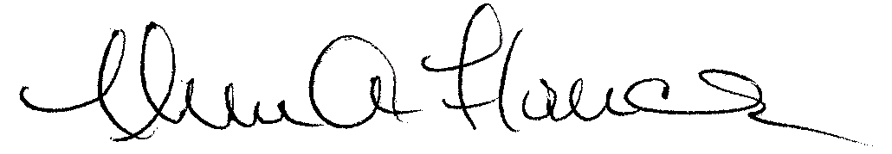
Administrator

Nondiscrimination Statement
In accordance with federal civil rights law and U.S. Department of Agriculture (USDA) civil rights regulations and policies, this institution is prohibited from discriminating on the basis of race, color, national origin, sex, disability, age, or reprisal or retaliation for prior civil rights activity.

Program information may be made available in languages other than English. Persons with disabilities who require alternative means of communication to obtain program information (e.g., Braille, large print, audiotape, American Sign Language), should contact the responsible state or local agency that administers the program or USDA’s TARGET Center at (202) 720-2600 (voice and TTY) or contact USDA through the Federal Relay Service at (800) 877-8339.

To file a program discrimination complaint, a Complainant should complete a Form AD-3027, USDA Program Discrimination Complaint Form which can be obtained online at: https://www.usda.gov/sites/default/files/documents/ad-3027.pdf, from any USDA office, by calling (866) 632-9992, or by writing a letter addressed to USDA. The letter must contain the complainant’s name, address, telephone number, and a written description of the alleged discriminatory action in sufficient detail to inform the Assistant Secretary for Civil Rights (ASCR) about the nature and date of an alleged civil rights violation. The completed AD-3027 form or letter must be submitted to USDA by:

mail:
U.S. Department of Agriculture
Office of the Assistant Secretary for Civil Rights 1400 Independence Avenue, SW
Washington, D.C. 20250-9410; or

fax:
(833) 256-1665 or (202) 690-7442; or

email:
Program.Intake@usda.gov

This institution is an equal opportunity provider.

Mail To:

Fox 10 News
1501 Satchel Paige Drive
Mobile, AL 36606

Alabama Career Center
515 Springhill Plaza Court
Mobile, AL 36608

