Saint Sebastian

Council of Catholic Women

How to Join
Please join us at our next monthly meeting, held the first Thursday of each month from September to May inside LeSage Hall
Hospitality begins at 6:30 pm, followed by our meeting at 7:00 pm
All women are welcome to join!

For additional information please visit:
https://www.stsebastian.com/Council-of-Catholic-Women

Annual Membership Dues $18.00
Payable to SSCCW



2026 – 2027

~ Elected Officers ~

President: Barbara Andreas
Vice President: Brandie delaPaz
Treasurer: Michelle Morin
Recording Secretary: Lauren Famiano

~ Standing Committee Chairs ~
Spirituality: Paula Witt
Leadership: Karen Rusk
Service: Kathy Bray & Cathy Bonin
Legislative Advocacy: Jacquelyn Keane Coughlin

Spiritual Advisor
Deacon John Henderson

~ Appointed Board Members ~
Parliamentarian: Vacant
Historian: Madonna Barashke
Corresponding Secretary: Jeanne Curtis

Immediate Past President: Ann Nolan

Saint Sebastian
Council of Catholic Women

The Lord lifts us up so that we may uplift others.

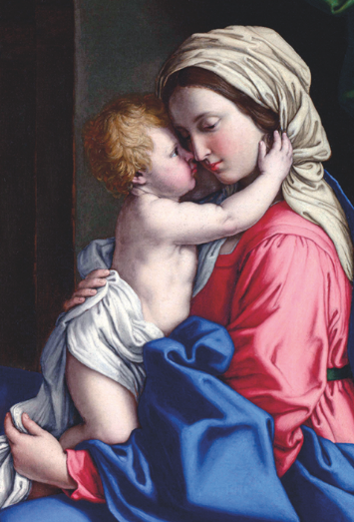

Mission Statement
The National Council of Catholic Women acts through its members to support, empower, and educate all Catholic women in spirituality, leadership and service. NCCW programs respond with Gospel values to the needs of the Church and society in the modern world.

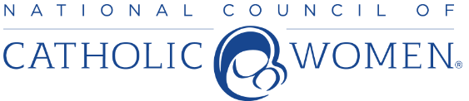NCCW- FCCW- PBDCCW- SSCCW
Established by the U.S. Catholic Bishops in 1920

Who We Are

We are the St. Sebastian Council of Catholic Women. Guided by our mission statement, we act through our membership to support, empower and educate all Catholic women in spirituality, leadership and service.

We are women who assist our Pastor in the needs of the parish through service projects and financial support from fundraising.

Our council will value your time, gifts and talent, as we strive to make every “sister” feel appreciated and that they belong.

As members of the National Council of Catholic Women, the Florida Council of Catholic Women and the Palm Beach Diocesan Council of Catholic Women, we are a nationwide organization of over 3,000 affiliations representing millions of Catholic Women.

We Are a Council Who Welcomes You!

What We Promote

Spirituality- creating a community of
God’s people who are educated and dynamic in their faith.

Leadership- empowering members through leadership, enrichment grants and personal development.

Service- involving members in responding to the needs of our own communities in programs that affect the lives and well-being of all.

Legislation- providing information about legislative issues and encouraging involvement and social responsibility.



Some of What We Offer

Opportunities to participate in National, State, and Diocesan workshops through programs, conferences, and conventions. Connecting with other women and sharing common interests. Parish stewardship of time and talent by participating in projects and ministries for the support of our Church and community.
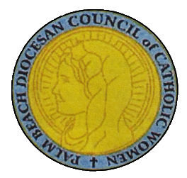

Outreach & Some of the
Programs We Support

- Water for Life
- Purse Club- Supporting Women who pursue a Religious Vocation
- Bishop’s Burse Fund- Supporting Men entering the Seminary
- Hugs for the Homeless
- Responding to Domestic Violence
- Scholarships for Education
- Our Lady of Guadalupe Food Program
and Migrant Worker Ministry
- A Caring Center for Women
- St. Sebastian Faith Formation
- St. Sebastian Meal Ministry

