Platelet Donors Save Lives!
Schedule a Platelet Donation Appointment Near You
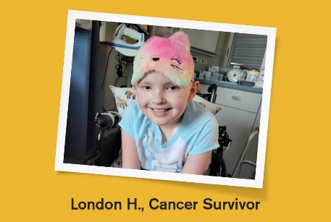
Platelets are tiny cell fragments in your blood that help form clots and stop bleeding. Nearly 50% of donated platelets go to cancer patients.
Your platelet donation this week can help save lives for cancer patients like London.

https://www.redcrossblood.org/giveplatelets.html?cid=brandPLT&med=cpc&source=google&scode=RSG00000E017&gclsrc=aw.ds&gad_source=1&gad_campaignid=21695946657&gbraid=0AAAAADx8NHTL83suJ7Cr99jmXI6-_hluG&gclid=Cj0KCQiA4eHLBhCzARIsAJ2NZoJokgwyetPC0GKPPEeCKRbTPwaDH8Ao1t8z_gHrbosPDxCGFZagTcYaAiV6EALw_wcB

Upcoming Gifts for Your Generosity:
- Jan. 26-Feb. 28: $20 e-gift card to your choice of merchant.*

Donate Platelets to Help Cancer Patients

Exclusively for New Platelet Donors:
Make your first-ever platelet donation*** with the Red Cross Dec. 1-Feb. 28 and also get a $30 Gift Card by email!*
Schedule Now

