
Meetings are now 6:30-7:30 pm every 2nd Tuesday of each month.

Meeting Minutes from Monday 9/14/2026 (rescheduled mtg for 9/8/26)
Board Members present: Paul, Serge, Ray B., Brittney, Marisa, Tia
Residents present:

41 F  M. Hlavac | 265 E  L. Rice | 58 E  C. Johnson & C. Baldwin

Opening 6:30 pm

Happenings & Updates:
*Flash Flood Alerts Discussion-Things we can do; what can we do to prepare? You should sign up for email/text message alerts via AppFolio website for FVCA to receive alerts from FVCA by both email and text messages. (This was extremely helpful to the folks who live on Leslie Road recently. The City of Bridgeport paved Leslie Road, which was great for us; however, they did not provide notice and only posted one sign.) **An urgent text & email went out to the residents who live there. It also alerted residents to park on Madison Ave that night and the following day/night while the road settled.
**We appreciate everyone’s prompt cooperation, as this was a significant help to the community from the city.

Flash Flood Alerts are serious! When alerts are sent out, such as the ones we all receive on our phones nowadays. Preparations should be taken to mitigate the situation and protect as much personal property as possible. This includes basements and cars should be moved from the Edgemoor Rd. turn because that is the low spot.

Education: What residents should have in case of emergency/Preparedness: shop vac/wet/dry vacuum to soak up water as quickly as possible, signing up for FVCA notifications as mentioned earlier. *Catch Basins: The catch basins to Edgemoor Rd.-creek is no more than approx. 2 tables wide (rooster river, so think from Price Rite down Madison & Park Ave all the way to Fairfield by Stop & Shop/Aldi’s. This is the reason for so much flooding. When raining 4 inches an hour, there is nowhere for it to go. “Garden units on Edgemoor/walk out below ground level.” Hence the overflow and flooding.

Tired of Rooster River Flooding? FVCA Residents are encouraged to attend the Friends of Rooster River Meeting 10/1/2026, 7-8 pm @ Fairfield Woods Library. (see the attachment)

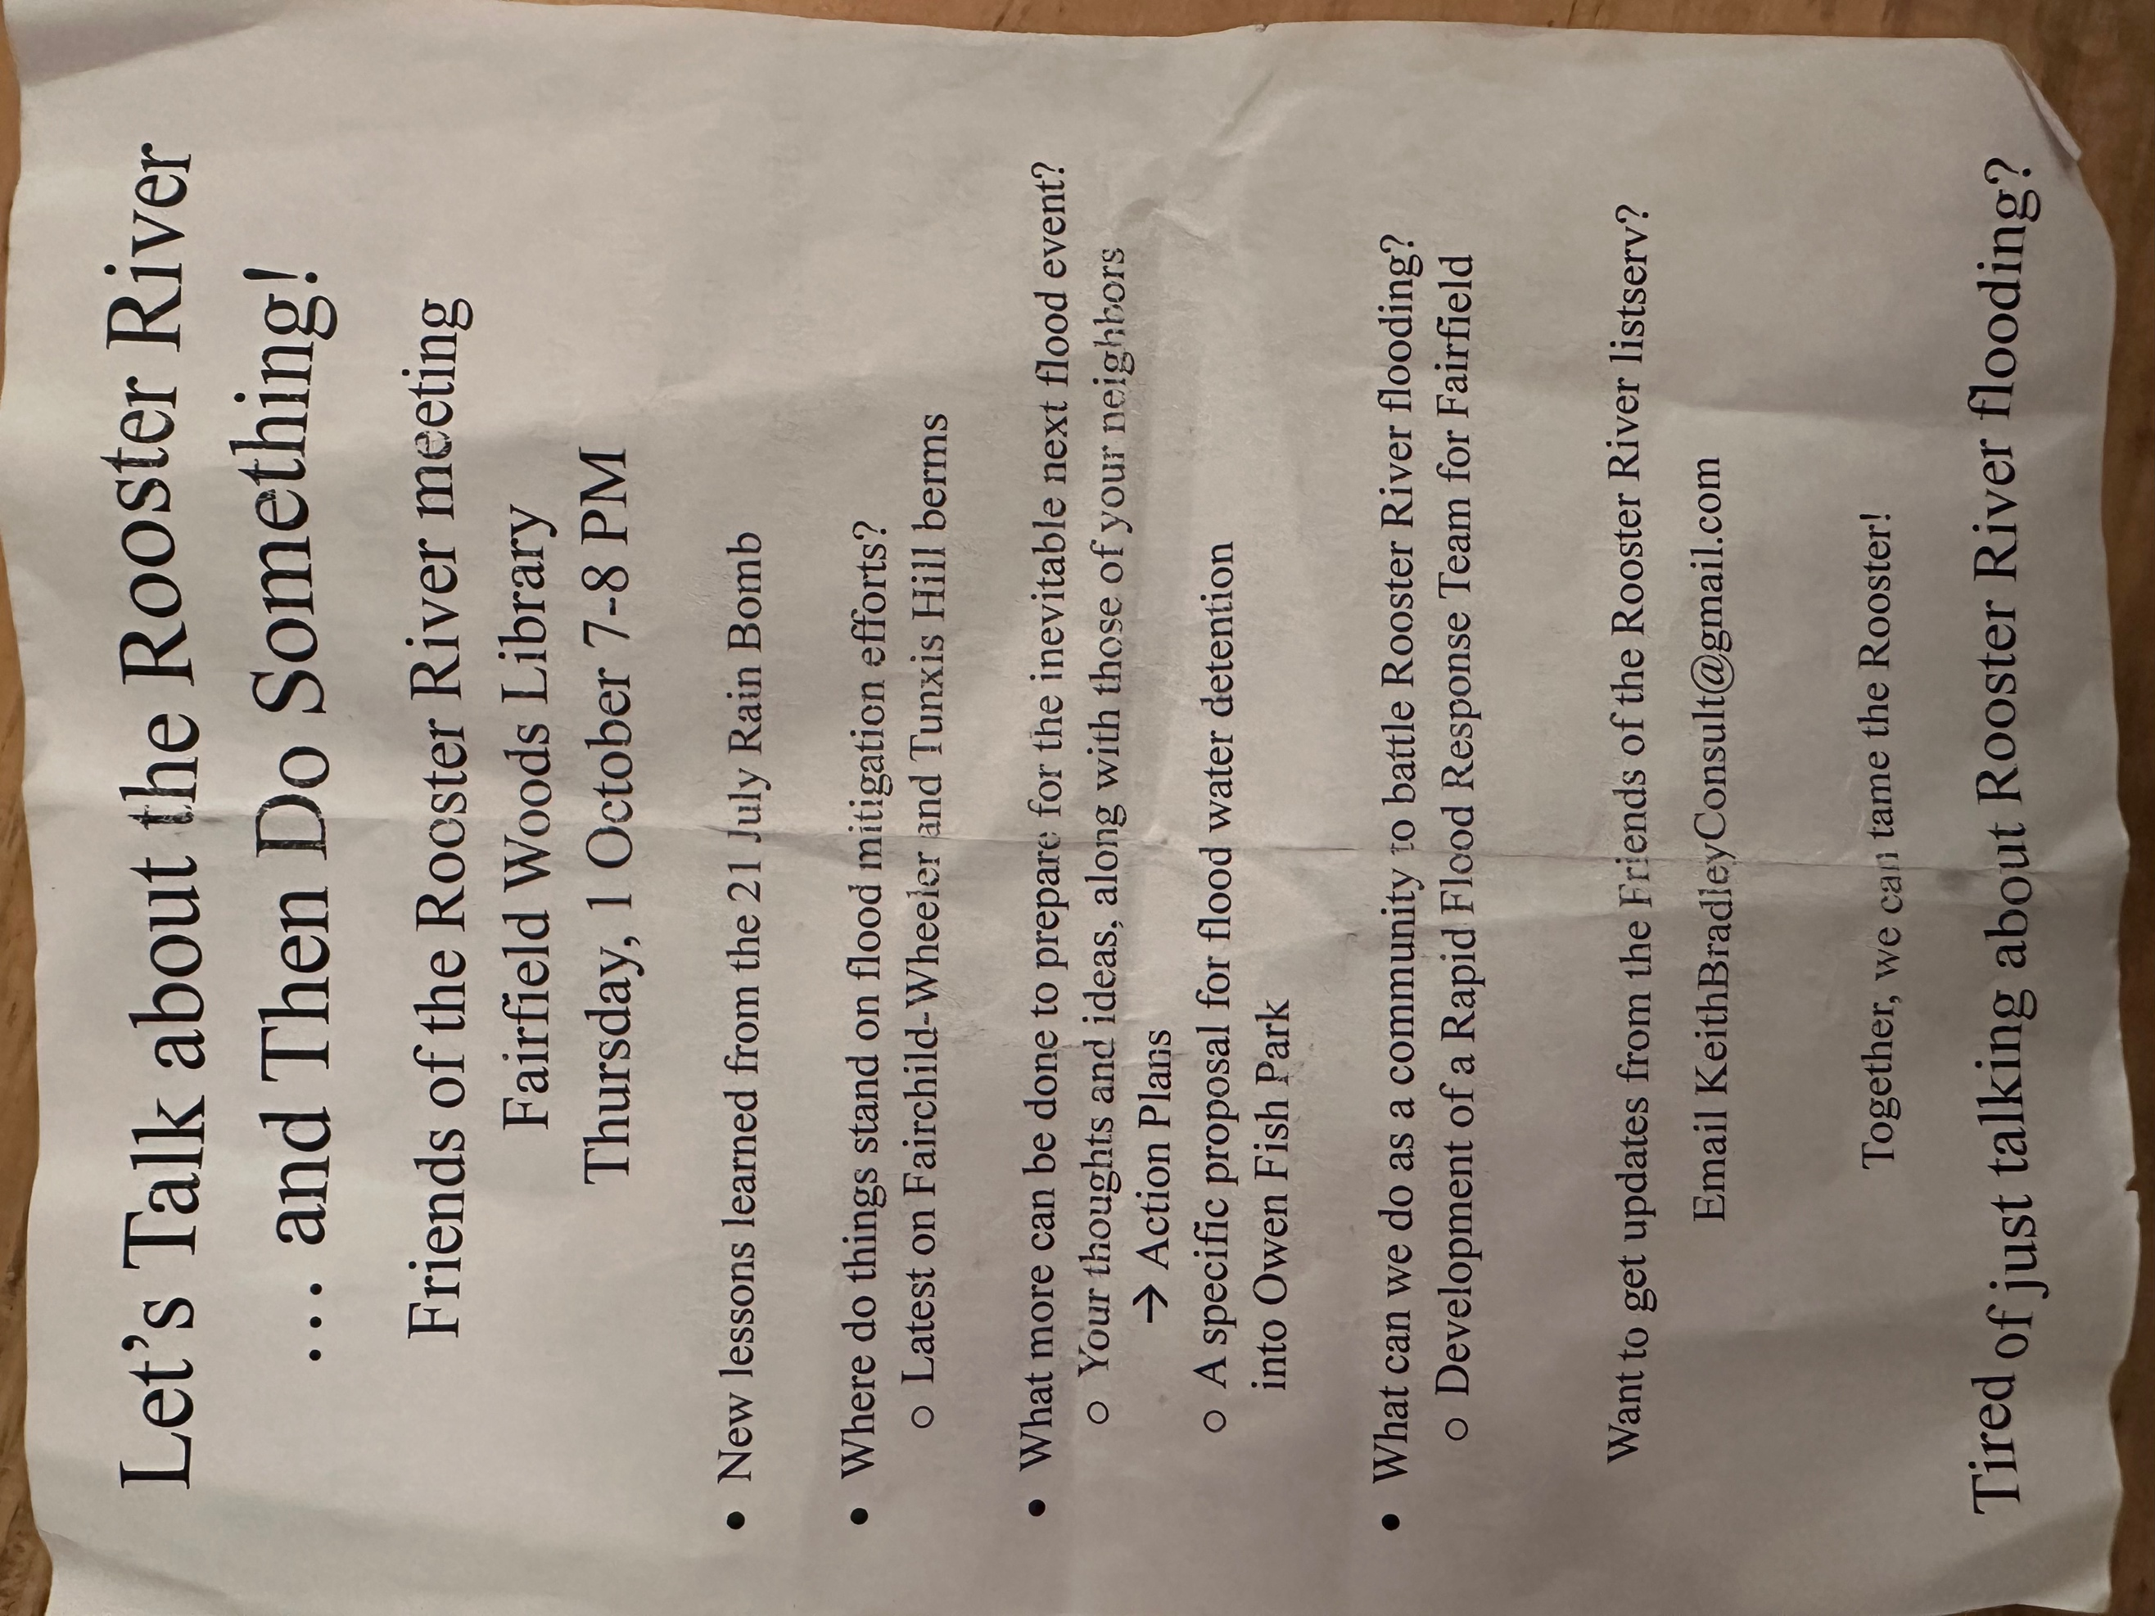

Flooding from yesterday, Sunday 9/13/26
- FVCA catch basins are going to back up because of the condo complex’s system design.
- Based on the FVCA property map, the major issue is Edgemoor and Building 225 pipes.

Upcoming Projects:
- Pool Closing Sunday 9/20/26 @ 9:30 am.
- All board members present voted to replace the stairs at units 41 B/C because of the safety issue. Bldg 70, (it costs aprox. $15,000 for 2 block stairs (stairs shared b/w 2 units)
- Casey -Arborist will probably come out in September.
- Steve is coming for lighting/parking lots. There has to be a wire that is busted underground.
- 3000 Madison Ave Condos-Still haven’t been paid their percentage of the snow removal this past winter.

- Reminders:
- Dryer Vent and Chimney cleanings and documentation to FVCA must be provided by November 1^{st,} YEARLY.

- Know where your water valve shut off in case of an emergency. If unsure, contact the board.

- Each unit MUST have WORKING smoke detectors and a fire extinguisher.

- DO NOT FLUSH-Nothing should EVER be flushed down toilets besides toilet paper. NO “FLUSHABLE WIPES”, TAMPONS, RAGS, DIAPERS, PAPER TOWELS, COTTON BALLS, etc. Most of the plumbing infrastructure at FVCA is over 40 years old and the pipes simply can’t handle it. These items cause blockage and WILL cause a sewage backup of your own feces. This is CRITICAL to all our health and sanitation!

- PARKING-Remains an ongoing problem here at FVCA. Each unit may use 2 parking spots per parking lot. Their 1 assigned number spot, and 1 guest spot. Any additional vehicles must be parked on the street. It is the responsibility of residents to inform their guests and visitors, or risk being towed. Any vehicle that has not moved from a guest spot or FVCA road for 10 days will be towed.

- All vehicles must be registered and operable.

- Towed Vehicles- Vehicles are towed by Midtown Autobody 203.384.1537. The cost of a tow is upwards of $350. They charge $100 drop fee once hooked up to any vehicle on the property.

- Dumpsters-FVCA dumpsters are for residents only. NO visitors should be disposing of large amounts of trash in the dumpsters. This will result in a fine of $300. Blocking dumpsters with vehicles or will result in the vehicle getting towed. No exceptions!

Meeting adjourned at 7:18 pm. Next meeting scheduled for 10/13/26.

