*Please think of God’s creation when coming to church; walk or cycle if you can or consider car-sharing.*

*If there is anything that we can do to make worship or information about what we do more accessible please speak to one of the clergy or call Rachel in the office on* 846230 / [office@portisheadparish.co.uk](mailto:office@portisheadparish.co.uk)

|  |
| --- |
| **Sunday 21st September – St Matthew** |
| *This week’s readings are:*  *Proverbs 3.13-18; 1 Corinthians 4.1-6; Matthew 9.9-13*  **8.00am Holy Communion at St Peter’s Church**  **9.15am for 9.30am Café Church at St Nicholas’ Church**  **9.45am *The 9.45* Special at St Peter’s Church**  11.15am Café Church with The URC at St Nicholas’ Church  **11.30am Parish Eucharist at St Peter’s Church**  **6.00pm Evensong at St Peter’s Church**  For safeguarding reasons we are not able to livestream the 9.45 Special this week.  You can access a service from the Church of England at 9.00am on Sunday at <https://www.churchofengland.org/prayer-and-worship/church-online>  *We depend on the regular faithful giving of the church family to continue our mission and ministry to Portishead and maintain our church buildings. If you do not already do so please prayerfully consider giving regularly to the church – no matter how small the sum you can afford. Visit*[*www.portisheadparish.co.uk/welcome*#Giving](http://www.portisheadparish.co.uk/welcome#Giving) *for more information of how to do this.* |

**Parish Calendar for the Week Ahead:**

|  |  |  |
| --- | --- | --- |
| **Mon 22nd September** | 7.15am | Mission Prayer - https://teams.live.com/meet/9399632380155?p=xl0GS1guFQs7vCocPK |
| **Tues 23rd September** | 9.00am  10.30am | Refresh Parent, Baby and Toddler Group at St Peter’s Church  Lighthouse Carers Group at St Nicholas’ Church |
| **Weds 24th September** | 9.00am  11.45am  7.30pm | Morning Prayer via Zoom <https://bit.ly/WednesdayMorningPrayer>  Funeral for the late Gregory Iles at St Peter’s Church  PCC Meeting at St Nicholas’ Church |
| **Thurs 25th September** | 10.30am  10.40am  2.00pm  2.30pm | Midweek Communion at St Peter’s Church  Midweek Church Coffee via Zoom <https://bit.ly/3RybNnJ>  Lighthouse Café at St Nicholas’ Church  Mothers’ Union at St Peter’s Church |
| **Fri 26th September** | 11.30am | Thanksgiving service for the late Pauline Simper at St Peter’s Church |

Next week’s services:

**Sunday 28th September – Trinity 15**

*Jeremiah 32.1-3a, 6-15; 1 Timothy 6.6-19; Luke 16.19-end*

**9.30am Parish Eucharist at St Nicholas’ Church**

**9.45am *The 9.45* at St Peter’s Church**

**11.30am Parish Eucharist at St Peter’s Church**

**2.00pm Pet Service at St Peter’s Church**

**Our Prayers**

****

**Those in need** John Massey, Anne Lewins, Peter Finch, Mary Powell, Judith, Art, Amy and Family, Irene Flockhart, Charmaine Cornish, Sam Edwards, Ann Field, Margaret Carey, Pat Jouxson, Maureen Noakes, Brenda Greenham

**The departed** Gregory Iles, Terry Kilvington, Antoinette Stratford, Pauline Simper, Barbara Mary Hall, Brian Best, John Dunkley, Graham Bond, Harry Kenah

The Thanksgiving Service for Pauline Simper will take place on Friday 26th September, 11.30am at St Peter’s Church, there will be a committal at 10.00am at South Bristol Crematorium, if you wish to attend, please do.

**Psalms, Prayer & Contemplation. A short course for the Autumn**

Is your Autumn in need of this…

Time to refresh yourself spiritually? Time to reflect on prayer?

Time to undertake a new course?

If yes, then the following might be of interest to you…

A different psalm will be pondered on each week. Questions on the psalm will be posed which might help us to deepen our understanding of God and ourselves. A time of quiet will be included, along with a time for sharing.

Sounds interesting? Then read on…

**Time & Place:** 7.15pm – 8.45pm, at St Nicholas’ Church, Nore Road.

**When:** Tuesday 23rd September

Tuesday 30th September

For further information speak to Revd Tonya 01275 840016

**Please be aware the church office opening times are now 9.30am until 12.30pm.**

**Celebrating Church Tots**

After many year, Church Tots has sung its final song and lovingly packed away its coloured pens. This much-loved group has been a welcoming space for little ones and their grown-ups – a place of songs, stories, juice and gentle introduction to faith. To give thanks to the incredible ministry of Church Tots and the wider children’s work in our parish, we invite you to a **Service of Celebration** on Saturday 20th September at 2pm at St Peter’s Church. If you’ve ever sung “*If I Were a Butterfly,”* drunk juice in a sippy cup or been part of the Church Tots family in any way, please come along and join us. Bring your stories, your memories, and maybe even your old craft masterpieces – we’d love to celebrate together!



**St Peter’s Church Tidy-Up Morning**

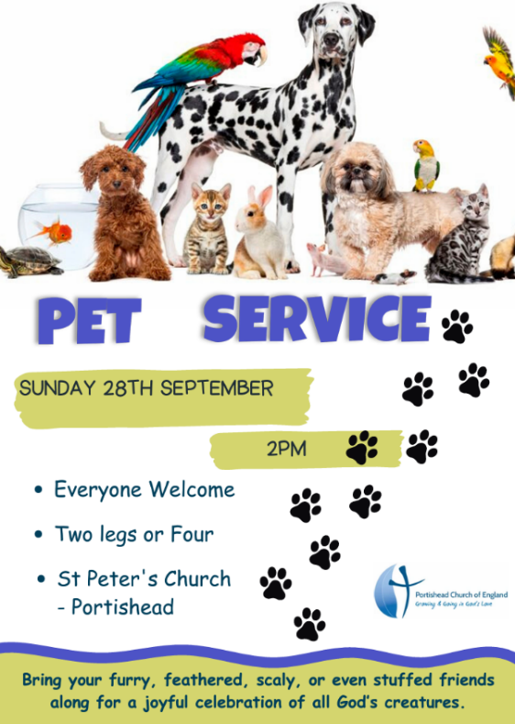Saturday 27th September, from 10am to 12noon at St Peter’s Church. A chance to help tidy up the church, churchyard and garden. If you’re coming, bring gloves and any gardening tools you have. Everyone is welcome, no matter your age or experience. Tea, coffee and friendly company will be on hand throughout the morning.

**Calling All Creatures Great and Small!**

Bring your furry, feathered, scaly or even stuffed friends along for a joyful celebration of all God’s creatures. Whether your pet barks, meows, chirps or just sits & looks cute, we’d love to see you. Everyone welcome, two legs or four at St Peter’s Church. Sunday 28th September, 2pm.

**Marthas Kitchen at Impero Lounge**

Volunteers from Martha’s Kitchen will be in the Impero Lounge on Tuesday 23rd Sept from 8am until 9.30am. Children can stop by on their way to school for a FREE breakfast of cereals and toast, while parents can enjoy an early morning coffee and chat. They will also be available to issue foodbank vouchers and lunch bag vouchers.

**Caring for Creation this Harvest**

As part of our harvest celebrations and our commitment to caring for God’s creation, we’re thinking about how our churches can reflect that care – right down to the flowers in the church.

On Saturday 4th October, from 10am – 12pm, we’re hosting a **Sustainable Flower Workshop at St Peter’s Church.**

The brilliant **Sarah Lewis from St Johns, Clevedon**, will be sharing her expertise in sustainable flower arranging. Whether you’ve arranged flowers for church before or never tried it, this is a great chance to learn something new. Many people discover they’re more creative than they thought! Please bring along **flowers and foliage** if you can – we’ll provide **tea, coffee, and cake** to keep everyone going. From 11am to 12noon there’ll be a special activity for younger ones: making **salt dough creations** to celebrate harvest in their own way. Everyone is welcome – come and be part of something beautiful, creative and caring.

**Sustainable Harvest Supper**

Following the success of last year’s harvest supper, we are holding another this year with the theme *‘Sustainable and Fairtrade’* in mind. Come and feast together with us and enjoy a wonderful evening. There will be no bar so please bring your own drinks. We have a limited amount of spaces for the meal, so please contact Rachel in the office if you would like to attend or have any questions.

**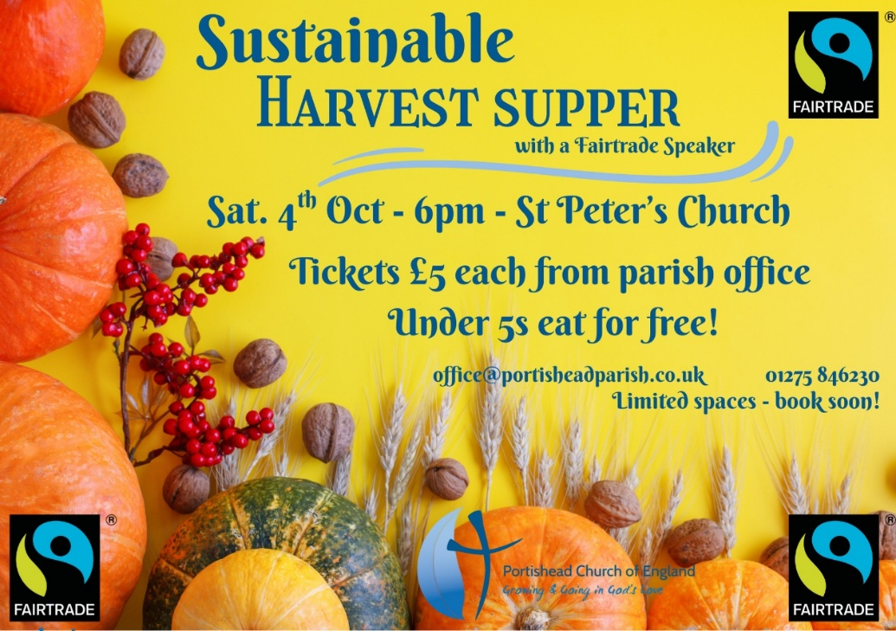**

**An Auction of Goods and Promises – Saturday 18th October – St Peter’s Church**

Get ready for a wonderful evening full of fun, fellowship and fundraising! Our Auction of Promises event is returning this October. We’re currently gathering promises and any donations to auction! Could you offer:

* A skill you’re proud of (think: cake decorating, guitar lessons, gardening advice)
* A helpful service (perhaps dog walking, ironing or tech support)
* A prize or experience (an afternoon tea, a boat trip, or even homemade jam?)

If you have an idea or talent to share, we’d love to hear from you. OR What would you love to know or have a go at?? (We may be able to provide a coach!) Every promise helps us build a fun-filled auction. To offer a promise, an item to donate or learn more, get in touch with the Church Office, Kathryn Phillips – [kathrynphillips018@gmail.com](mailto:kathrynphillips018@gmail.com) / 07834097595

Thank you for your support and creativity – we can’t wait to hear from you!

**Ethics Forum – Social Media, Self Esteem and Mental Wellbeing**

Monday 20th October, 7.30pm at St Peter’s Church

We are delighted to welcome ***Katharine Hill, a Director of Care for the Family***, to lead the session. Smartphones, Snapchat, TikTok, gaming, AI… Technology forms the backdrop to our lives – there are many advantages but also huge challenges.

Discover how to keep young people safe online, while forging good habits ourselves. Learn how to shape our digital lives so they don’t shape us! Katharine Hill is a Director of Care for the Family, a national charity which aims to strengthen family life and help those who face family difficulties. She is the author of several books, including the popular “*Left to their own Devices? Confident parenting in a digital world*” and “*A Mind of Their Own – building your child’s emotional wellbeing in a fast changing world*”. All are welcome, no tickets needed. Admission is free but donations are welcome etc cover costs and to support the work of Care for the Family (suggested donation £5). We also plan to livestream the forum to the church’s YouTube channel: <https://www.youtube.com/live/yvU7h88GnDI> - Contact David on 01275 840245 or [David.tyers@gmail.com](mailto:David.tyers@gmail.com) for further information.

**The Nest at St Peter’s Church**

St Peter’s Church warmly invites you to experience Hamish Young’s latest poignant and thought-provoking community art installation, which we are delighted to welcome to the church from 23rd-28th September for Portishead Arts Festival’. Nestling inside our welcoming community space of St Peter’s Church, you’ll find the Nest: an ambitious sculpture that initially seems to defy the laws of psychics and gravity; a structure constructed from hundreds of cardboard postal tubes.

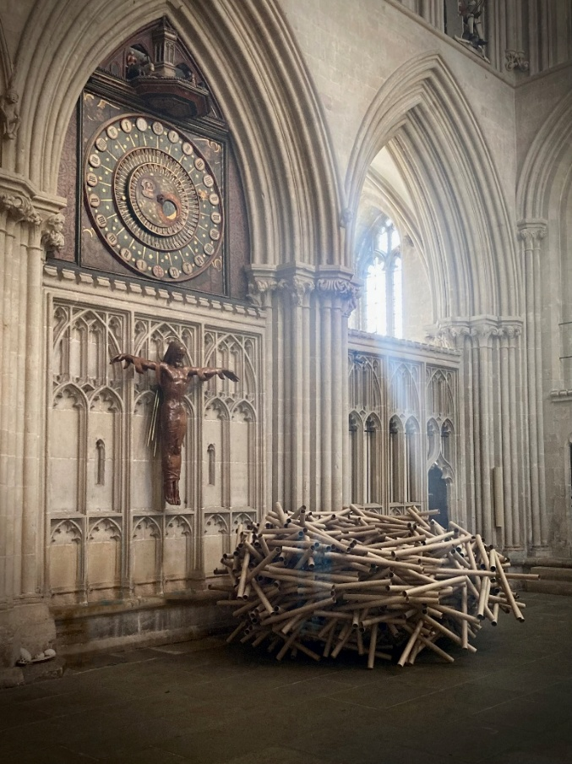This humble material allows both artist and visitor to draw on the rich associations of a material so often utilised as protection for objects in transit. You are invited to write – if you wish – a letter home, to wherever, whenever or whomever that might be, seal this in the special envelope provided and post it in the Nest sculpture. Your message might be one of remembrance or reconciliation, of thanks or hope, something you never got to say or wish you had said, or something else you might want to say.. The message you leave will remain private and unread.

On **Saturday 27th September, 2pm – 4pm, at St Peter’s Church,** Hamish will take part in a meet and greet session and an interview about the concept of Nest. An audience Q&A will also be held if there is time.

**Families Worker Vacancy – Maternity Cover**

The Parish of St Andrew’s Backwell seeks to appoint a part-time Families Worker for a ten-month fixed term contract, starting on 1st October, to cover for the permanent office-holder whilst they are on maternity leave. The work is primarily associated with the Pupil Chaplaincy work at Backwell Junior School and is therefore mainly a term-time role. The work will take around fifteen hours a week (flexible but will need to be able to commit to Wednesdays) and will be paid at a rate of £14 per hour. A full DBS clearance will be required. For more information and a job description please contact either Timi Booy, the present office holder at [childrensworker@saintandrewsbackwell.org.uk](mailto:childrensworker@saintandrewsbackwell.org.uk) or the Rev Sam Norton at revsamnorton@gmail.com

|  |  |
| --- | --- |
| Church Office opening times Mon – Fri 9.00am – 12.00pm  Tel: 01275 846230 Email: office@portisheadparish.co.uk | To make a donation to the church please use:   |
| Revd Rob Eastwood Dewing 01275 846592 [rector@portisheadparish.co.uk](mailto:rector@portisheadparish.co.uk) |
| Revd Tonya Nixon 01275 840016 [pastorportishead@outlook.com](mailto:pastorportishead@outlook.com) |
| Revd Mark Fuller 07766310509 [pilgrim@portisheadparish.co.uk](mailto:pilgrim@portisheadparish.co.uk) |
| Revd Lindsay Smith 07483932608 [pioneer@portisheadparish.co.uk](mailto:pioneer@portisheadparish.co.uk) |
| Parish Magazine Editors [portisheadparishmageditors@gmail.com](mailto:portisheadparishmageditors@gmail.com) |  |



**Portishead Quakers invite you to**

**A Fairtrade Cream Tea**

**Sunday 5th October 2025**

**3 pm - 4.30 pm**

**At 11, St. Mary’s Road, Portishead BS20 6QP**

Enjoy Fairtrade tea, cake and scones while listening to

‘Old Moll’ with her Folk-Tinged music and song.

Kindly RSVP to: [portishead.clerk@bristolquakers.org.uk](mailto:portishead.clerk@brisyolquakers.org.uk)

IMG_0799.PNG

Or Telephone/Text 07746592687

‘*Fairtrade is not just a label. It’s a life-changing system. A movement of hope!’*

*Felix Tetteh*

We look forward to seeing you!