How to use Volunteer Hub

Table of Contents
How to Sign In Online 2
How to Browse and Sign Up for Volunteer Opportunities 3
How to View Your Scheduled Volunteer Shifts 5
How to Cancel an Event You’re Signed Up For 6
How to Update Your Profile Information 7
How to Sign Out 8

How to Sign In Online
*** If you don’t know your username and password please ask our staff on site***
- Go to: https://ccstcloud.volunteerhub.com/vv2/lp/EmergencyServices
- Click "Sign In" in the top right corner.
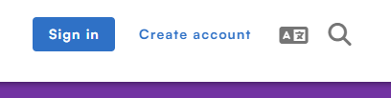
- Enter your username or email, then click "Next."
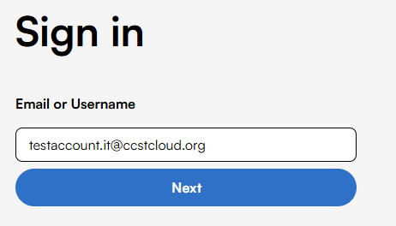
- Select "I'll use my password."
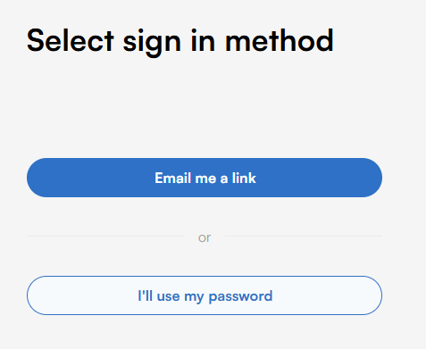
- Enter your password, then click "Sign In."
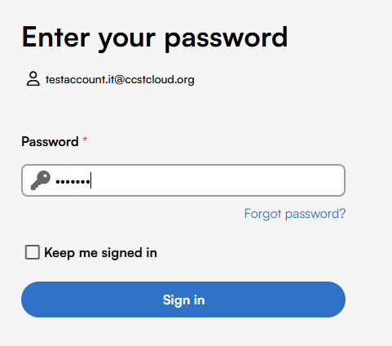

How to Browse and Sign Up for Volunteer Opportunities
- The Events page is the first page you’ll see. It displays all available volunteer opportunities.
- To narrow down your options, use the "Events" dropdown and the "Filters" button:
  - The Events dropdown lets you filter by volunteer area (e.g., Food Shelf, Intake).
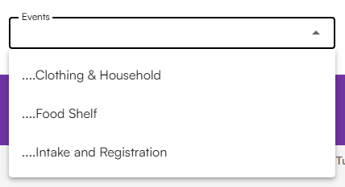
  - The Filters button allows you to select a specific date range or day of the week.
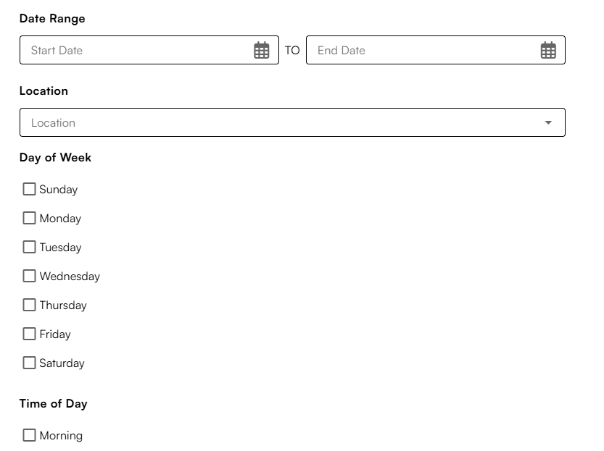
- Click on a volunteer opportunity to view its details.
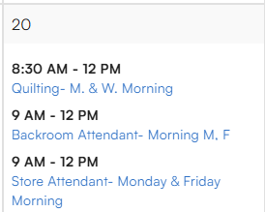
- To sign up, click the blue "Sign Up" button.
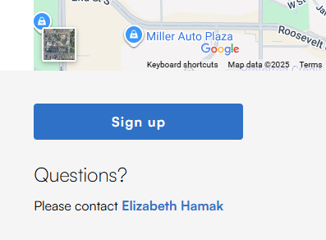
- Then click "Finish" to confirm your registration.
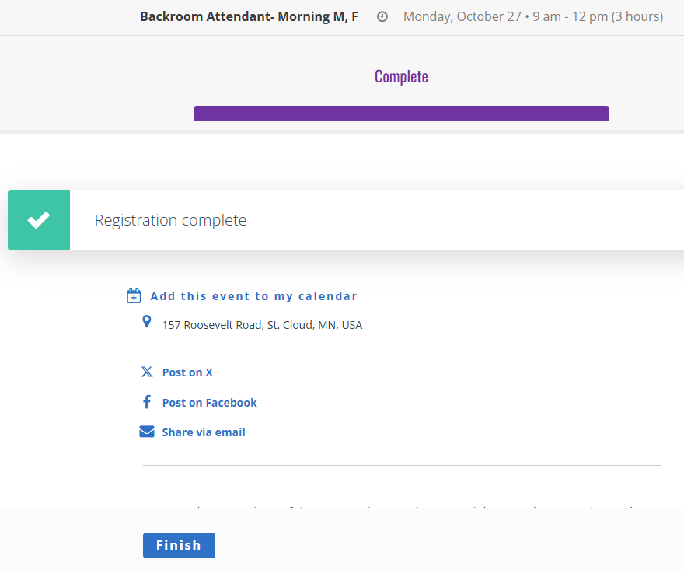

How to View Your Scheduled Volunteer Shifts
- Click on "My Schedule" at the top of the page.
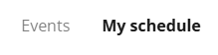
  - This will display a calendar view showing all the events you’re signed up for.
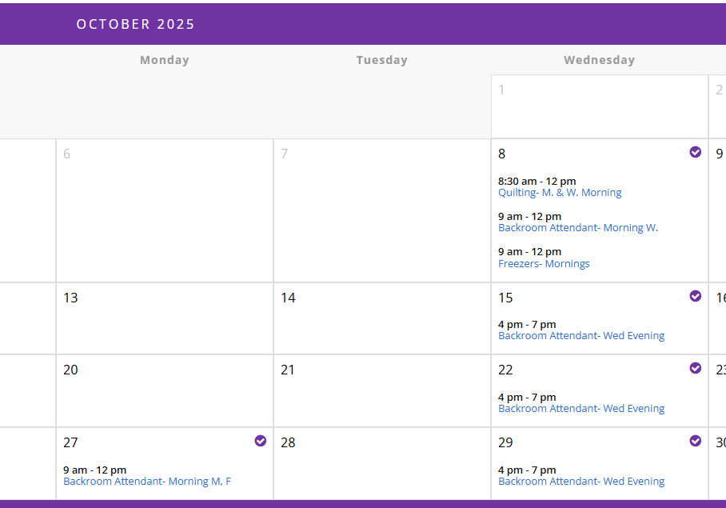
  - To switch to a list view, click the list icon near the top of the calendar.
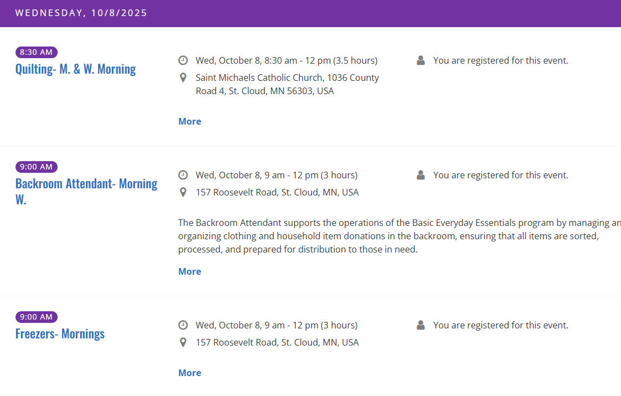

How to Cancel an Event You’re Signed Up For
- Click on "My Schedule" at the top of the page.
- For easier viewing, click the list icon near the top.
- Scroll through your scheduled events and find the one you want to cancel.
- Click the gray "Cancel" button next to that event.
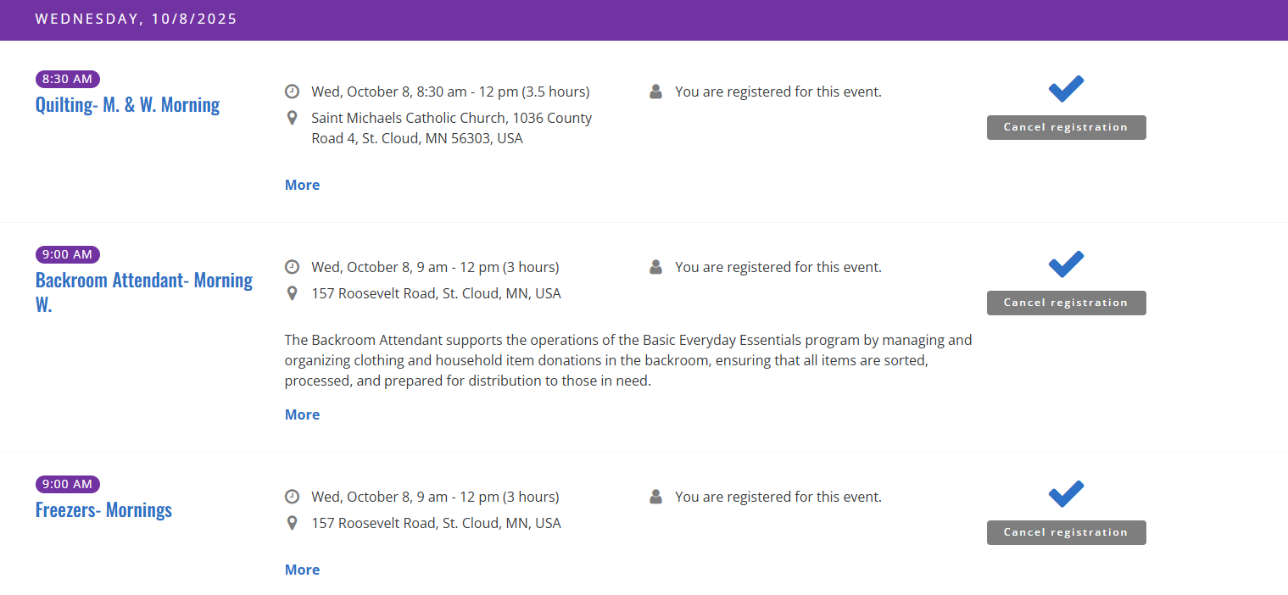
- A confirmation screen will appear — click "Next", then close the page to complete the cancellation.
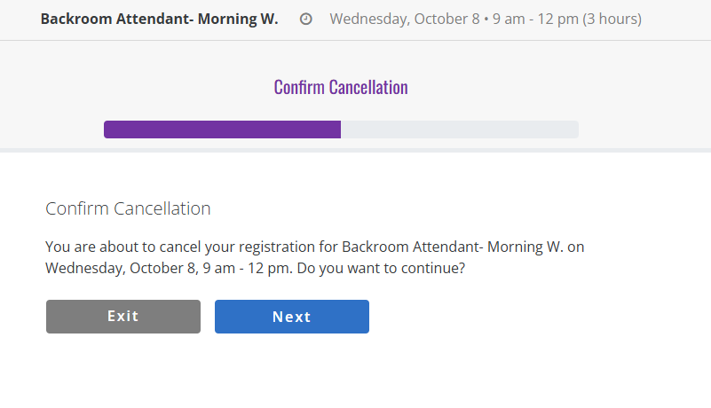
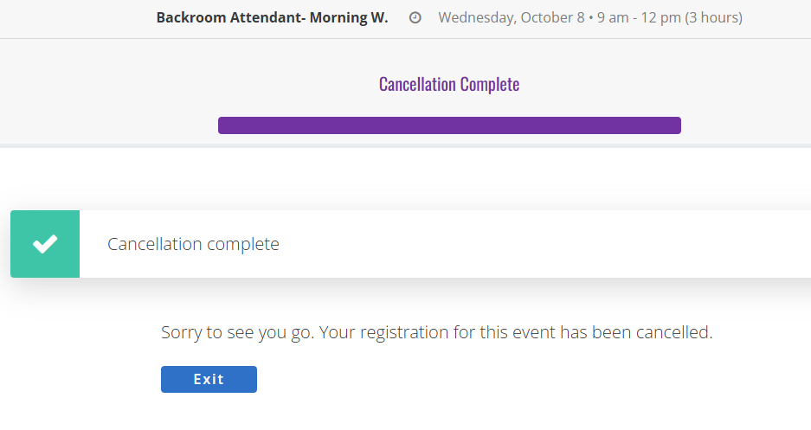

How to Update Your Profile Information
- Click on your name in the top right corner and select "Update Profile."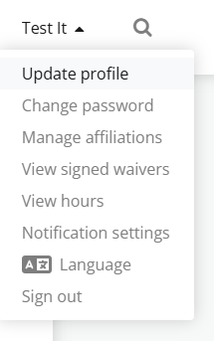
- Make any necessary changes to your information.
- Scroll to the bottom of the page and click "Save" to apply your updates.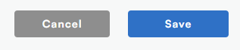

How to Sign Out
- Click on your name in the top right corner and select "Sign out".
