|  |  |  |  |  |  |  |  |
| --- | --- | --- | --- | --- | --- | --- | --- |
| Lot | Ident | Wgt 19/07 | EMA | Rump | Rib | IMF | Scotal |
| 1 | QPD23U418 | 822 | 124 | 12 | 8 | 6.5 | 38 |
| 2 | QPD23U414 | 836 | 125 | 10 | 8 | 6.8 | 39 |
| 3 | QPD23U430 | 848 | 126 | 11 | 8 | 6.6 | 41 |
| 4 | QPD23U484 | 806 | 130 | 11 | 8 | 6.8 | 39 |
| 5 | QPD23U402 | 786 | 127 | 11 | 8 | 7.4 | 40 |
| 6 | QPD23U416 | 878 | 133 | 14 | 12 | 6.7 | 39 |
| 7 | QPD23U67 | 898 | 130 | 16 | 11 | 7.6 | 40 |
| 8 | QPD23U413 | 828 | 126 | 15 | 12 | 7.7 | 39 |
| 9 | QPD23U903 | 832 | 130 | 10 | 8 | 6.4 | 40 |
| 10 | QSN23U902 | 842 | 124 | 11 | 8 | 7.0 | 40 |
| 11 | QPD23U411 | 848 | 123 | 12 | 10 | 7.4 | 39 |
| 12 | QPD23U403 | 848 | 127 | 15 | 10 | 7.8 | 37 |
| 12A | QPD23U404 | 804 | 132 | 11 | 9 | 7.0 | 40 |
| 13 | QPD23U908 | 774 | 126 | 13 | 9 | 6.4 | 39 |
| 14 | QPD23U904 | 794 | 123 | 13 | 10 | 7.3 | 43 |
| 15 | QPD23U406 | 742 | 125 | 10 | 8 | 5.8 | 34 |
| 16 | QPD23U76 | 770 | 128 | 10 | 7 | 7.6 | 35 |
| 17 | QPD23U447 | 768 | 126 | 15 | 11 | 7.3 | 41 |
| 18 | QPD23U488 | 748 | 132 | 8 | 7 | 6.2 | 39 |
| 19 | QPD23U139 | 780 | 114 | 10 | 8 | 7.5 | 40 |
| 20 | QPD23U135 | 768 | 115 | 11 | 8 | 6.7 | 41 |
| 21 | QPD23U443 | 798 | 121 | 15 | 10 | 7.4 | 37 |
| 22 | QPD23U92 | 788 | 116 | 11 | 7 | 6.4 | 42 |
| 23 | QPD23U474 | 780 | 126 | 12 | 9 | 7.8 | 36 |
| 24 | QPD23U442 | 825 | 124 | 10 | 7 | 6.5 | 39 |
| 25 | QPD23U106 | 830 | 118 | 10 | 7 | 6.5 | 41 |
| 26 | QPD23U132 | 800 | 120 | 12 | 8 | 6.6 | 36 |
| 27 | QPD23U112 | 790 | 136 | 13 | 8 | 7.1 | 38 |
| 28 | QPD23U144 | 782 | 128 | 12 | 10 | 8.0 | 37 |
| 29 | QPD23U914 | 774 | 124 | 12 | 8 | 6.8 | 41 |
| 30 | QPD23U140 | 758 | 120 | 10 | 7 | 7.5 | 38 |
| 31 | QPD23U155 | 756 | 126 | 8 | 6 | 6.1 | 40 |
| 32 | QPD23U454 | 762 | 125 | 11 | 8 | 6.4 | 42 |
| 33 | QPD23U153 | 758 | 124 | 13 | 10 | 7.7 | 38 |
| 33A | QPDU490 | 778 | 124 | 12 | 8 | 7.4 | 38 |
| 34 | QPD23U143 | 726 | 130 | 10 | 7 | 7.1 | 34 |
| 35 | QPD23U195 | 800 | 124 | 10 | 6 | 6.2 | 40 |
| 36 | QPD24V1 | 792 | 112 | 10 | 7 | 7.1 | 42 |
| 37 | QPD23U179 | 708 | 116 | 10 | 7 | 7.1 | 36 |
| 38 | QPD23U148 | 790 | 118 | 9 | 8 | 7.5 | 39 |
| 39 | QPD23U158 | 770 | 126 | 11 | 8 | 6.7 | 38 |
| 40 | QPD23U202 | 776 | 116 | 11 | 7 | 6.3 | 40 |
| 41 | QPD23U446 | 726 | 112 | 12 | 8 | 6.7 | 40 |
| 42 | QPD23U424 | 728 | 118 | 11 | 8 | 7.1 | 39 |
| 43 | QPD23U189 |  |  |  |  |  |  |
| 44 | QPD24V21 | 722 | 108 | 8 | 6 | 7.4 | 39 |
| 45 | QPD23U901 | 688 | 107 | 10 | 7 | 6.4 | 39 |
| 46 | QPD23U170 | 680 | 113 | 11 | 7 | 6.8 | 40 |
| 47 | QPD23U302 | 718 | 124 | 12 | 9 | 6.6 | 40 |
| 48 | QPD23U154 | 698 | 118 | 13 | 10 | 6.6 | 38 |
| 49 | QPD23U310 | 740 | 116 | 11 | 8 | 7.4 | 38 |
| 50 | QPD23U312 | 720 | 121 | 9 | 7 | 7.2 | 39 |
| 51 | QPD23U905 | 724 | 131 | 9 | 6 | 6.3 | 35 |
| 52 | QPD23U124 | 718 | 131 | 11 | 8 | 5.7 | 36 |
| 53 | QPD23U491 | 772 | 124 | 13 | 9 | 6.6 | 40 |
| 54 | QPD23U128 | 744 | 116 | 9 | 8 | 5.7 | 36 |
| 55 | QPD23U460 | 722 | 126 | 10 | 8 | 7.6 | 38 |
| 56 | QPD23U471 | 750 | 118 | 9 | 7 | 7.4 | 39 |
| 57 | QPD23U445 | 700 | 123 | 7 | 6 | 5.7 | 36 |
| 58 | QPD23U452 | 730 | 116 | 9 | 7 | 5.6 | 36 |
| 59 | QPD23U171 | 738 | 124 | 10 | 7 | 7.3 | 35 |
| 60 | QPD23U469 | 692 | 114 | 9 | 7 | 7.1 | 40 |
| 61 | QPD23U105 | 680 | 116 | 10 | 7 | 6.7 | 37 |
| 62 | QPD23U425 | 718 | 120 | 9 | 7 | 6.4 | 42 |
| 63 | QPD23U211 | 660 | 111 | 12 | 10 | 6.4 | 38 |
| 64 | QPD23U123 | 714 | 117 | 9 | 6 | 6.4 | 34 |
| 65 | QPD23U192 | 666 | 112 | 10 | 6 | 7.5 | 39 |
| 66 | QPD23U149 | 698 | 118 | 12 | 9 | 5.8 | 37 |
| 67 | QPD23U468 | 654 | 116 | 11 | 7 | 6.6 | 36 |
| 68 | QPD23U110 |  |  |  |  |  |  |
| 69 | QPD23U480 |  |  |  |  |  |  |
| 70 | QPD23U167 |  |  |  |  |  |  |
| 71 | QPD23U109 |  |  |  |  |  |  |
| 72 | QPD23U134 |  |  |  |  |  | 41 |
| 73 | QPD23U483 |  |  |  |  |  | 41 |
| 74 | QPD23U159 |  |  |  |  |  |  |
| 74A | QPD23U911 | 724 | 124 | 9 | 6 | 7.2 | 44 |
| 75 | QPD23U101 |  |  |  |  |  |  |
| 76 | QPD23U161 |  |  |  |  |  | 36 |
| 77 | QPD23U87 |  |  |  |  |  |  |
| 78 | QPD23U90 |  |  |  |  |  | 37 |
| 79 | QPD23U117 |  |  |  |  |  | 39 |
| 80 | QPD23U455 | 670 | 106 | 9 | 7 | 6.8 | 37 |
| 81 | QPD23U461 |  |  |  |  |  |  |
| 82 | QPD23U111 | 688 | 123 | 11 | 7 | 7.2 | 37 |
| 83 | QPD23U146 | 652 | 117 | 10 | 7 | 6.4 | 37 |
| 84 | QPD23U201 | 648 | 123 | 14 | 8 | 7.1 | 35 |
| 85 | QPD23U912 | 667 | 121 | 9 | 7 | 7.5 | 37 |
| 86 | QPD23U475 | 682 | 116 | 7 | 5 | 6.3 | 37 |
| 87 | QPD23U178 | 658 | 118 | 11 | 8 | 6.3 | 39 |
| 88 | QPD24V6 | 668 | 118 | 13 | 9 | 7.2 | 37 |
| 89 | QPD24V5 | 682 | 117 | 11 | 7 | 6.8 | 37 |
| 90 | QPD24V18 | 636 | 117 | 11 | 7 | 7.0 | 39 |
| 91A | QPD24V55 | 716 | 114 | 11 | 8 | 6.6 | 37 |
| 92 | QPD23U472 | 628 | 120 | 12 | 7 | 7.7 | 38 |
| 93 | QPD23U489 | 662 | 116 | 15 | 9 | 7.3 | 36 |
| 94 | QPD23U499 | 666 | 111 | 10 | 8 | 7.4 | 37 |
| 95 | QPD24V29 | 702 | 110 | 10 | 7 | 7.3 | 38 |
| 96 | QPD24V54 | 676 | 115 | 9 | 7 | 6.6 | 37 |
| 97 | QPD24V57 |  |  |  |  |  |  |
| 98 | QPD24V56 | 676 | 116 | 12 | 10 | 5.7 | 39 |
| 99 | QPD24V40 | 642 | 113 | 9 | 7 | 6.8 | 39 |
| 100 | QPD23U194 |  |  |  |  |  |  |
| 101 | QPD23U451 | 588 | 108 | 9 | 6 | 6.2 | 33 |
| 102 | QPD23U487 | 602 | 126 | 10 | 7 | 6.6 | 34 |
| 103 | QPD23U906 | 624 | 97 | 10 | 6 | 6.2 | 37 |
| 104 | QPD23U915 | 590 | 105 | 9 | 7 | 6.4 | 38 |
| 105 | QPD24V24 | 620 | 115 | 12 | 8 | 7.1 | 38 |
| 106 | QPD24V950 | 598 | 118 | 12 | 9 | 7.3 | 37 |
| 107 | QPD24V15 | 584 | 112 | 9 | 6 | 6.3 | 36 |
| 108 | QPD24V7 | 580 | 110 | 11 | 8 | 6.7 | 38 |
| 109 | QPD24V19 | 572 | 111 | 9 | 6 | 5.7 | 35 |
| 110 | QPD24V52 | 546 | 100 | 8 | 7 | 5.5 | 33 |

*note weights taken 19th July 2025*

**Lot 12 a**

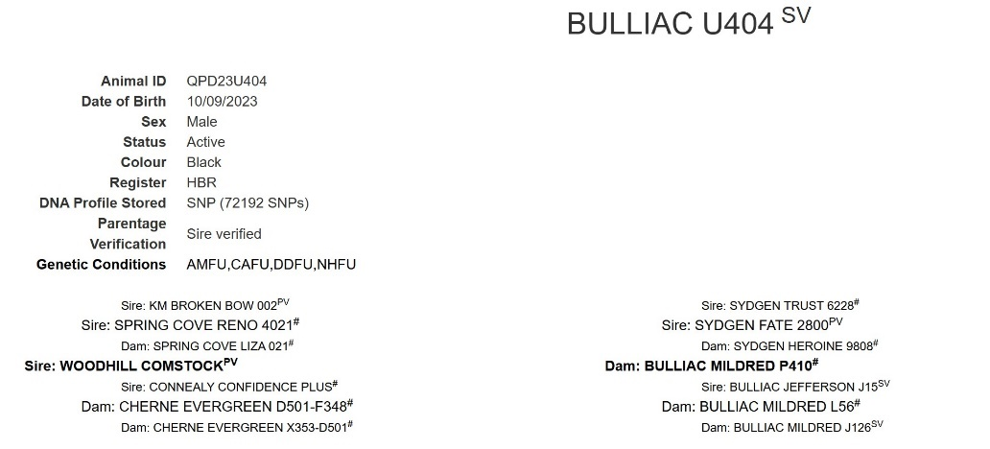



**Lot 33 a**



**Lot 74 a**



**Lot 91 a**

