Dear Councillor

You are summoned to attend the Annual Meeting of the Parish Council which will be held on Tuesday 20 May 2025 at 6.30pm in Whitley Village Hall, Village Lane, Higher Whitley.

The Annual Parish Assembly will commence at 7.30pm.

Please advise me as soon as possible if you are unable to attend.

Signed:

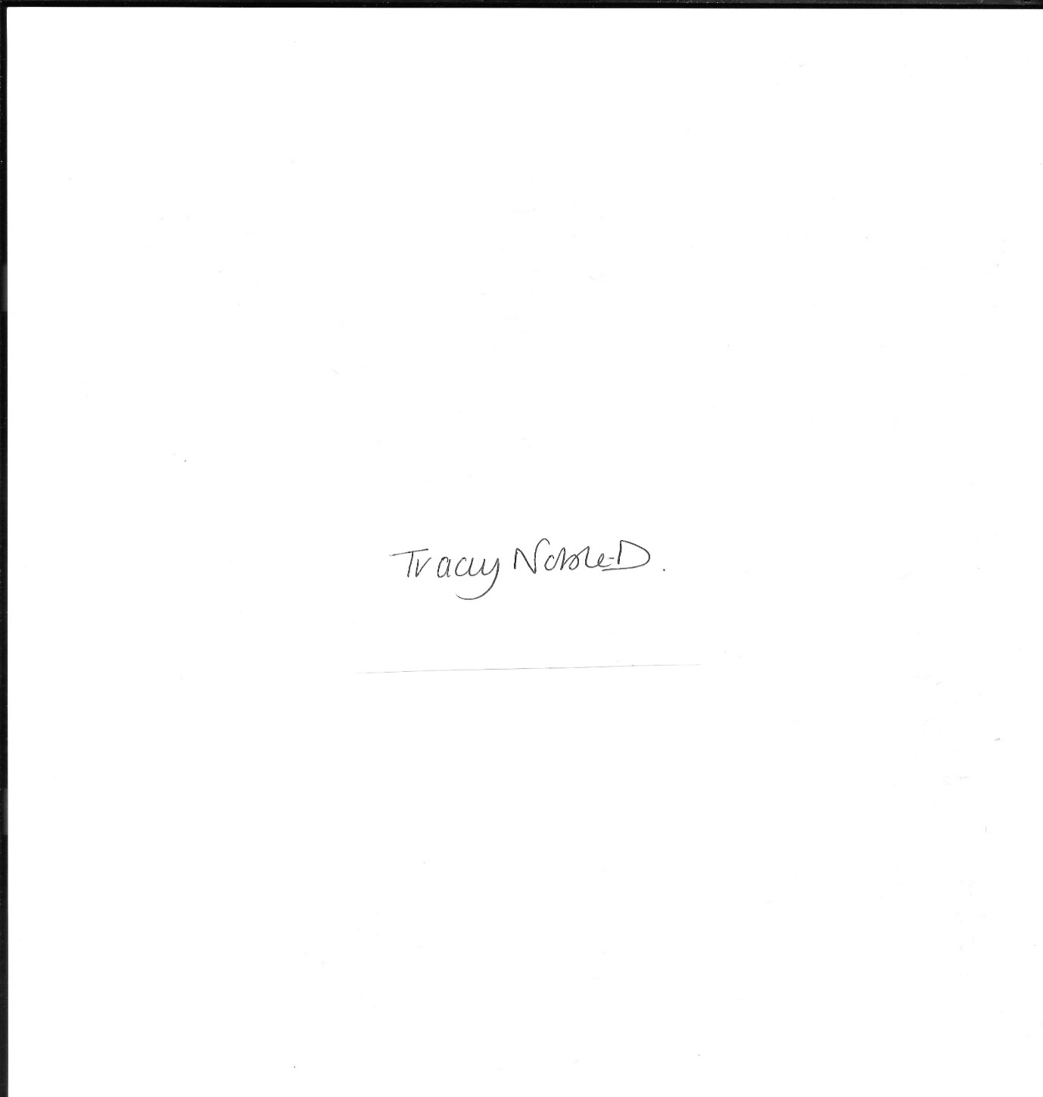

Clerk to the Parish Council

14 May 2025

**Annual Meeting of the Parish Council Agenda 6.30pm**

1. Election and Appointment of Chair
2. Election and Appointment of Vice Chair
3. Chair and Vice Chair Acceptance of Office Signed
4. Election and Appointment of Village Hall Representative
5. Election and Appointment of Burleymen
6. Apologies
7. Declaration of Interest
8. Minutes of the Previous Meeting – 15 April 2025
9. Public Forum - In accordance with the Standing Orders, the meeting shall be adjourned for a maximum of 30 minutes for Public Participation. Speeches will not last for more than 3 minutes.
10. To Consider the Calendar of Meetings for 2025-2026
11. To Receive the Report from Cheshire West and Chester Borough Councillors
12. Planning Applications
13. Finance
14. Standing Orders
15. Whitley Nature Reserve Update
16. Insurance Renewal 01 June 2025
17. Greenhill Lane Update
18. To Agree the Time and Date of Next Meeting

**Annual Parish Assembly 7.30pm**

Meet the Electors, Tea and Coffee Available