Dear Councillor

You are summoned to attend a meeting of the Parish Council which will be held on Tuesday 29 June 2021 at 7.30pm in Whitley Village Hall, Village Lane, Higher Whitley.
Please advise me as soon as possible if you are unable to attend.

Signed:
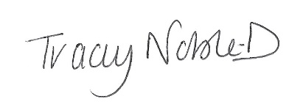
Clerk to the Parish Council
23 June 2021

Agenda
- Apologies
- Declaration of Interest
- Minutes of the Previous Meeting – 18 May 2021
- To Agree Co-option of Councillor – 1 Vacancy
- Public Forum
- To Receive the Report from Cheshire West and Chester Borough Councillors
- Planning
- Finance
- Correspondence
- Whitley Grass Verges
- Whitley Nature Reserve
- To Note Matters Arising
- Time and Date of Next Meeting

