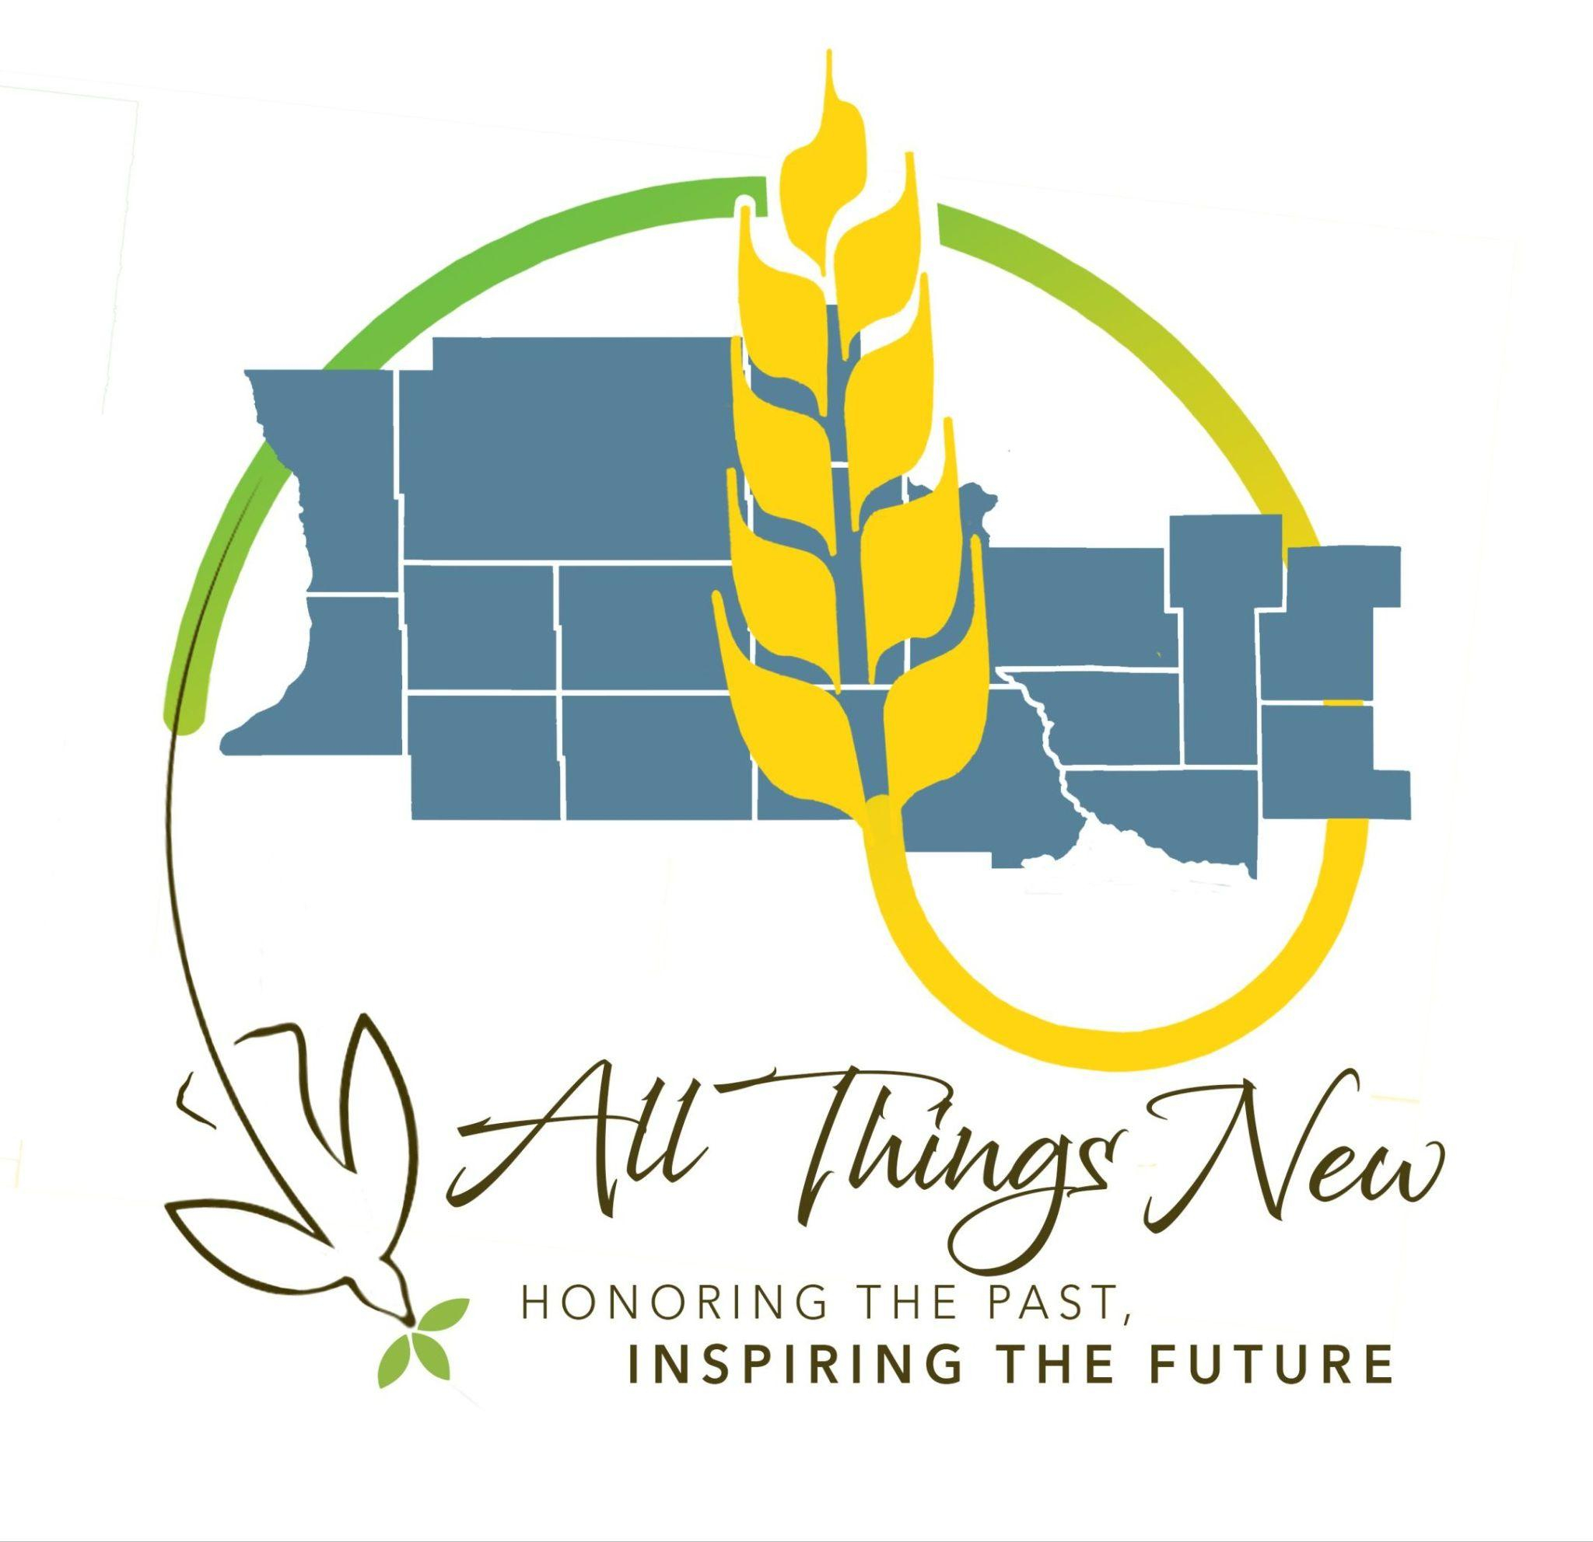
Hello MOTV and St. Marcus fellow worshipers.

We are thrilled that so many of you attended the meetings we offered after masses on December 14. It’s so important that we focus on these changes together as a community. Thank you so much for the letters, emails, and feedback that you were willing to share with the ACC Committee. We shared all of them at our meeting last Thursday and were able to utilize your comments and ideas to look back through our past meetings and discussion notes to make sure that we better align our proposals with the needs of our parishioners. We want you to know that we are listening.

This has been a very challenging six months. Although we had half the amount of time than the other ACC’s to develop our proposals, we feel inspired that we can finish this step of the process with a strategy that will allow us to build relationships in our community rather than tear them down. Your patience, attention and support regarding our future together is greatly appreciated. We share the same pain you are feeling and, at the same time, feel a bit of excitement at the potential for the vibrancy of our communities to continue to grow through the guidance of the Holy Spirit. It really has warmed our hearts to see our churches full every weekend. Please know that we support you and the proposals that we developed are meant to show you our love and connection to you.

The Diocese has developed a process to follow. The parishes within the St. Cloud Diocese utilizes the guidelines and parameters determined to compose a proposal(s) to present to the Diocese CAP committee. This committee will use the parameters to ask a series of questions and request information to assess the best course of action for the parishes presenting. This committee and the Bishop will allow some time for us to discuss and develop answers to their questions. They will, then, decide what is best for the Diocese and our community. Our proposals may not be accepted by the Diocese, but don’t let this bring you to a place of fear. Trust the Holy Spirit and His guidance through the process. God’s path is the right path.

Several questions were asked about the cemeteries. The various cemetery funds are separate from the parish operating funds (perpetual care) and will not be affected by any final decisions from the Diocese.

You will find additional copies of the final proposals the ACC Committee composed in the entrance of each church.

Again, thank you for your continued support. God Bless you and our community. Lastly, have a very Merry Christmas and a Happy New Year!. Thanks be to God!

Sherburne County All Things New Committee

Sherburne County Area Catholic Community
All Things New Proposals

The Sherburne County Area Catholic Community (ACC)—including Mary of the Visitation, St. Marcus, Christ Our Light, and St. Andrew’s Parishes—proposes two phased plans to consolidate worship sites and merge parish corporations for Mary of the Visitation and St. Marcus. This initiative aims to ensure sustainability and improve pastoral care and resource stewardship.

Proposal #1
Becker Becomes the Primary Church for Mary of the Visitation and a phased merger with St Marcus as a partner church

Becker will serve as the main church. St. Marcus will merge with MOTV (Extinctive union) and function as a partner church for the Sherburne County ACC subset ( MOTV and St Marcus), while Christ our Light and St Andrews remain separate corporations. This proposal outlines our plan to meet guidelines, support parish growth, improve collaboration, and create a welcoming environment by aligning resources, schedules, and facilities for long-term sustainability.

Accessibility to Sunday Mass

20 Minute Drive to Mass
● The two corporations include the Mary of the Visitation parish, Becker and Big Lake campus, and St. Marcus parish in Clear Lake. The Becker campus is centrally positioned among the three sites, making it accessible to at least 80% of the parish members. The Becker campus accommodates approximately 450 people, St. Marcus accommodates approximately 300 people.

All Sunday masses are well attended, especially MOTV’s 10:00 a.m. Sunday Mass which gathers around four hundred participants. The large number of participants is credited to the new Faith Formation program, Revive. Youth sessions are held directly after Mass at the Becker campus. St. Marcus averages 230 attendees at 70% capacity. Both Parishes also meet the 25% operating expense limit.

Mass Schedule
● As primary church, Becker, will celebrate two weekend masses with one mass celebrated at the partner church, St. Marcus. Daily mass will be offered at both sites.

Budgeted Ministries

ACC Business Administrator
● The All-Things New binder states that ACCs with over 3,000 households do not need a single business administrator; our ACC has over 3,000 households. Christ our Light and St Andrew both have parish administrators on staff as well as a pastoral associate at each location. Given our situation, for at least the near future, MOTV plans to employ their own as well. As time progresses, the parish will continue to assess and make changes regarding a business administrator.

Faith Formation
● Revive Faith Formation began at MOTV in October 2025 to boost spiritual growth and further the Church's evangelization, discipleship, and community aim. This proposal includes plans to collaborate with St Marcus in the sharing of information and training regarding Revive. St. Marcus will assess the Revive program, then consider options for Faith Formation after the merger. Sharing resources regarding the Faith Formation Ministry will help enhance outreach to our youth as well as hopes in providing valuable sharing and learning opportunities with the parents at MOTV and St. Marcus.
Social Outreach
● Supported ministries at Mary of the Visitation and St. Marcus will continue to be supported, sharing when possible. St. Marcus facilities are also used by members of the community, including the Cub Scouts, Red Cross Blood Drives, and Clear Lake Lions Annual Fish Fry during Lent. After the merger, all social outreach programs will be unified to serve all three communities efficiently. This will strengthen our impact, enhance collaboration, and maintain support for every community.

Pastoral Care
● Mary of the Visitation and St. Marcus has a strong emphasis on Pastoral Care within the Central Minnesota Community at large. The Pastor provides sacramental and spiritual care opening and lovingly, while our area Deacons provide support where the Pastor may need additional help. Our staff and parishioners provide services to local food shelves, prison inmates, homebound, and elderly confined to Nursing Homes. Those services will continue and potentially grow when campuses are consolidated and pastor administrative responsibilities reduced.

Hispanic Ministries
● While the Hispanic communities within Big Lake, Becker, and Clear Lake are not large enough to celebrate a dedicated Mass, there is support set aside for support for local Hispanic families and St. Andrew’s Parish does offer a Mass each weekend in Spanish.

Priests/Pastors

Pastoral Ministry
● Reducing to one corporation will allow the pastor to spend at least 50% of his time on pastoral ministries. Reducing the pastoral burden is central to our plans for the Sherburne County ACC sub-set (Mary of the Visitation and St. Marcus). We propose consolidating, assigning Mass times, and moving to a single corporation by 2027 to ease priests’ workload and ensure he has the necessary support and resources. Though the cities are close, limited time prevents the pastor from greeting parishioners, finishing post-Mass duties, preparing for upcoming service, and traveling between locations. Minnesota’s winter weather and a train crossing on Highway 10 can further delay travel, making timely arrival at Becker uncertain.
● At Mary of the Visitation, Pastoral Council members function as liaisons to committees for consistent communication. They submit monthly reports, keeping the pastor informed without his required attendance at each meeting.
Masses
● We will continue to have three weekend Masses: One mass at St. Marcus, and two Masses at Becker, as established on July 1, 2025 when MOTV began sharing a pastor with St. Marcus.
Desire for the priest to live in a community within the ACC.
● The Becker location includes a rectory within walking distance of the church, providing convenient housing for the pastor. The property is in good condition with a new roof and updated appliances such as a water heater, dishwasher, and washing machine. Keeping the pastor at this address minimizes the need for relocation or increased maintenance.

Buildings

Occupancy
● As of July 1, 2025, when St. Marcus began sharing a Pastor with MOTV, all masses are well attended and exceed the 50% occupancy requirement at a rate of 65-70%. Due to maintaining St. Marcus as a partner church, we anticipate that mass counts will stay relatively the same depending on decisions made by the parishioners to remain at MOTV and St. Marcus after the transition.
Building Accessibility
● St. Marcus and MOTV Becker/Big Lake have no issues regarding building accessibility. Becker, built as a single level church, is fully accessible with a single-level entrance and ADA push-button doors, making it convenient for seniors, families with babies, and people with mobility issues. St. Marcus and MOTV Big Lake have fully functioning elevators to all levels. The dining hall at MOTV Big Lake is located in the basement while the dining hall at St. Marcus is located on the 1st level of the new addition.

Building Use and Repurposing
● Starting July 1, 2026, a Property Evaluation Committee will be established under parish leadership to assess uses for Big Lake properties, explore fundraising for transition costs, and evaluate leasing, repurposing, or selling options per diocesan guidelines with cost analysis for each decision.
● MOTV has two campuses: Big Lake (church, adjoining lots, youth house (formerly the rectory located on a separate property) and Becker (church, youth house, rectory).
Currently, the Becker Church’s seating capacity has been able to accommodate parishioners from MOTV and St. Marcus on the weekends when Mass is celebrated at Becker. With St. Marcus functioning as a partner church, the mass counts are projected to remain relatively stable and most likely will not require the Becker site to immediately consider a building project to add more square footage.
A Property Evaluation Committee will be established by the pastor to determine the best strategy to sell all the Big Lake property, including the church, parking lot, hockey rink, and baseball field currently being leased by the city of Big Lake. After the merge is complete, the merged parish committee will also follow the same procedure to evaluate the selling of the St. Marcus youth house and potential sale or repurposing of the rectory and church.
● The Big Lake youth house (formerly a rectory) is currently used by students in grades 3–12 and adult groups. The Pastoral Council, Finance Council, and Property Evaluation Committee will evaluate its use and consider its sale, estimated at $400,000. The Property Evaluation Committee will work with the other groups to determine if or when this portion of the property will be sold.
● St. Marcus will continue to work on decreasing its already low operating costs by selling the youth house, continue to provide office space for staff at Clear Lake, and work within The Property Evaluation Committee to evaluate the viability of the Rectory to be sold or function as a retreat for men considering a vocation to the priesthood.
● All MOTV staff will move to the Becker campus by July 1, 2026. Becker has enough space for everyone and will save costs by eliminating duplicate equipment and supplies. This move also ensures a regular staff presence at the main church for parishioner support and daily operations.
● Once the Big Lake campus is sold and consistent data is collected on new mass counts and operating costs, the Property Evaluation Committee with other parish groups will evaluate if the Becker church building or Becker Youth House needs expansion to support Sherburne County’s anticipated annual 4% growth.

Finances

● Currently, MOTV and St. Marcus parishes meet the 25% operating expense limit. However, this plan will serve to improve the operating budget by eliminating some portions of the properties that contribute to the overall operating cost at St. Marcus and MOTV Big Lake.

Timeline
July 1, 2026
● Becker will become the primary Church location for MOTV.

● There will be two Masses offered at Becker and one Mass at St. Marcus.
● A Property Evaluation Committee will be established to determine which pieces of property will be sold at Big as well as the sale of the youth house at St. Marcus and/or repurposed to accommodate these proposed changes.
● The Property Evaluation Committee will work with other committees in the parish to review the proper use of the Youth House in Big Lake. These committees will decide on plans to either continue as a youth and adult ministry facility or to be sold.
● The Revive curriculum will be shared and training offered to St Marcus Faith Formation as a means of sharing resources.
● All staff members from MOTV will relocate to the Becker campus.

July 1, 2027
● St Marcus Parish and Mary of the Visitation Parish will merge (extinctive union) and will maintain mass schedules, integrate staff, prepare canonical decrees, transfer assets and liabilities, and align parish registers.
● After the merger is completed, St. Marcus will become a partner church with MOTV Becker functioning as the primary church. One mass will continue to be offered at St. Marcus and Becker will offer two masses each weekend.
● St. Marcus church staff may maintain current offices, but will be offered office space at MOTV, Becker. Bulletins, websites, and all parish communications will be centralized to encourage collaboration, better communication, and a unified mission.

After the merger, the unified parish will serve as one of three pillars in our Sherburne County ACC. The timeline allows for organized planning and smooth integration of finances, records, ministries, and parish identities.
Proposal #2
Big Lake Becomes the Primary Church for Mary of the Visitation, Becker serves as a site for Youth Ministry, and a phased merger with St Marcus as a partner church

Big Lake will serve as the main church with the Becker site repurposed as a Youth Ministry campus housing Faith Formation, Retreats, and support for the youth of MOTV. St. Marcus will merge with MOTV (extinctive union) and function as a partner church for the Sherburne County ACC subset ( MOTV and St Marcus), while Christ our Light and St Andrews remain separate corporations. This proposal outlines our plan to meet guidelines, support parish growth, improve collaboration, and create a welcoming environment by aligning resources, schedules, and facilities for long-term sustainability.

Accessibility to Sunday Mass

20 Minute Drive to Mass
● The two corporations include the Mary of the Visitation parish, Becker and Big Lake campus, and St. Marcus parish in Clear Lake. The Big Lake site is located in the most densely populated area within the Clear Lake, Becker, and Big Lake area. Although Clear Lake and Big Lake are located furthest apart, 80% of the Clear Lake and Big Lake residents can reach each town within the 20 minute drive time parameter set by the Diocese. Becker residents can reach either church site within the 20 minute drive time.

Mass Schedule
● The primary church, Big Lake, will celebrate two weekend masses with one mass celebrated at the partner church, St. Marcus. Daily mass will be offered at both sites. Although the Becker site will host all Youth Ministries including, and not limited to, the Revive Faith Formation Program.

Budgeted Ministries

ACC Business Administrator
● The All-Things New binder states that ACCs with over 3,000 households do not need a single business administrator; our ACC has over 3,000 households. Christ our Light and St Andrew both have parish administrators on staff as well as a pastoral associate at each location. Given our situation, for at least the near future, MOTV plans to employ their own as well. As time progresses, the parish will continue to assess and make changes regarding a business administrator.

Faith Formation
● The Becker site will host Faith Formation for all three sites increasing a sense of community and building a solid foundation of unity among parishioners as merger and site changes occur. The Revive Faith Formation curriculum which began at MOTV in October 2025 will be assessed for its viability to continue to be used once the merger is complete. This proposal emphasizes the need for ministries that encourage and support the youth and future growth in the community. The Becker site will be dedicated to supporting and nurturing youth, with the goal of encouraging more young people to maintain their practice of the Catholic Faith as they become young independent adults. Dedicating resources to our young Catholics may also help create an environment conducive to fostering and encouraging more young men to consider a vocation to the priesthood.
Social Outreach
● Supported ministries at Mary of the Visitation and St. Marcus will continue to be supported, sharing when possible. St. Marcus facilities are also used by members of the community, including the Cub Scouts, Red Cross Blood Drives, and Clear Lake Lions Annual Fish Fry during Lent. After the merger, all social outreach programs will be unified to serve all three communities efficiently. This will strengthen our impact, enhance collaboration, and maintain support for every community.
Pastoral Care
● Mary of the Visitation and St. Marcus has a strong emphasis on Pastoral Care within the Central Minnesota Community at large. The Pastor provides sacramental and spiritual care opening and lovingly, while our area Deacons provide support where the Pastor may need additional help. Our staff and parishioners provide services to local food shelves, prison inmates, homebound, and elderly confined to Nursing Homes. Those services will continue and potentially grow when campuses are consolidated and pastor administrative responsibilities reduced.
Hispanic Ministries
● While the Hispanic communities within Big Lake, Becker, and Clear Lake are not large enough to celebrate a dedicated Mass, there is support set aside for support for local Hispanic families and St. Andrew’s Parish does offer a Mass each weekend in Spanish.

Priests/Pastors

Pastoral Ministry
● Reducing to one corporation will allow the pastor to spend at least 50% of his time on pastoral ministries. Reducing the pastoral burden is central to our plans for the Sherburne County ACC sub-set (Mary of the Visitation and St. Marcus). We propose consolidating, assigning Mass times, and moving to a single corporation by 2027 to ease the pastor’s workload and ensure he has the necessary support and resources.
● Currently, at Mary of the Visitation, Pastoral Council members function as liaisons to various committees for consistent communication. They submit monthly reports, keeping the pastor informed without his required attendance at each meeting.
Masses
● Beginning July 2026 we will continue to have three weekend Masses: One mass at St. Marcus, and two Masses at Big Lake, as established on July 1, 2025 when MOTV began sharing a pastor with St. Marcus. This change reduces travel stress between sites with limited time between services.

Desire for the priest to live in a community within the ACC.
● The Becker location includes a rectory within walking distance of the church, providing convenient housing for the pastor. The property is in good condition with a new roof and updated appliances such as a water heater, dishwasher, and washing machine. Keeping the rectory at this address minimizes the need for relocation or increased maintenance.

Buildings

Occupancy
● As of July 1, 2025, when St. Marcus began sharing a Pastor with MOTV, all masses are well attended and exceed the 50% occupancy requirement at a rate of 65-70%. Due to maintaining St. Marcus as a partner church, we anticipate that mass counts will stay relatively the same depending on decisions made by the parishioners to remain at MOTV and St. Marcus after the transition.
Building Accessibility
● St. Marcus and MOTV Becker/Big Lake have no issues regarding building accessibility. Becker is built as a single level church and St. Marcus and MOTV Big Lake have fully functioning elevators.
Building Use and Repurposing
● Starting July 1, 2026, a Property Evaluation Committee will be established under parish leadership to assess buildings to improve operation costs, explore fundraising for transition costs, and evaluate leasing, repurposing, or selling options per diocesan guidelines with cost analysis for each decision.
● MOTV has two campuses: Big Lake (church, adjoining lots, youth house (formerly the rectory located on a separate property) and Becker (church, youth house, rectory).
Currently, the Big Lake Church’s seating capacity has been able to accommodate parishioners from MOTV and St. Marcus on the weekends when Mass is celebrated at Big Lake, with exception of the Fall Festival, which can be relocated to the Becker site. With St. Marcus functioning as a partner church, the mass counts are projected to remain relatively stable and most likely will not require Big Lake to immediately consider a building project to add more square footage. A Property Evaluation Committee will be established to determine how the Big Lake Church will be updated to bring operating costs down as well as the repurposing and/or selling of the other portions of the campus. The Big Lake Youth House (formerly a rectory) may be converted or sold (estimated to sell for around $400,000) to fund a new building to house office staff. Further consideration needs to be dedicated to the hockey rink and baseball field space. It may be sold as a whole or split - a portion sold and a portion kept to accommodate a building to include office spaces for staff.
● St. Marcus will sell its youth house, reducing its already low operating cost further and contributing funds to help repurpose Becker as a youth ministry site or completing Big Lake updates. St. Marcus staff will continue to staff out of Clear Lake, with a possible exception of a Faith Formation Coordinator who will office in Becker at the Youth Ministry site. The Property Evaluation Committee to be established will work to evaluate the viability of the Rectory to be sold or function as a retreat for men considering a vocation to the priesthood.
● All Youth Ministry staff (MOTV and St. Marcus) will be housed at the current Youth House in Becker. It is already set up with a main area, kitchenette, and separate rooms that can be used for offices and/or conference rooms. The sanctuary can become the Revive Vision for Youth Worship. The kitchen hall for meals and snacks and small meeting space. The classrooms will continue to be used for Faith Formation with available overflow space in the youth house. This site may also be used to host adult worship and bible study. The size of the space will also be conducive to hosting events for the entire Sherburne County ACC. The Property Evaluation Committee will also determine how the sanctuary can be updated for this purpose and which spaces will be able to be rented or used for secular purposes.
● Once the Big Lake and Becker campuses are updated and consistent data is collected on new mass counts and operating costs, the Property Evaluation Committee with other parish groups will evaluate if the Big Lake church building or Becker Youth site needs expansion to support Sherburne County’s anticipated annual 4% growth.

Finances

● Currently, MOTV and St. Marcus parishes meet the 25% operating expense limit. However, this plan will serve to improve the operating budget by eliminating some portions of the properties that contribute to the overall operating cost at St. Marcus and MOTV Big Lake as well as diverting funds to address any issues at the Big Lake site such as heating expenses which may require updating to improve operating costs.

Timeline
July 1, 2026
● Big Lake will become the primary Church location for MOTV.

● There will be two Masses offered at Big Lake and one Mass at St. Marcus.
● A Property Evaluation Committee will be established to determine which pieces of property will be sold and/or repurposed to accommodate these proposed changes.
● The Revive curriculum will be merged and function at the Becker campus to include members from St. Marcus and Mary of the Visitation.

July 1, 2027
● St Marcus Parish and Mary of the Visitation Parish will merge (extinctive union) and will maintain mass schedules, integrate staff, prepare canonical decrees, transfer assets and liabilities, and align parish registers.
● After the merger is completed, St. Marcus will become a partner church with MOTV Big Lake functioning as the primary church. One mass will continue to be offered at St. Marcus and Big Lake will offer two masses each weekend.
● Primary church staff will complete the move to Big Lake, Youth Ministry staff will complete the move to the offices in Becker, and St. Marcus staff may maintain current offices. Bulletins, websites, and all parish communications will be centralized to encourage collaboration, better communication, and a unified mission.

After the merger, the unified parish will serve as one of three pillars in our Sherburne County ACC. The timeline allows for organized planning and smooth integration of finances, records, ministries, and parish identities.

