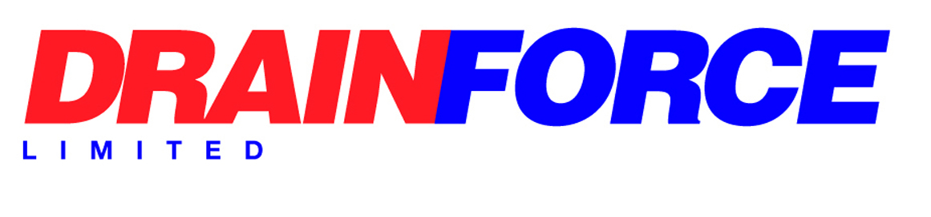

Whistleblowing
Introduction
Drainforce is committed to conducting its business with honesty and integrity. All employees are expected to maintain high standards. Any suspected wrongdoing should be reported as soon as possible. This policy covers all employees, officers, consultants, contractors, casual workers, and agency workers. This policy does not form part of any employee's contract of employment, and we may amend it at any time.
2 What is whistleblowing?
Whistleblowing is the reporting of suspected wrongdoing or dangers in relation to our activities. This includes bribery, facilitation of tax evasion, fraud or other criminal activity, miscarriages of justice, health and safety risks, damage to the environment and any breach of legal or professional obligations. It also includes the following matters specific to this workplace.
3 How to raise a concern.
We hope that in many cases you will be able to raise any concerns with your manager. However, where you prefer not to raise it with your manager for any reason, you should contact the Managing Director, who additionally undertakes the role of Whistleblowing Officer.
The company will arrange a meeting with you as soon as possible to discuss your concern. You may bring a colleague or union representative to any meetings under this policy. Your companion must respect the confidentiality of your disclosure and any subsequent investigation.
4 Confidentiality
The company hope that employees will feel able to voice whistleblowing concerns openly under this policy. Completely anonymous disclosures can be difficult to investigate. If you want to raise your concern confidentially, the company will make every effort to keep your identity confidential and only reveal it where necessary to those involved in investigating your concern.
5 External disclosures
The aim of this policy is to provide an internal mechanism for reporting, investigating, and remedying any wrongdoing in the workplace. In most cases you should not find it necessary to alert anyone externally.
The law recognises that in some circumstances it may be appropriate for you to report your concerns to an external body such as a regulator. We strongly encourage you to seek advice before reporting a concern to anyone external. Protect operates a confidential helpline. Their contact details are at the end of this policy.
6 Protection and support for whistle-blowers
The company aim to encourage openness and will support whistle-blowers who raise genuine concerns under this policy, even if they turn out to be mistaken. Whistle-blowers must not suffer any detrimental treatment because of raising a genuine concern. If you believe that you have suffered any such treatment, you should inform the Whistleblowing Officer immediately. If the matter is not remedied, you should raise it formally using our Grievance Procedure.
Employees must not threaten or retaliate against whistle-blowers in any way. If you are involved in such conduct, you may be subject to disciplinary action. In some cases, the whistle-blower could have a right to sue you personally for compensation in an employment tribunal. However, if the company concludes that a whistle-blower has made false allegations maliciously, the whistle-blower may be subject to disciplinary action.
This Policy is reviewed at least annually in order to ensure its continuing suitability.
Signed: Date:

