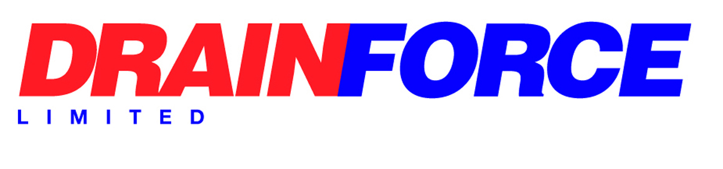

Modern Slavery Act 2015 Policy

Modern slavery is a crime and a violation of fundamental human rights. It takes various forms, such as slavery, servitude, forced and compulsory labour and human trafficking, all of which have in common the deprivation of a person's liberty by another in order to exploit them for personal or commercial gain.
We are committed to improving our practices to combat slavery and human trafficking.
This statement is made pursuant to section 54(1) of the Modern Slavery Act 2015 and constitutes Drainforce Group’s slavery and human trafficking statement.
We are a provider of specialist drainage services. Our supply chains include equipment and service providers.
We are committed to ensuring that there is no modern slavery or human trafficking in our supply chains or in any part of our business.
In the light of the obligation to report on measures to ensure that all parts of our business and supply chain are slavery free we have put in place a designated Modern Slavery and Human Trafficking Policy.
Our workplace policies and procedures demonstrate our commitment to acting ethically and with integrity in all our business relationships and to implementing and enforcing effective systems and controls to ensure slavery and human trafficking is not taking place anywhere in our supply chains.
We have in place systems to:
- Identify and assess potential risk areas in our supply chains.
- Mitigate the risk of slavery and human trafficking occurring in our supply chains.
- Monitor potential risk areas in our supply chains.
- Protect whistle blowers.
We have zero tolerance to slavery and human trafficking. To ensure all those in our supply chain and contractors comply with our values we will hold our own suppliers to the same high standards.

This policy will be reviewed annually.

Signed: 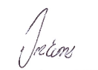

Director/Senior Management

Dated: 25/08/25

