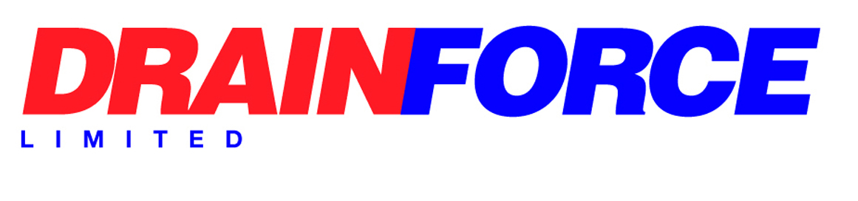

Quality Policy Statement

The Quality Management System defined in this document has been established to control the organisational and business operational functions of the Company in line with ISO 9001. The general principle of the management system is to provide a framework to enable the business objectives and agreed customer requirements to be achieved.

The operational structure of the company is dependent upon a complex arrangement of individual processes to achieve operational targets. In order to manage and control these processes from a business efficiency perspective, and in order to comply with the requirements contained within the approval standard, the following operational principles have been put into place in the organisation:
- Identify Processes: Each of the processes that are employed within the organisation to enable the product and service requirements to be met have been identified and documented. The evidence of these defined processes may be in the form of written procedures, process flowcharts or simple activity lists or check lists.
- Process Effectiveness: In order to determine the effectiveness of the operation and the control of all the processes employed, suitable and sufficient inspection, monitoring and auditing activities are used at various stages of relevant processes together with adequate supervision to verify that the process outputs meet the requirements. Appropriate criteria to measure effectiveness will be selected as well as the methods employed.
- Resources: The provision of resources to meet the demands of the business operation is the responsibility of Management. Recruitment of personnel will be dictated by the needs of the business to give adequate provision. Sufficient financial, equipment and infrastructure resources will be provided to balance requirements or, following evaluation as part of quality planning, suitable resources will be provided when justification exists.
- Competence: The Company is committed to providing adequate and sufficient information, instruction and training to ensure employees are knowledgeable, skilled and competent to carry out their tasks so as not to compromise the high standard of service expected by our customers. Training will be provided where needed and records maintained.
- Improvement: Within all monitoring and review activities is the setting of quality objectives for improvement in the organisation’s processes.
This policy will be reviewed at least annually at SMT meetings.

Signed: 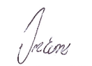

Director

Date: 25.08.2025

