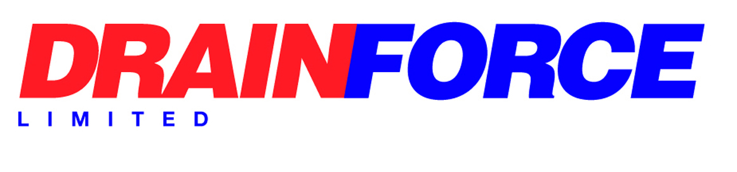

Alcohol and Drugs Policy

Drainforce has adopted the principles of the Network Rail Alcohol and Drugs Policy as follows: -

All employees should be aware that while working on or for Managed Infrastructure, additional legislation is applicable to them and their work. In particular the Transport and Works Act 1992 Part 2 Section 27 specifically notes the need for employees to be free from the effects of Alcohol and Drugs. The requirements of Network Rail Company Standards NR/L2/OHS/00120 Drugs and Alcohol and Substance. Misuse in the workplace and TfL Standards S1257 & S1251 all apply. Results of D&A testing in accordance with RIS-8070-TOM shall be recorded on the Sentinel database.

Employees should therefore:
- Not present themselves for work if they are unfit, due to alcohol or drugs.
- Not present themselves for work if they have just consumed or taken drink or drugs.
- Not be in possession of drink or drugs in the workplace (including the van).
- Not consume or take drink or drugs whilst at work

If employees are on prescribed medication or are taking medicines that may make them drowsy, e.g. cold cures, Solpadine, they should advise their doctor and seek alternatives AND report the fact to the Director.

If employees are considered unfit for work, then we, with Network Rail have a legal duty to test their blood, urine or breath for drink or drugs. For the purpose of this policy an unfit state through consumption of alcohol is defined as detection by testing of:

- More than 29 milligrams per 100ml of blood.
- More than 13 micrograms of alcohol in 100ml of breath; or
- More than 39 milligrams of alcohol in 100ml of urine.

This is known as a ‘positive result’ of an alcohol test. Any traces of Ketamine, Tramadol or illegal drugs, such as Cannabis, Cocaine, Amphetamines, Barbiturates, Methadone etc. found will be deemed a positive test result. Employees must be aware that LU adopts a zero tolerance for drugs and alcohol.

If proved positive the individual’s Sentinel card will be removed or cancelled and they will be immediately suspended, removed from the Railway Infrastructure and possibly the Company and reported to Sentinel & Network Rail. Testing will be carried out by RISQS approved medical providers.

Drainforce is not looking to victimise employees who admit to having a drink or drug related problem, and who approach the Company for help and are prepared to undergo an agreed form of treatment. We offer to assist any employee who voluntarily declares an alcohol or drug related problem. This will provide both confidential support and guidance to employees and their families. If you have or think that you may be developing an alcohol or drug related problem, then you must advise the Director immediately so that the help procedures can be applied. Disclosure or discovery of a problem prompted by a positive test result, or an impending test is not acceptable.

All employees are strongly advised to drink in moderation during the week and preferably leave 24 hours before commencing a shift. Don’t forget to take into account any on-call, weekend or night shift work.

Sporadic unannounced drug & alcohol testing will be carried out annually on a 20% random selection Sentinel Card holders and safety critical staff on a no-notice basis. Testing will be carried out anytime following the RISQS audit and at least one month before the next again RISQS audit provided the period does not exceed 12 months.

All new employees and those existing employees who wish to start work on Managed Infrastructure will be required to undertake full screening for drugs and alcohol before employment unless there is record of one having been done within the last 3 months. Drainforce will not knowingly employ people who are recreational or habitual users of drugs.

For-cause screening will be carried out with no notice if there are reasonable grounds for someone to be suspected of being under the influence of alcohol or drugs or if their behaviour prompts it or if there has been an incident or accident in the work area. If laboratory analysis reveals the presence of prohibited substances consistant with a therapeutic dosage of undeclared medication the donor will be interviewed to establish the reason for non-declaration. If the Medical Officer is satisfied a ‘negative’ result may be given. If not satisfied this will recorded as a No Result and the donor must be re-tested immediately and will not be allowed to work on MI until a negative (pass) result is achieved. Network Rail also has a policy of unannounced screening for which no notice will be given.

A refusal to undertake any of the above tests would be deemed to be a positive result resulting in the same disciplinary action as if tested positive. If you fail to turn up for an arranged test without good reason accepted by the Director, you will be considered as having refused the test.

This policy will be reviewed at least annually.

Signed: 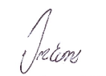
Date: 25/08/2025
Managing Director

