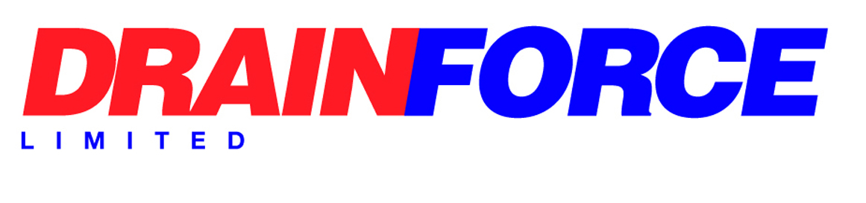

Environmental Policy

In implementing the company’s Environmental Management Policy, it is the intent of management to ensure that:
- All employees are informed, instructed and, where necessary, trained as to their responsibilities in adhering to the principles of this Environmental Policy and all matters detailed in the Environmental Procedures.
- Measures are taken to control processes and activities that directly and indirectly affect the environment.
- Work undertaken by the company is reviewed at survey, planning and execution stages to determine if there are any environmental issues which require to be addressed.
- All reasonable steps will be taken to control all activities, processes and usage of materials to minimise and control waste through re-cycling and to conserve materials, energy and natural resources.
- All existing regulatory legislation, consents, codes and customers’ specific requirements are complied with in carrying out the protection of the environment.
- A commitment is made by all employees for continual improvement, the prevention of pollution and compliance with ISO14001.
- We will minimise the environmental impact for the life cycle (including disposal) of plant, equipment and other assets.
This policy will be reviewed at least annually at senior management meetings.

Signed: 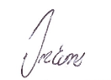

Director
Date: 25/08/2025

