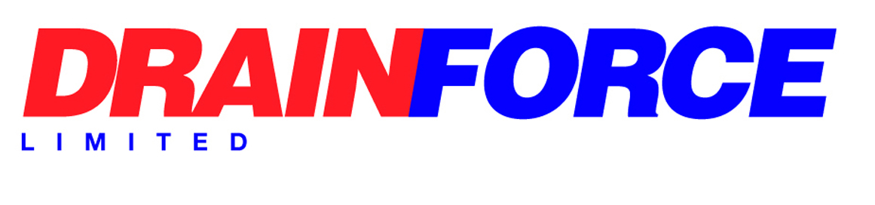

Health & Safety Policy Statement

Statement of Intent

Drainforce Ltd undertakes CCTV surveys of drainage systems, high pressure water jetting and pipe rehabilitation using trenchless technology.
Our aim is to provide a safe working environment for our employees and others who may be affected by our activities. Compliance with legislation is the minimum acceptable standard and we are committed to achieving the highest levels of health and safety performance through continual, cost effective improvement and by seeking out & re-educating un-safe behaviours.
Health and safety is an integral part of our business and has equal status to other aspects of business performance. Appropriate financial and physical resources will therefore be provided to implement this policy.
We recognise that successful health and safety management can only be achieved with the support and commitment of our employees. All employees will be actively encouraged to take ownership of health and safety and empowered to assist in decision making.
We will ensure that this policy is implemented and maintained across all levels in the organisation.
Responsibilities for health and safety are defined in our Health and Safety Management System. The day to day management of health and safety is a responsibility of managers at all levels but overall responsibility rests with the Director.
To assist with the implementation of our health and safety management system we have appointed a Health and Safety Co-ordinator. External advice will also be obtained where necessary.
To facilitate continuous improvements in health and safety standards we will identify specific health and safety objectives. Progress towards the objectives will be closely monitored.
Periodic auditing of our Health and Safety Management System will be undertaken to ensure its continued adequacy and effectiveness.
The company will review this policy at least annually and revise it as often as is appropriate.

Signed: 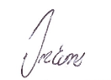

Position: Director

Date: 25/08/2025

