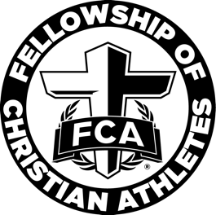

Douglas County FCA Elementary
Student Leadership Information

Congratulations! Your child has been selected to be a student leader for our FCA huddle at (name of school) Elementary School! We ask you to prayerfully consider allowing your child to serve on our FCA student leadership team.

FCA Elementary will be active on our campus beginning in (month). FCA leaders will meet several times a month to do Bible studies, develop leadership skills, and participate in mission projects. Our FCA student leaders will also plan and lead during our monthly FCA huddles. (Teacher name) will serve as the FCA sponsor.

Our FCA student leadership team will meet on (day of week and time). Our monthly FCA huddle will meet on (date and time).

If you would like for your child to be an FCA student leader, please complete and return the Student Leadership Commitment (attached to this permission slip), and complete and return this permission slip by (date to be returned). The Student Leadership Commitment gives information on FCA’s vision, mission and values, and states the expectations of student leaders.

Please also register your child to participate in FCA. This registration link can be found at https://www.douglascountyfca.org/registration . Please select (name of school) Elementary School as the school name.

Our first FCA student leadership meeting will be on (date and time). A snack (will or will not) be provided. (If not provided, you may want to ask parents to send one.) Our Remind 101 code is (code). Please sign up for reminders and FCA leadership information.

Child’s Name: __________________________________________________________________

Child’s Teacher: ________________________________________________________________

I give my child permission to participate as an FCA student leader.

Parent’s Name: _________________________________________________________________

Parent’s Signature: ______________________________________________________________

Parent’s Phone Number: _________________________________________________________

Parent’s Email Address: __________________________________________________________

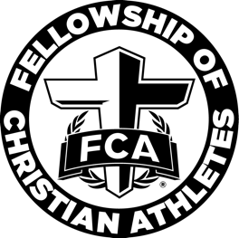

Douglas County FCA Elementary
Student Leader Commitment

I understand as a student leader I am an example among my peers of how to lead a Christian life. I promise to uphold the mission, vision and values of FCA to the best of my ability. I commit to spend time with God daily both in prayer and reading His Word. I understand as a student leader I am held to a higher standard than those whom are not student leaders and I am the face of FCA at my school. I and my parents understand that by serving on the FCA student leadership team, I will need to attend the weekly FCA student leadership meetings to prepare for the monthly all-campus FCA huddle and will make attending all meetings a priority. I understand there will be monthly pre-planning meetings over the summer and will do my best to attend.

FCA Vision:
To see the world transformed by Jesus Christ through the influence of coaches and athletes.

FCA Mission:
To lead every coach and athlete into a growing relationship with Jesus Christ and His church.

FCA Values:
Our relationships will demonstrate steadfast commitment to Jesus Christ and His Word through Integrity, Serving, Teamwork and Excellence.

Integrity: We will demonstrate Christ-like wholeness, privately, and publicly. (Proverbs 11:3)
Serving: We will model Jesus’ example of serving. (John 13:1-17)
Teamwork: We will express our unity in Christ in all our relationships. (Philippians 2:1-4)
Excellence: We will honor and glorify God in all we do. (Colossians 3:23-24)

Student Leader’s Name: ____________________________________________________________

Student Leader’s Signature: _________________________________________________________

Parent’s Name: ___________________________________________________________________

Parent’s Signature: ________________________________________________________________

