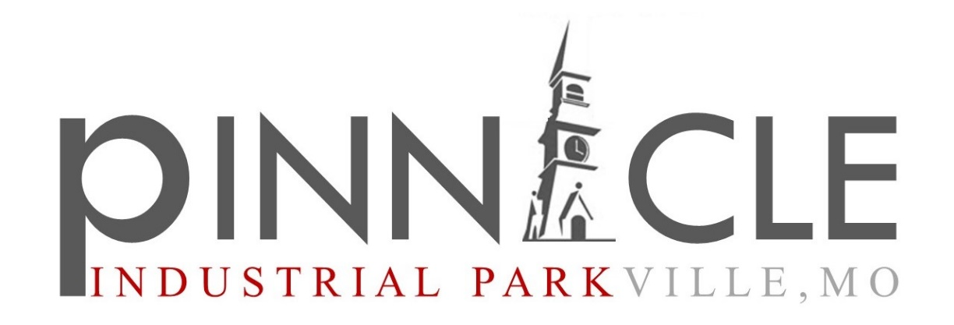

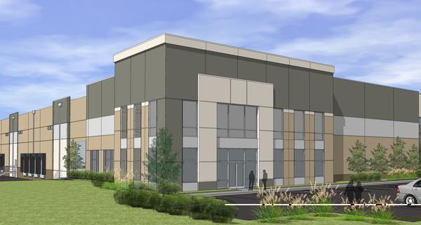

pinnacle INdustrial development Overview
Incentives, Tax Rates, Competitive Landscape, and Market Research Development Site: Parkville, MO.

AREA Real Estate Advisors

Contents
Thesis for Pinnacle Development 2
Pinnacle Industrial Park Overview 4
Competitive Market Overview 6
Incentives Overview 13
Municipal Tax Information 21
AREA Industrial Team 25
Appendix 26

Thesis for Pinnacle Development

Competetive LandScape
Across the Kansas City region, we are seeing an increase in new “Big Box” Industrial development within both new and existing industrial zones and parks. Considered #2 in rail and #3 in trucking nationally, Kansas City is an important transportation port for North America. At the geographic center of the country, it provides single-day truck access to nearly every major Midwestern market. Kansas City also boasts more freeway-lane miles per capita than any other U.S. city, with four intersecting interstates (I-29, I-35, I-70 and I-49).
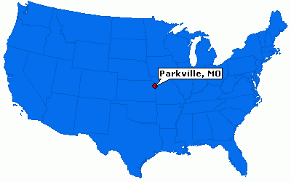
The majority of existing industrial space exists within a 15-mile radius of the Kansas City Central Business District. The newest and largest Industrial Development sites are being built outside of this circle. As you will see on the map located in the appendix, the strategic location of each park is dictated by its geographical position to Kansas City and to the interstate corridor, which establishes a specific need for each site.

Economic Incentives
With the current industrial market experiencing low-vacancy rates it has created an opportunity and need for new larger and more efficient manufacturing, distribution and warehouse centers. Incentives at the state and local level have helped to drive this market shift. The current the low vacancy rates along with the 4,000,000+ square feet of new industrial development over the previous 24 months indicates the trend for growth in this area.

Based on the need for new construction in the Industrial market, Parkville has an opportunity to capitalize on its strategic geographical and economic position. Being one of the premier suburban towns to Kansas City it captures residences with a higher net worth than other surrounding municipalities. As a result, preserving the Historical and cultural feel of the town will be important. The location of the proposed site allows for economic growth within city limits while not encroaching upon historical and residential areas.

Thesis for Pinnacle
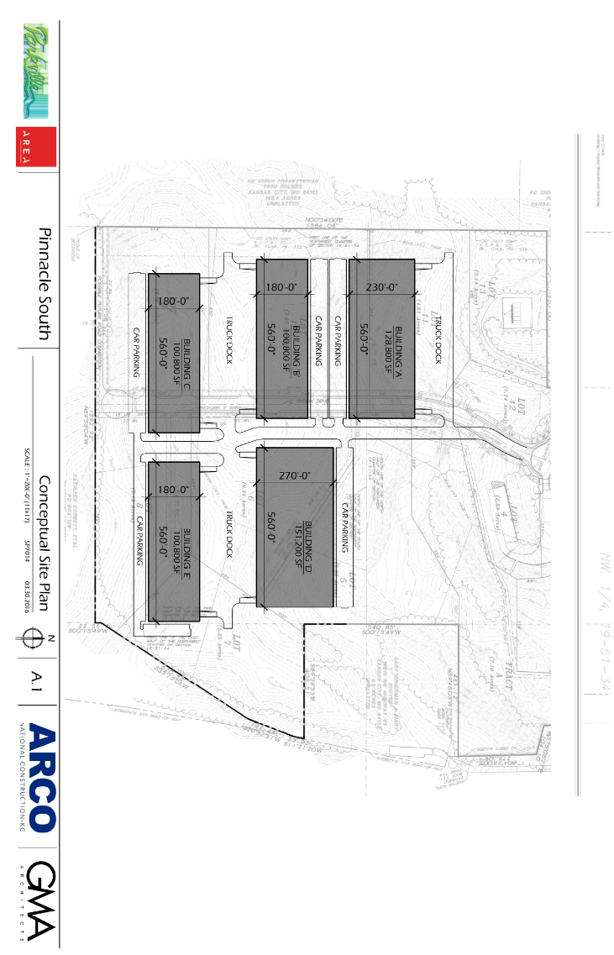
A new and modern Big Box Industrial Development which is strategically positioned on I-435, holds upwards of 8 million square feet of industrial space, and is properly incentivized for the developer and future tenants will be a successful enterprise. The market is currently demanding this type of space. There are very few locations around the I-435 loop that currently present this type of opportunity. Parkville affords a great residential opportunity to future employees of this manufacturing and distribution park that other sites do not offer. Proximity to major north, south, east and west interstate lanes that bypass major congestion areas is another strong benefit to the location. The incentives for this space directly from the state, county and city further bolster the financial benefit to its future development. Finally, the cost of construction and current market rates for similar property suggests a positive investment CAP rate.
See Full Size Concepts in Appendix

The geographic location within the country and to the city of Parkville improve both the national and local appeal. The city of Parkville boasts a strong school system, a somewhat dense suburban population, strong retail and above average median income. These factors will play a large role in the market. Future tenants will compare this development to other large scale spaces using metrics that include cost of operations as well as the incentives of location for their employees. The fact that other large scale developments are being built proves the need in the market yet none of the major industrial developments are located within a strong community like Parkville.

The timing of this development opportunity is excellent. Current building costs, lending rates, state employment rates, and even the limited residential development in Parkville point to a strong economic foundation for an industrial park in this area. It is a mutually beneficial endeavor for the city, developer and future park residents that will grow the local economy and the value of the development site.

Pinnacle Industrial Park Overview

Pinnacle Overview

Pinnacle Industrial Park
I-435 and Highway 45, Parkville, MO
176+/- Acre Complex

8,200,000+/- SF of planned building space includes:
- Warehouse/distribution centers
- Office/warehouses
- Flex space/service centers
- Light manufacturing facilities

Pinnacle Industrial Park offers great access and visibility to I-435 and minimal drive time (directly south) to I-70. The park rests inside the Parkville City limits allowing for great incentives from the state of Missouri, Platte County, and the city.
See Full Size Concepts in Appendix

Pinnacle Incentives
The City of Parkville and its Economic Development Council are proactive in its recruitment and attraction of business and new development. The Economic Development Council utilizes a malleable Economic Development Incentive Policy to each specific opportunity. This allows them to utilizes any and all potential state and local incentives. The City and the EDC are focused and determined to partner in the development of Pinnacle Industrial Park.

“The Parkville Plan for Progress sets forth a strategic plan containing seven key items, each with its own goal, policies, and implementation recommendations. Specific to the adoption of this EDI Policy, one of the seven key items is Development Process and Incentives. The identified goal for this key item is to “increase development through the creation of fair, consistent and timely review processes while providing responsible opportunities for incentives.” The stated policies relative to this goal include (a) the creation of roles and processes for communicating a consistent public position to developers on major projects, and (b) the identification of available incentive programs. One of the implementation recommendations for this item is the creation of an economic development incentive policy for the use of economic development incentives to achieve economic development goals. Specifically, the Parkville Plan for Progress calls for a policy of when, what and the extent to which available incentives will be used.”

The Parkville EDC’s EDI Policy is a guideline used in reviewing the approval of public incentives for proposed projects. “Each project must be viewed on its own merits under the market and public conditions that exist at the time of the request.”

The entire EDI Policy document can be found here:
- http://parkvilleedc.com/wp-content/uploads/Economic-Incentive-Policy.pdf

The following are proposed incentives available for Pinnacle Industrial Park development:

Missouri Incentives
- MO Certified Site
- Foreign Trade Zone
- Enhanced Enterprise Zone

Parkville Incentives
- Revenue Bonds
- Tax abatement
- Low sales tax rate (7.1%)
- Low permitting and license fees
- The City works closely to provide quick reviews and approvals
- Low development fees

Pinnacle Benefits
- Lower occupancy costs as compared to competitive industrial parks
- Abundant, well-educated and productive workforce in a growing job market
- Direct interstate access
- Proximity to KCI International Airport
- Speculative space and build-to-suit available
- Pad ready sites available for development; all infrastructure brought to site

Competitive Market Overview

Intermodal Industrial Parks

KCI Intermodal BusinessCentre
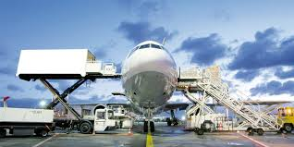
112th & I-29 Kansas City International Airpory
800+ Acre Complex

5,400,000 SF planned building space:
- AirFreight & LogisticsCentres TM
- Air CargoCentres TM
- Warehouse/distribution centers
- Office/warehouses
- Flex space/service centers
- Light manufacturing facilities
- Building-ready sites and LEED construction

The KCI Intermodal BusinessCentre is a 690-acre master-planned business park. Phase 1 will be 183 acres able to accommodate 1.8M +/- SF of distribution centers, traditional office/warehouse, air cargo facilities, etc. The site provides direct access to the Kansas City International Airport onramps, immediate interstate access (I-29; I-435), and is located in a Foreign Trade Zone and Enhanced Enterprise Zone. All buildings will be LEED certified. Phase I infrastructure completed to support 1,800,000 SF of buildings on 180+/- acres with a 500,000+/- SF spec building available.

CenterPoint KCS
Built on the site of the shuttered Richards Gebaur Airport, which closed in 2000, the cleanup and land transfer process began prior to 2005. CenterPoint Properties and The Kansas City Southern Railway Company have partnered together to develop a 1,340-acre intermodal logistics center in Kansas City, Missouri. This state-of-the art facility offers the newest and fastest inland route to the heart of North America and allows suppliers to avoid costly west coast port congestion.

- Total Investment: $300 million
- Site Size: 1,340 acres
  - 370-acre intermodal facility
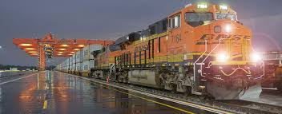
  - 970-acre industrial park
- 5,000,000 +/- SF planned space
- Use: Distribution, Warehouse, Intermodal
- Incentives:
  - Property Tax Abatement
  - Foreign Trade Zone
  - Missouri Enhanced Enterprise Zone
  - Off-site storm water detention

Logistics Park KC
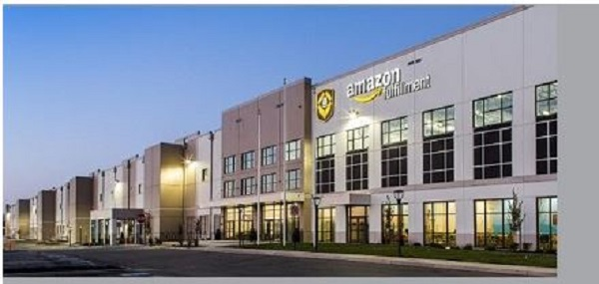
Logistics Park Kansas City (LPKC) is equipped to be one of America’s premier logistics facilities. By locating your facility at LPKC, you will have the advantage of direct use of the services at BNSF’s newest Intermodal Facility, inexpensive land costs, savings on lease and drayage rates, a strong available workforce, convenient interstate highway access and benefits of Foreign Trade Zone.

The City of Edgerton has limitless potential and promising possibilities and is open for opportunity. Incentives to help secure the bright future of business in Edgerton, thanks to an agreement the City has with BNSF and NorthPoint Development, warehouse and distribution facilities that locate within LPKC are eligible for a 10-year net-effective 50 percent property tax abatement. More than $100 million in public infrastructure investments, substantially lowering development costs at LPKC.

- 1700-acre master plan
- 17 Million total future square feet
- 64,000 feet of rail track (eight 8,000-foot strip tracks)
- 1,810 paved parking spaces
- 4,300 container stacking spots
- Five wide-span all-electric cranes

LPKC is the only full-service facility in the western two-thirds of the United States offering the combination of:
- Domestic Intermodal Service – Container, Trailer, Expedited and Standard Service Levels
- International Intermodal Service
- Direct-rail / Carload Service

BIG BOX INDUSTRIAL PARKS

Riverside Horizons Business Park
4600 NW 41st Street Riverside, MO 64150 (Platte)
260 acres of City owned property in Riverside, MO. (340,000 SF+ Currently Available Industrial Space)

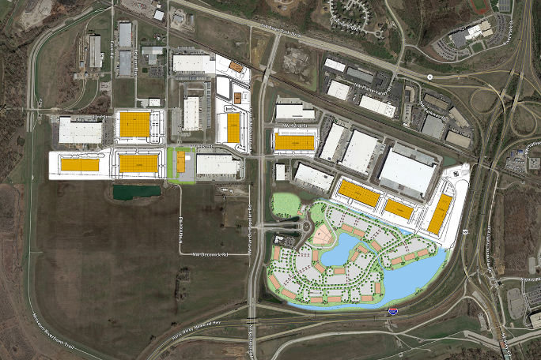
Great central location for local/regional distribution. Immediate interstate and highway access and excellent exposure along Interstate 635 and Horizons Parkway. Low operating costs and no City real or personal property tax. Abundant, well-educated and productive workforce in growing job market. Levee protected project. No E-Tax. LEED certified construction. T-5 high efficiency lights with motion sensors.

The Horizons project encompasses over 2.6 million square feet of total building area comprised of high end office and industrial development over a 260-acre Master Planned Business Park. The park is laid out in a strategic manner to take advantage of amenities like 25 acres of lakes, three miles of tree-lined canals, and public amenities. Architectural elements and landscaping are a key agent in the master plan. The park has the flexibility to serve multiple types and sizes of clients, and with critical transportation access and visibility Riverside Horizons will be a success for decades. It is also a low-property tax environment with levee protected land available for future development.

Hunt Midwest
Independence, MO
2,500 total acres with 8,500,000+ SF Total Industrial Space (1,500,000 SF proposed above ground space)

Located in the heart of the Midwest, this Kansas City, Missouri-based company is developer of over 6,200 acres of commercial, retail, industrial and residential property, and owner/developer of SubTropolis, the world’s largest underground business complex. SubTropolis is a subterranean, 1,150-acre industrial park in Kansas City, Missouri, with over 6 million square feet of leasable space. The complex is home to more than 55 local, national and international businesses with 1,600 employees. SubTropolis is an ENERGY STAR certified warehouse facility.

Hunt Midwest is currently expanding its 692 acre above ground Industrial park that will hold 7,200,000 SF of Industrial space. HMBC Logistics 1 is the first completed building in this development. It’s close proximity to FedEx/UPS terminals and Northfolk Southern Intermodal is perfect for logistics/e-commerce operations. HMBC offers easy access to I-435, I-35, I-29 and I-70 and is the home to Ford’s NAVLOS facility.

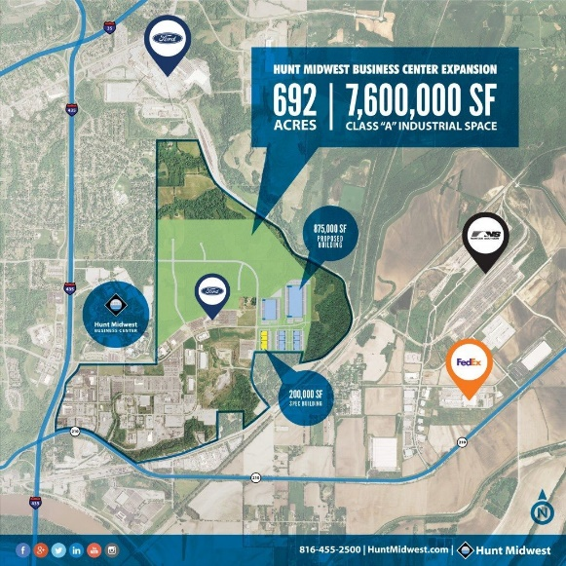
HMBC Logistics 1 specifications:
- 1.5 Million SF planned
- 200,582± square feet currently available
- Divisible to 30,000 square feet
- 210’ truck court
- 32+’ clear height
- 239 car parking
- Trailer parking available
- Build-to-suit office
- ESFR sprinklered
- Insulated precast concrete tilt-up construction
- 48’ x 50’ column spacing

Lenexa Logistics
Lenexa, KS
60 Acres (1,700,000 SF Proposed Industrial Space)

Lenexa Logistics Centre is located at the intersection of College Boulevard and Renner Boulevard. Construction has been completed of the 260,707 square feet at LLC #4 and the 354,055 square feet at LLC #5. When completed this eCommerce-ready business park will offer roughly 1,700,000 square feet of bulk industrial/warehouse space with multi-tenant occupancy.

Woodend Industrial
Edwardsville, KS
40 Acres (640,000 SF Proposed Industrial Space)

Woodend Industrial Building I is located west of the intersection of Woodend Road and Interstate 435 in Edwardsville, KS. The current development holds a 369,000 square feet speculative building.

COMPETETING INDUSTRIAL AREAS
There are 5 major Industrial Areas that may compete for tenants with the proposed Pinnacle Development in Parkville, MO. Each of these zones or areas is highlighted on the spreadsheet in the appendix that breaks down the current market rates and available space as well as the map which is partially shown below. There is minimal new construction and room for expansion in these areas.

We have defined each “Industrial Area” as one that is primarily zoned and used for industrial space.

Riverside (1)
Riverside, MO has a new large scale development with Horizons but it also boasts a strong industrial area along the river. In total there is approximately 400 acres of developed area outside of the Horizons project. These 400 +/- acres approximately 2,500,000 +/- SF of existing Industrial space with 200,000 SF currently available for lease.

West Bottoms (5)
The West Bottoms are situated south of Riverside, MO. It falls east of the river bend and sit north of I-625 and west of I-35. This area is approximately 960 acres with 8,000,000 SF of existing Industrial space and 750,000 SF currently available for lease.

East Bottoms (6)
The East Bottoms are situated south of Riverside, MO and sit between I-29 and I-435 south of the Missouri River and north of the rail line. This area is approximately 3,000 acres and has nearly 40 million square feet of industrial space with approximately 3,100,000 SF currently available for lease.

Fairfax (7)
Fairfax rests south of Riverside just across the river and sits between the Missouri River to the north and the railroad on its south. The area is approximately 2,000 +/- acres and has nearly 20 million square feet of industrial space with 950,000 +/- available for lease.

North Kansas City (8)
North Kansas City has a very dense concentration of Industrially zoned and used space from Armour Rd. south to W 9th St, between Highway 169 and the river. This 1500 +/- acre area has approximately 30 million square feet of industrially used space with 1,350,000 sf currently available for lease.

See Full Size Spreadsheet in Appendix

Platte COunty competing Sites

Congress Business Park
NEC 108th and N Congress Kansas City, MO 64153 (Platte)
87 shovel-ready acres available.

Congress Business Park is a nearly 88-acre master-planned industrial park near the Kansas City International Airport. The site is located on Congress, between the Harley-Davidson manufacturing plant and the 400,000 SF Pure Fishing distribution center. The project is partially developed, with roads, entitlement, zoning, utility extension, and has a few lots partially platted. Many of the buildings are permitted to have metal on three sides. Outside storage is permitted. Located in the Enhanced Enterprise Zone the property may be eligible for tax abatement opportunities.

Congress Corporate Center
11200 NW Congress Kansas City, MO 64153 (Platte)
78 shovel-ready acres available.

Congress Corporate Center is a business park containing in excess of 1,600,000 square feet of planned buildings on the northwest quadrant of North Congress Avenue and 112th Street, Kansas City, MO. Congress Corporate Center is served directly by a full diamond interchange at Interstate 29 and 112th Street. This interchange also provides access to Interstate 435 within two miles. Businesses may earn state income tax credits based on the facility’s new jobs and investments as well as real property tax abatement on improvements for up to a ten-year period after the project commences operation. VanTrust currently controls 78 acres for future development.

Amity Avenue and Tiffany Springs
8501 NW 101st Ter. Kansas City, MO 64153 (Platte)
Approximately 95.68 acres of vacant land zoned for industrial use.

Tiffany Springs Parkway will be extended and will run through the property once complete. I-29 is the primary corridor from Downtown Kansas City to Kansas City International airport (KCI). Nearly 50,000 vpd. Convenient access from interchanges at Tiffany Springs Parkway, N 112th Street. Businesses have flourished along this Platte County corridor since the opening of the Airport in 1960. Convenience to highways, strong utility base, high worker productivity, excellent school systems, and worker availability. Kansas City encourages business growth and new businesses.

SkyPort Industrial Park
7500 NW 106th Terrace Kansas City, MO 64153 (Platte)
67.37 Net acres, divisible to 9 acre sites

Vertical construction ready with road and infrastructure improvements completed. Regional storm water detention in place to maximize net usable acreage. Water, sewer, gas utilities in place. M-2-3 zoning appropriate for industrial manufacturing, distribution and general office. Located within Missouri Enhanced Enterprise Zone and Foreign Trade Zone (ASF Zone Procedures). Owners association in place to insure long term quality development.

KCI Intermodal BusinessCentre East
SE Corner of NW 104th St &N Amity Kansas City, MO 64153 (Platte)
105 acres zoned and planned for addition to existing KCI Intermodal Complex

Platte Valley Industrial Centers
Riverside, MO …Size SF available location…How many building…how many total acres

Airworld Distribution Center
7601 NW 107th Terrace Kansas City, MO 64153 (Platte)
187,600 SF available located off I-29 at 107th Terrace

Ambassador Distribution Center
10800 Ambassador Drive Kansas City International Airport, MO 64153 (Platte)
120,000 SF available located off I-29 and Ambassador Drive

Incentives Overview

Missouri Economic Development Incentive Programs
There are a number of state wide and local incentives for business, community, infrastructure and redevelopment that may be utilized in any given project. A list of the most applicable to our pursuit of development and redevelopment within Commercial Real Estate are listed below. All information was obtained through the following sites:
- Missouri EDC: www.missouripartnership.com
- Missouri DED Programs: www.ded.mo.gov/Programs.aspx
- Missouri Incentives and Financing: www.business.mo.gov/incentives/index.html
- Foreign Trade Zones: www.foreign-trade-zone.com/benefits.htm
- Kansas City ADC: www.thinkkc.com/
- Kansas City EDC: www.edckc.com/
- Platte County EDC: www.plattecountyedc.com/
- Parkville EDC: www.parkvilleedc.com/

BUILD
Provides a financial incentive for the location or expansion of large business projects. The incentives are designed to reduce necessary infrastructure and equipment expenses if a project can demonstrate a need for funding.

Business Facility Tax Credit Program
Provide tax incentives to facilitate the expansion of new or existing businesses in Missouri.

Chapter 100 Sale Tax Exemption
The program may be used by companies for which Chapter 100 bond proceeds are used to purchase tangible personal property. Companies eligible for Chapter 100 bond financing include manufacturing, warehousing, distribution, office, research and development, agricultural processing, and services in interstate commerce. Retail and services in intrastate commerce and others are not eligible.

Chapter 353 Tax Abatement
Chapter 353 Tax Abatement is an incentive that can be utilized by cities to encourage the redevelopment of blighted areas by providing real property tax abatement. Tax abatement is only available to for-profit “Urban Redevelopment Corporations” organized pursuant to the Urban Redevelopment Corporations Law.

Community Development Block Grant
The Community Development Block Grant Program (CDBG) offers grants to small Missouri communities to improve local facilities, address critical health and safety concerns, and develop a greater capacity for growth. We offer funds for projects that can range from housing and street repairs to industrial loans and job training.

Downtown Preservation
Facilitate the redevelopment of downtown areas and the creation of jobs by providing essential public infrastructure. Redevelopment areas must be classified as “blighted” or a “conservation area,” shall not exceed 10% of the entire geographic area of the municipality, and must be located in a “central business district.” At least 50% of the buildings in the central business district must be 35 years old or older.

DREAM Initiative
The Downtown Revitalization and Economic Assistance for Missouri (DREAM) Initiative provides select communities with access to the technical and financial assistance they need to accomplish their downtown revitalization plans. The program is framed by a multi-year commitment between the state of Missouri and designated communities to offer a comprehensive, streamlined approach to establish grassroots downtown revitalization.

Global Market Access Program (GMAP)
Global Market Access Program (GMAP) is a cost-share program that allows eligible Missouri companies to participate in specific events designed to create export sales. Increased export sales create a public benefit through their positive effect on Missouri’s economy including job creation and increased wealth for Missouri’s families.

Historic Preservation
Provide an incentive for the redevelopment of commercial and residential historic structures in Missouri. The costs and expenses associated with the rehabilitation must exceed 50% of the total basis of the property (acquisition cost).
An eligible property must be:
listed individually on the National Register of Historic Places;
certified by the MO Department of Natural Resources as contributing to the historical significance of a certified historic district listed on the National Register; or
of a local historic district that has been certified by the US Department of the Interior.

Industrial Development Bonds ("IDBs")
Industrial development bonds ("IDBs") were developed by the US Congress and the Missouri General Assembly to facilitate the financing of business projects. Industrial revenue bonds (IRBs) are among the most popular and cost-efficient methods of financing up to 100% of a growing business' land, buildings, and equipment, with the only equity requirement being the cost of bond issuance. IRBs are securities issued by cities and counties to provide the funds for credit-worthy companies to purchase land, to pay for the cost of constructing and equipping new facilities, or for purchasing, remodeling, or expanding existing facilities. Other developmental and financing costs, such as engineering, architectural, legal, and bond underwriting costs, may also be financed from bond proceeds.
The various types of IDBs are discussed below:
- "Chapter 100" Industrial Development Bond
- Revenue Bond
- General Obligation Bond
- Tax-Exempt Interest
- Property Tax Abatement
Industrial Infrastructure Grant
Assist local governments in the development of public infrastructure that allows industries to locate new facilities, expand existing facilities, prevent the closing of a facility or the relocation of a facility outside the state.

Land Assemblage Tax Credit Program
Supports redevelopment of blighted areas into productive use and must be:
- An area of at least 75 acres;
- At least 80% must be within a Distressed Area (applicable to other DED programs) or a federal “Qualified Census Tract” (26 U.S.C. Section 42)
- The redeveloper must acquire at least 50 acres of the area;
- The average parcels per acre must be four or more; and
- Less than five percent of the acreage for acquisition by the redeveloper under the redevelopment plan shall consist of owner-occupied residences.

Local TIF
Local Tax Increment Financing (Local TIF) permits the use of a portion of local property and sales taxes to assist funding the redevelopment of certain designated areas within your community. Areas eligible for Local TIF must contain property classified as a "Blighted", "Conservation" or an "Economic Development" area, or any combination thereof, as defined by Missouri Statutes.
TIF may be used to pay certain costs incurred with a redevelopment project. Such costs may include, but are not limited to:
- Professional services such as studies, surveys, plans, financial management, legal counsel
- Land acquisition and demolition of structures
- Rehabilitating, repairing existing buildings on site
- Building necessary new infrastructure in the project area such as streets, sewers, parking, lighting
- Relocation of resident and business occupants located in the project area

Missouri Certified Sites
The purpose of the Missouri Certified Sites program is to provide consistent standards regarding the availability and development potential of commercial or industrial development sites. The certification of a site is performed through a comprehensive review of items including the availability of utilities, site access, environmental concerns, land use conformance, and potential site development costs. Having a site “certified” reduces the risk associated with development of particular sites by providing up front and consistent information.

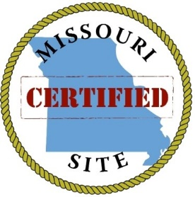
The following are competitive Missouri Certified Sites:
- KCI Intermodal Business Center in Kansas City, MO (690 acres)
- Horizons Riverside in Riverside, MO (179.9 acres)
- CenterPoint KCS in Grandview, MO (310 acres)

Missouri Enhanced Enterprise Zones
Enhanced Enterprise Zones are specified geographic areas designated by local governments and certified by the Missouri Department of Economic Development (DED). Individual business eligibility will be determined by the zone based on the creation of sustainable jobs in a targeted industry or demonstrated impact on local industry cluster development. Gambling establishments, retail trade, food and drinking places, educational services, religious organizations, and public administrators are prohibited from receiving the state tax credits. Service industries can be eligible if a majority of their annual revenues will be derived from services provided out of the state. DED will consult with the local government in determining eligibility.

MORESA
Provide financial incentives for public infrastructure for the development of a renewable fuel production facility or eligible new generation processing entity facility, creating new jobs and agricultural product markets in rural Missouri

Mutual Fund Tax Apportionment
To stimulate the mutual fund industry in the state by allowing those certified by DED to utilize a more favorable state income apportionment method for tax purposes.

Private Activity Bond Allocation
Provides lower-interest financing for certain types of projects to certain state agencies, cities, counties and industrial development authorities.

Speculative Building Loans
The purpose of this program is to provide an inducement for a speculative industrial building. The Department of Economic Development provides funding through a city or county government on behalf of an eligible borrower. An eligible borrower is a nonprofit development corporation. The maximum funding available is the lesser of $1 million per project or $25,000 per new job. Funds can be used for the purchase of land, the development of on-site infrastructure, the purchase of an existing building and improvements, or the construction of a new building. The term of the loan is a maximum of 30 months. The interest is 1% of the amount borrowed.

Platte COunty Incentives
Along with the state wide incentives there are specific opportunities through the local governing bodies as well for development that may be utilized in any given project.

2010 Platte County Land Use Plan
The Platte County 2010 Land Use Plan (“Plan”) updates the first county-wide Land Use Plan completed in 2002. The Plan serves as the guide for growth and development in unincorporated Platte County, Missouri.
The Plan is the primary tool used by the County to plan for long-term growth and development. It is organized into analysis and recommendations for each component of growth, such as utility, sewer extensions, education, historic and cultural preservation, housing, and the like. The Plan will present careful and detailed information regarding each issue, and offer guidelines for the best and most appropriate pattern of growth. In each case, the ultimate goals for development are those desired by local residents, and will serve the overall goal of improving the quality of life within Platte County.

Platte County Industrial Development Authority (IDA)
According to Chapter 349 of Missouri statute the IDA can issue bonds to assist in the following activities:

An eligible “Project means the purchase, construction, extension and improvement of plants, buildings, structures, or facilities, whether or not now in existence, including the real estate, used or to be used as a factory, assembly plant, manufacturing plant, processing plant, fabricating plant, distribution center, warehouse building, public facility, waterborne vessels excepting commercial passenger vessels for hire in a city not within a county built prior to 1950, office building, for-profit or not-for-profit hospital, not-for-profit nursing or retirement facility or combination thereof, physical fitness, recreational, indoor and resident outdoor facilities operated by not-for-profit organizations, commercial or agricultural facility, or facilities for the prevention, reduction or control of pollution. Included in all of the above shall be any required fixtures, equipment and machinery.”

Over the last few years, the IDA has been quite active, issuing over $100 million in bonds. A majority of these bond projects developed much needed road infrastructure in Platte County.

Parkville Incentives
“The Parkville Plan for Progress sets forth a strategic plan containing seven key items, each with its own goal, policies, and implementation recommendations. Specific to the adoption of this EDI Policy, one of the seven key items is Development Process and Incentives. The identified goal for this key item is to “increase development through the creation of fair, consistent and timely review processes while providing responsible opportunities for incentives.” The stated policies relative to this goal include (a) the creation of roles and processes for communicating a consistent public position to developers on major projects, and (b) the identification of available incentive programs. One of the implementation recommendations for this item is the creation of an economic development incentive policy for the use of economic development incentives to achieve economic development goals. Specifically, the Parkville Plan for Progress calls for a policy of when, what and the extent to which available incentives will be used.”

The Parkville EDC’s EDI Policy is a guideline used in reviewing the approval of public incentives for proposed projects. “Each project must be viewed on its own merits under the market and public conditions that exist at the time of the request.”

The entire EDI Policy document can be found here:
- http://parkvilleedc.com/wp-content/uploads/Economic-Incentive-Policy.pdf

Horizons Riverside Incentives
The City of Riverside is a pro-business community, sharing a close relationship with its corporate citizens. Riverside offers a very favorable costs to do business. Businesses in Riverside pay NO city property tax and employees are exempt from the 1% earnings tax levied on workers in Kansas City proper. Additionally, businesses enjoy a low sales tax rate (6%) and low permitting and license fees.
Riverside is not only financially friendly, but also strives to find creative solutions to attract new companies and retain and expand existing ones. The City government works closely with businesses and developers to provide quick reviews and approvals. A 2012 study by the KC chapter of the Society for Industrial Office Realtors and the University of Missouri-Kansas City's Lewis White Real Estate Center rated Riverside #1 in the KC metro area in terms of quickest approval times and low development fees.

KCI Intermodal Incentives
- Lower occupancy costs as compared to other business parks
- Foreign Trade Zone:
  - Deferral, reduction, or elimination of U.S. Customs duties and fees on imported goods/merchandise
  - Expedited Customs Clearance of imports at seaports and boarder crossings.
  - Imported goods/merchandise remain duty free in an FTZ for an unlimited period of time
- Key incentive programs including Enhanced Enterprise Zone
- Abundant, well-educated and productive workforce in a growing job market
- Direct interstate access:
  - Reduce trucking costs by minimizing time spent in traffic
- Direct and immediate access to air freight logistics companies at KCI:
  - Extended drop off and delivery times
  - Longer order fulfillment window during work day
- Immediate access to airport terminals:
  - Added convenience when meeting with out of town clients
  - Day versus overnight trips for executives
  - Avoid downtown traffic and congestion
- Speculative space and build-to-suit available
- Regional storm water detention for entire park
- Pad ready sites available for development; all infrastructure brought to site

Centerpoint KCS Incentives

Conduit Bond Port Improvement District
Port KC can serve as the issuer of RSMO Chapter 68 Port Authority Revenue Bonds. Port KC can own the facility and lease it to the borrower. Port KC would issue Chapter 68 Port Authority revenue bonds.
Possible Benefits:
- Rated or non-rated bonds sold in capital markets or private placement.
- Sales tax exemption on construction materials.
- Property tax exemption (Based upon illustrated need, financial analysis, economic and fiscal impact).
- Lease options customized for project needs.
- Fixed interest rates that are based on taxable or tax-exempt bond issuances.

Port Improvement District
The Port Improvement District (PID) is a Port Authority sales, use and or property tax. The PID was created to fund qualified project costs in furtherance of its mission as a port authority. Qualified project costs include reasonable costs incurred by a port authority during a port improvement project. Examples include the cost of studies, plans, architectural, engineering, legal, marketing, administrative costs, and real property rights.
Possible Benefits:
- Levy of a maximum of one percent (1%) of sales and use, and/ or real property tax within the boundaries of the designated PID.
- Costs eligible to be paid with these tax revenues can include but are not limited to studies, plans, surveys, professional services, administrative fees, land acquisition, demolition, grading, construction of new buildings, rehabilitation of old facilities, repair, financing costs, relocation costs, and other expenses (RSMo 68.205). There is not necessarily a maximum time period for the redirection taxes to run.

Foreign Trade Zone
Greater Kansas City Foreign Trade Zone, Inc. (“GKCFTZ”) is a not-for-profit corporation registered in the State of Missouri (since 7/30/71). GKCFTZ applied and received a Grant of Authority from the U.S. Foreign Trade Zone’s Board in Washington, D.C. to establish, and operate Foreign Trade Zone 15 (Missouri). The GKCFTZ serves as “Grantee” for foreign trade zone status under the U.S Foreign Trade Zone Act of 1934, as amended. Port KC works with the Kansas City Southern Railway and CenterPoint Properties to allow 1,567 acres to become a FTZ in Kansas City.

Logistics Park KC Incentives
LPKC brings a cost-efficient solution to logistics-oriented companies focused on development. These efficiencies consist of competitive lease rates and other benefits such as:
- More than $100 million in public infrastructure investments, substantially lowering development costs at LPKC.
- Development of regional stormwater detention facilities, allowing additional building coverage within LPKC. Benefits accrue in the form of less land required for development, corresponding with lower lease rates.
- In partnership with the City of Edgerton, a zoning ordinance and master land permits are consistent with the unique attributes of LPKC to ensure quality development and protection from incompatible land uses such as residential development.
- LPKC’s electric service provider offers an economic development rider that includes reduced power costs and extensions of power to the buildings at no cost to LPKC. Rebates of electric utility expenses accrue directly to tenants.
- An exemption from the National Pollutant Discharge Elimination System (NPDES) Phase II requirements, which lowers construction costs and increases development density resulting in less land used per square foot of building.

State of Kansas
In 2014, Kansas was named as the No. 5 “Pro-Business State” by Pollina Corporate Real Estate Inc. The ranking is based on 32 factors controlled by state government, including taxes, human resources, education, right-to-work legislation, energy costs, infrastructure spending, workers compensation laws, economic incentive programs and state economic development efforts. In addition to the recognition by Pollina, Area Development magazine recently gave Kansas a Silver Shovel Award, which recognizes state economic development agencies that drive significant job creation.

City of Edgerton
The City of Edgerton has limitless potential and promising possibilities and is open for opportunity. New roads, projects and opportunities are paving the way for a bright future in Edgerton. Development is welcomed here. Average Development Time: Application to Construction is 170 Days Unlike other communities, the City of Edgerton understands how to eliminate the challenges of the development process. Edgerton is ready to assess and review your project plan, provide a realistic timeline that will be required and outline any fees that you will incur as a result of your development progressing through each step of the process so there are no surprises. Incentives To help secure the bright future of business in Edgerton, thanks to an agreement the City has with BNSF and NorthPoint Development, warehouse and distribution facilities that locate within LPKC are eligible for a 10-year net-effective 50 percent property tax abatement.

Municipal Tax Information

State of Missouri
Missouri is the only state that allows companies to choose their own income allocation formula (three-factor or single-factor), whichever results in the lesser corporate income tax liability. And by allowing 50 percent of federal income tax to be deducted from taxable income, Missouri is able to offer companies an effective tax rate of 5.2 percent.

Both Kansas and Missouri administer an income tax measured by net income of the corporation. The determination of taxable income begins with net taxable income reported for federal income tax purposes. Both states permit deduction of operating expenses from gross income in arriving at net taxable income.

State to State Income Tax Rates
Kansas | 4% of net taxable income. In addition, income in excess of $50,000 is subject to a 3.0% surtax.
Missouri | 6.25% of net taxable income earned in the state. (Note that Missouri allows 50% of federal income tax payments to be deducted before computing taxable income.)

Effective 2013 Real Property, Sales and Use Tax Rates (%)
Selected KS and MO Municipalities
KANSAS | Sales Tax | Use | Commercial | Residential | Individual
Edwardsville, Wyandotte Co. | 8.15 | 6.15 | 3.76 | 1.73 | 4.51
Gardner, Johnson Co. | 8.875 | 6.15 | 3.61 | 1.66 | 4.34
Kansas City, Wyandotte Co. | 8.775 | 6.15 | 3.80 | 1.75 | 4.56
Lenexa, Johnson Co. | 8.75 | 6.15 | 2.99 | 1.38 | 3.59
Overland Park, Johnson Co. | 8.5 | 6.15 | 2.93 | 1.35 | 3.51
Shawnee, Johnson Co. | 8.625 | 6.15 | 2.87 | 1.32 | 3.44

Effective 2013 Real Property, Sales and Use Tax Rates (%)
Selected KS and MO Municipalities
MISSOURI | Sales Tax | Use | Commercial | Residential | Individual
Gladstone, Clay Co. | 7.725 | 7.6 | 2.99 | 1.48 | 2.59
Grandview, Jackson Co. | 7.975 | 4.2 | 3.25 | 1.65 | 2.90
Independence, Jackson Co. | 7.725 | 4.2 | 2.94 | 1.47 | 2.34
Kansas City, Clay Co. | 8.1 | 7.9 | 3.21 | 1.60 | 2.81
Kansas City, Jack. Co. | 8.35 | 7.1 | 3.03 | 1.53 | 2.68
Kansas City, Platte Co. | 8.475 | 8.475 | 2.80 | 1.60 | 2.80
Kearney, Clay Co. | 7.225 | 5.1 | 2.94 | 1.44 | 2.53
North Kansas City, Clay Co. | 6.725 | 5.1 | 2.97 | 1.46 | 2.45
Parkville, Platte Co. | 7.1 | 5.6 | 2.81 | 1.60 | 2.80
Riverside, Platte Co. | 6.6 | 6.6 | 2.27 | 1.28 | 2.25
Missouri Tax Rates
- Corporate income tax: 6.25%—50% of federal income tax payments may be deducted before computing taxable income, leading to an effective rate of 5.2%
- Taxable income apportionment formula: 3 factor or sales
- Personal income tax: up to $315 plus 6.0% of federal taxable income over $9,000
- Property tax: Commercial and industrial property assessed at 32%; personal property at 33 1/3%. Business inventories are not taxed. Tax rates are the aggregate of local taxing districts and a .03 state tax.
- State sales and use tax: 4.225%
- Unemployment insurance taxable wage base: $13,000
- Unemployment insurance new employer entry rate: 3.510%

Missouri Tax Rankings
- 3rd best corporate income tax index in the U.S. (Tax Foundation).
- 8th best property tax index in the U.S. (Tax Foundation).
- 12th best unemployment insurance tax index in the U.S. (Tax Foundation).

Missouri Utility Facts
Commercial electricity costs are nearly 15% lower than the U.S. average, at 9.02 cents/kWh (EIA, 2015).
Industrial electricity costs are nearly 10% lower than the U.S. average, at 6.22 cents/kWh (EIA, 2015).
Missouri Demographics Report
Population
2014 | Population (Most Recent Year) | 6,063,589
Income
2014 | Per Capita Personal Income (Current Year) | $41,613
Education
2013 | High School Graduates 25+yrs (% of Population) | 88.7
2013 | College Graduates 25+yrs (% of Population) | 27
Taxes
2015 | Corporate Income Tax Rate | 6.25
2015 | Federal Income Tax Deduction | Yes
2015 | State Apportionment of Corporate Income | 3 Factor
2015 | State Sales Tax Rate (%) | 4.23%
2015 | Vendor Discounts | 2.00%
2014 | Per Capita Total State Tax Revenue | $1,854
2014 | Per Capita Property Tax Revenue | $4.90
2014 | Per Capita State Sales and Gross Receipts Tax Revenue | $810.61
2014 | Per Capita State Personal Income Tax Revenue | $884.29
2014 | Per Capita Corporate Net Income Tax Revenue | $59.00
2015 | Gasoline Total Tax Per Gallon | 17.3
2015 | Diesel Total Tax Per Gallon | 17.3
Cost of Living
2015 | Cost of Living - Rank | 11
Business Climate
2014 | Gross State Product ($mil) | $284,462
2014 | Manufacturing Gross State Product ($ milllions) | $35,676
2014 | Total Value of Exports ($ thousands) | $14,141
2015 | Avg Industrial Electric July (Price/KiloWatt Hour) | 7.24
2015 | Avg. Commercial Electric July (Price/KiloWatt Hour) | 10.41
2015 | Avg. Residential Electric July (Price/KiloWatt Hour) | 12.69
2014 | Avg. Industrial Natural Gas (Price/1000cft) | 8.47
2014 | Avg. Commercial Natural Gas (Price/1000cft) | 8.94
2014 | Avg. Residential Natural Gas (Price/1000cft) | 10.56
Labor
2015 | Civilian Labor Force (thousands) | 3,112,000
2014 | Annual Average Total Employment (thousands) | 2,871,217
2014 | Annual Average Unemployment Rate | 6.1
2014 | Annual Average Manufacturing Wage | $72,967
2015 | Right-to-Work Law | No
Infrastructure
2014 | Residential Building Permits | 16,003
2011 | Number of Class 1 Freight Railroads | 6
2011 | Total Number of Freight Railroads | 17
2011 | Miles of Class 1 Freight Railroads | 3,400
2011 | Total Miles of Freight Railroads | 3,958
2012 | Miles of Interstate Roads | 1,379
2012 | Miles of Principal and Minor Arterial Roads | 10,498
2012 | Total Public Road Miles | 131,978
2012 | Number of Airports | 359
2012 | Number of Heliports | 116

Platte County
Platte County businesses have the advantage of some of the lowest taxes in the metro area.
- Real property (commercial & industrial) is assessed at 32% of the fair market value
- Personal property (such as furniture, cars, trucks etc.) is assessed at 33 1/3 % of fair market value
- Residential property is assessed at 19% of fair market value
- Agricultural property is assessed at 12% of fair market value.
The graph below provides a visual of Platte County taxes in the metro area.

The 2015 tax levies are shown in the table below.

Jurisdiction | Kansas City –  Park Hill | Kansas City –  Platte County | Parkville | Platte City | Riverside
State | .03 | .03 | .03 | .03 | .03
County | .06 | .06 | .06 | .06 | .06
Commercial Surtax* | .36 | .36 | .36 | .36 | .36
City | 1.5806 | 1.5997 | .6514 | 1.0886 | 0
School | 5.5650 | 5.0439 | 5.5650 | 4.5989 | 5.5650
Other | .91 | .89 | 2.3061 | 1.6427 | 1.0264
Total | 8.5056 | 7.9836 | 8.9725 | 7.7802 | 7.0414

City of Parkville
Parkville utilizes an Economic Development Incentive Policy to determine on a case by case basis which incentives the city will extend for any given project. The Parkville Economic Development Council utilizes the EDI Policy to guide it through the process of current and future development incentives.

AREA Industrial Team

Bradley Cook, MS  Associate Advisor |  | Cory Delong  ASSociate advisor |  | brent peterson  VP Industrial
 |  |  |  | 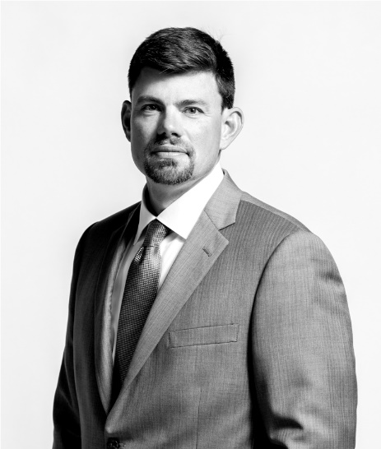
Office 816.876.2526  Mobile 225.505.6009  bcook@openAREA.com |  | Office 816.876.2502  Mobile 913.206.6396  cdelong@openAREA.com |  | Office 816.777.2848  Mobile 913.238.5127  bpeterson@openAREA.com

AREA Real Estate Advisors
4717 Central. KCMO 64112
Tel 816.777.3500
Fax 816.777.3501
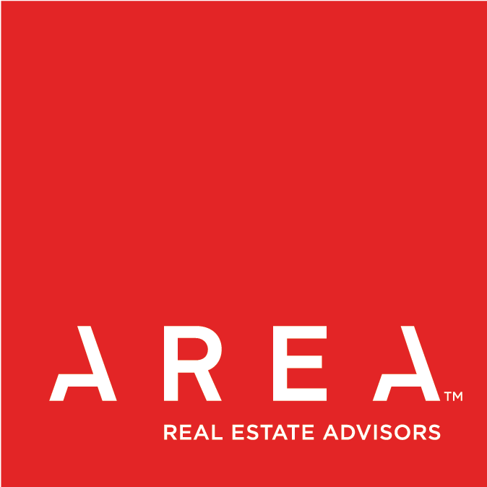
www.openAREA.com

Appendix

Competitive Market Map………………………………………………………………………………………………INSERT 1

Competitive Matrix…………………..…………………………………………………………..………………………INSERT 2

Pinnacle North Complex.…………..………………………………………………………………………………………………1

Pinnacle South Complex……………………………………………………………………………………………………….......2

Pinnacle Elevations…………………..………………………………………………………………………………………………3

Pinnacle Cut Fill Diagram……………………………………………………………………………………………………….....4

