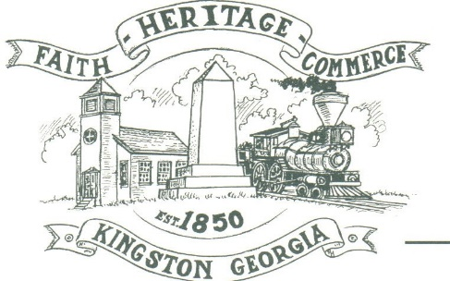
CITY OF KINGSTON
30 West Main St., Kingston, GA 30145
COUNCIL MEETING – CITY HALL
May 6, 2024 – 6:00 p.m.

The meeting began at 6:02 p.m. In attendance were council members, Louise Young-Harris, Allen Cochran, Mayor Elbert Wise, Payton Silvers, Kelly Ensley, City Clerk, Attorney Elliott Noll, and Police Chief TJ Sosebee. There were twenty (18) attendees.

The meeting began with Louise Young-Harris leading the invocation. The Pledge of Allegiance followed.

SIGN IN PERMISSION TO SPEAK.
Patresha Northgraves spoke asking the city’s 5-year plan regarding roads, street signs and more police officers

APPROVAL OF PREVIOUS MINUTES
Louise Young-Harris made a motion to approve the previous minutes. Payton Silvers seconded the motion. Motion was carried unanimously.

APPROVAL OF AGENDA
Payton Silvers made a motion to approve the agenda. Louise Young-Harris seconded the motion. Motion was carried unanimously.

DDA UPDATE
Charlie Pecchio spoke regarding the DDA. Jolie Mata has resigned from the DDA and they need to add a council member to be on the DDA. Louise Young-Harris made a motion to amend the agenda to Approve appointment of Allen Cochran to the DDA. Payton Silvers seconded the motion. Motion was carried unanimously.

POLICE UPDATE
Nothing to update

APPROVAL OF INTERGOVERNMENTAL AGREEMENT ON 2026 SPLOST
Payton Silvers made a motion to approve the Intergovernmental Agreement on 2026 SPLOST. Louise Young-Harris seconded the motion. Motion was carried unanimously.

APPROVAL OF RESOLUTION FOR METRO WATER DISTRICT-WATER EFFICIENCY CODE REQUIREMENTS
Elliot Noll asked to table for June’s meeting.

APPROVE APPOINTMENT OF ALLEN COCHRAN TO THE DOWNTOWN DEVELOPMENT AUTHORITY
Louise Young-Harris made a motion to approve Allen Cochran to the DDA. Payton Silvers seconded the motion. Motion carried unanimously.

COUNCIL COMMENTS
Mayor Wise thanked everyone that came to meeting.

ADJOURNMENT
At 6:32 p.m. Payton Silvers made a motion to adjourn. Louise Young-Harris seconded the motion. Motion was carried unanimously.

_____________________________ ________________________
Mayor Elbert “Chuck” Wise, Jr. Kelly Ensley, City Clerk

