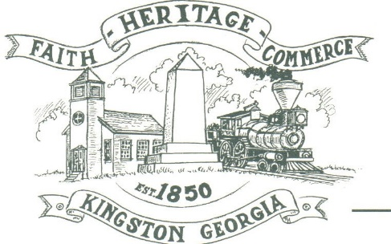
CITY OF KINGSTON
30 West Main St., Kingston, GA 30145
COUNCIL MEETING – CITY HALL
June 7, 2021 – 6:00 p.m.

The meeting began at 6:05 p.m. in attendance was council members, Louise Howell, and Michael McFarland, Payton Silvers (Video Chat), Mayor Elbert Wise, Chief T.J. Sosebee and City attorney Brandon Bowen. Absent was Louise Young-Harris, there was 2 attendees.

The meeting began with Mayor Wise leading the invocation. The Pledge of Allegiance followed.

SIGN IN PERMISSION TO SPEAK
None

APPROVAL OF PREVIOUS MINUTES
Payton Silvers made a motion to approve previous minutes. The motion was seconded by Louise Howell. Motion was carried unanimously.

APPROVAL OF AGENDA
Louise Howell made a motion to approval the agenda. The motion was seconded by Michael McFarland. Motion was carried unanimously.

DDA UPDATE
Michael McFarland gave an update with the prospect of getting the benches updated and painted downtown. Matt Fowler had offered to do the repairs and painting. DDA also wanted to help with festivals or other City activities.

APPROVE ARP LOCAL FISCAL RELIEF FUND CHECKING ACCOUNT
Louise Howell made a motion to get approve the ARP Local Fiscal relief fund checking account. The motion was seconded by Michael McFarland. Motion was carried unanimously.

DISCUSSION WHERE TO USE THE ARP LOCAL FISCAL RELIEF FUNDS
Delayed until next meeting in July

CLOSED SESSION: EMPLOYEES
At 6:15 p.m., Michael McFarland made a motion to go into closed session regarding employee issues. The motion was seconded by Louise Howell. Motion carried unanimously. Discussion. 6:30 p.m. Michael McFarland made a motion to go back into regular session. The motion was seconded by Louise Howell. Motion was carried unanimously.

COUNCIL COMMENTS
Mayor Wise thanked the City employees and council for everything they do for the City, especially while he was out with surgery.

ADJOURNMENT
Michael McFarland made a motion to adjourn at 6:39 p.m. Louise Howell seconded the motion. Motion was carried unanimously.

_____________________________ ________________________
Mayor Elbert “Chuck” Wise, Jr. City Clerk, Kelly L. Ensley

