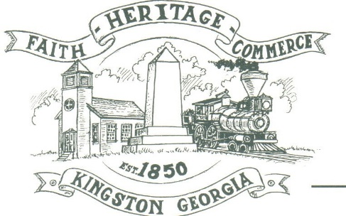
CITY OF KINGSTON
30 West Main St., Kingston, GA 30145
COUNCIL MEETING – CITY HALL
July 8, 2024 – 6:00 p.m.

The meeting began at 6:00 p.m. In attendance were council members, Louise Young-Harris, Allen Cochran, Mayor Elbert Wise, Payton Silvers, Kelly Ensley, City Clerk, Attorney Elliott Noll, and Police Chief TJ Sosebee. There were twenty three (23) attendees.

The meeting began with Louise Young-Harris leading the invocation. The Pledge of Allegiance followed.

SIGN IN PERMISSION TO SPEAK.
Larry Posey spoke re the mileage rate. Asked to explore other avenues for revenue and to reconsider restructure of employees.
Patresha Northgraves spoke asking why Mayor or City Clerk did not go to the LOST meeting. Also asked about the wells and repair of Dawson Street well.

APPROVAL OF PREVIOUS MINUTES
Payton Silvers made a motion to approve the previous minutes. Louise Young-Harris seconded the motion. Motion was carried unanimously.

APPROVAL OF AGENDA
Louise Young-Harris made a motion to approve the agenda. Payton Silvers seconded the motion. Motion was carried unanimously.

DDA UPDATE
Charlie Pecchio presented the Council with an outline to work with the City to meet with Hyundai plant management, park improvements, and get grants to help with water improvements, drainage and sewage.

APPROVE THE PROCESS OF A 2% MILEAGE RATE FOR ROAD IMPROVEMENTS AND MORE POLICE
Payton Silvers made a motion to deny to move forward with the mileage rate process. Louise Young-Harris seconded the motion. Motion was carried unanimously.

CLOSED SESSION-EMPLOYEES AND PROPERTY
Payton Silvers made a motion to go into closed session at 6:43 p.m. Allen Cochran seconded the motion. Motion carried unanimously. At 6:58 p.m. council was announced back in order.

COUNCIL COMMENTS
Louise Young-Harris thanked everyone that came to meeting. Mayor thanked everyone for coming out and thanked Mr. Posey and Mr. Pecchio for their input. Chief announced Cruiz in with a Cop August 24th

ADJOURNMENT
At 7:02 p.m. Payton Silvers made a motion to adjourn. Louise Young-Harris seconded the motion. Motion was carried unanimously.

_____________________________ ________________________
Mayor Elbert “Chuck” Wise, Jr. Kelly Ensley, City Clerk

