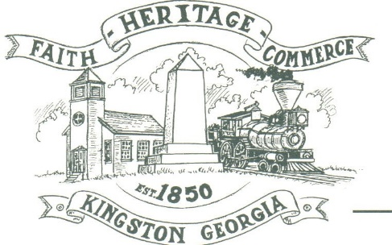
CITY OF KINGSTON
30 West Main St., Kingston, GA 30145
COUNCIL MEETING – CITY HALL
January 9, 2023 – 6:00 p.m.

The meeting began at 6:00 p.m. In attendance were council members, Louise Young-Harris, Michael McFarland, Allen Cochran, Mayor Elbert Wise, Payton Silvers, Treasurer Paula Stewart, (Kelly Ensley, City Clerk-Absent) Police Chief TJ Sosebee, Sargent Jonathon Cordell, Sean Lamb and Elliott Noll representing the City Attorney. There were two attendees

The meeting began with Louise Young-Harris leading the invocation. The Pledge of Allegiance followed.

SIGN IN PERMISSION TO SPEAK.
Jolie Mata spoke to get approval to open a liquor store across from her restaurant 2 Amigos.

APPROVAL OF PREVIOUS MINUTES
Louise Young-Harris made a motion to approve previous minutes. Payton Silvers seconded the motion. Motion was carried unanimously.

APPROVAL OF AGENDA
Louise Young-Harris made a motion to approve agenda. Payton Silvers seconded the motion. Motion was carried unanimously.

DDA UPDATE
Nothing at this time. Chuck Wise spoked to voice need for event volunteers.

APPROVAL TO MAKE DAWSON STREET A ONE-WAY STREET
Payton Silvers made a motion to approve the Dawson Street one way street. Allen Cochran seconded the motion. Motion carried unanimously.

COUNCIL COMMENTS
Mayor Wise recognized National Law Enforcement Day and the office in attendance. TJ Sosebee introduced Sean Lamb as the new officer on staff.

ADJOURNMENT
At 6:30 p.m. Payton Silvers made a motion to adjourn. Louise Young-Harris seconded the motion. Motion was carried unanimously.

_____________________________ ________________________
Mayor Elbert “Chuck” Wise, Jr. Paula Stewart, Treasurer

