A DISTRICT-WIDE SERVICE PROJECT FOR 35-I
The Mobile Education Center and the LCIF Matching Grant
Prepared for District Governor Beverly Flynn and the District 35-I Cabinet, for the vote of August 15, 2026
Lions District 35-I is asked to sponsor a Lions Clubs International Foundation Matching Grant. The district would be the applicant, the grantee, and the grant administrator. Manasota Lighthouse for the Blind, Inc. — Lighthouse Vision Loss Center — would be the beneficiary organization.
The grant funds one thing: a self-contained assistive-technology equipment package carried aboard a Mobile Education Center. The vehicle itself is already paid for by an $848,000 State of Florida appropriation, and that state money serves five counties on a weekly rotation. This grant is what lets the unit also reach six more District 35-I counties on a scheduled quarterly rotation, hosted by local clubs.

This Is Already a 35-I Project
District 35-I chartered a new club on June 26, 2026 at the Venezia Hotel in Venice: the Southwest Florida Lighthouse Lions Club, with Pamela Brown serving as Guiding Lion and George Heudorfer as President. That club grew directly out of Lighthouse's work — more than thirty of its founding members are people who came through Lighthouse programs and rebuilt their independence after vision loss.
That is the strongest argument in this briefing, and it is not a projection. It already happened, in this district, in the last month of the previous Lionistic year. A district that serves people with vision loss well ends up with more Lions. The Mobile Education Center is how that same work reaches six more counties.

The Six Counties
The map below replaces the county graphic in the earlier packet. Boundaries are drawn from official U.S. Census Bureau data, correctly placed and correctly labeled.
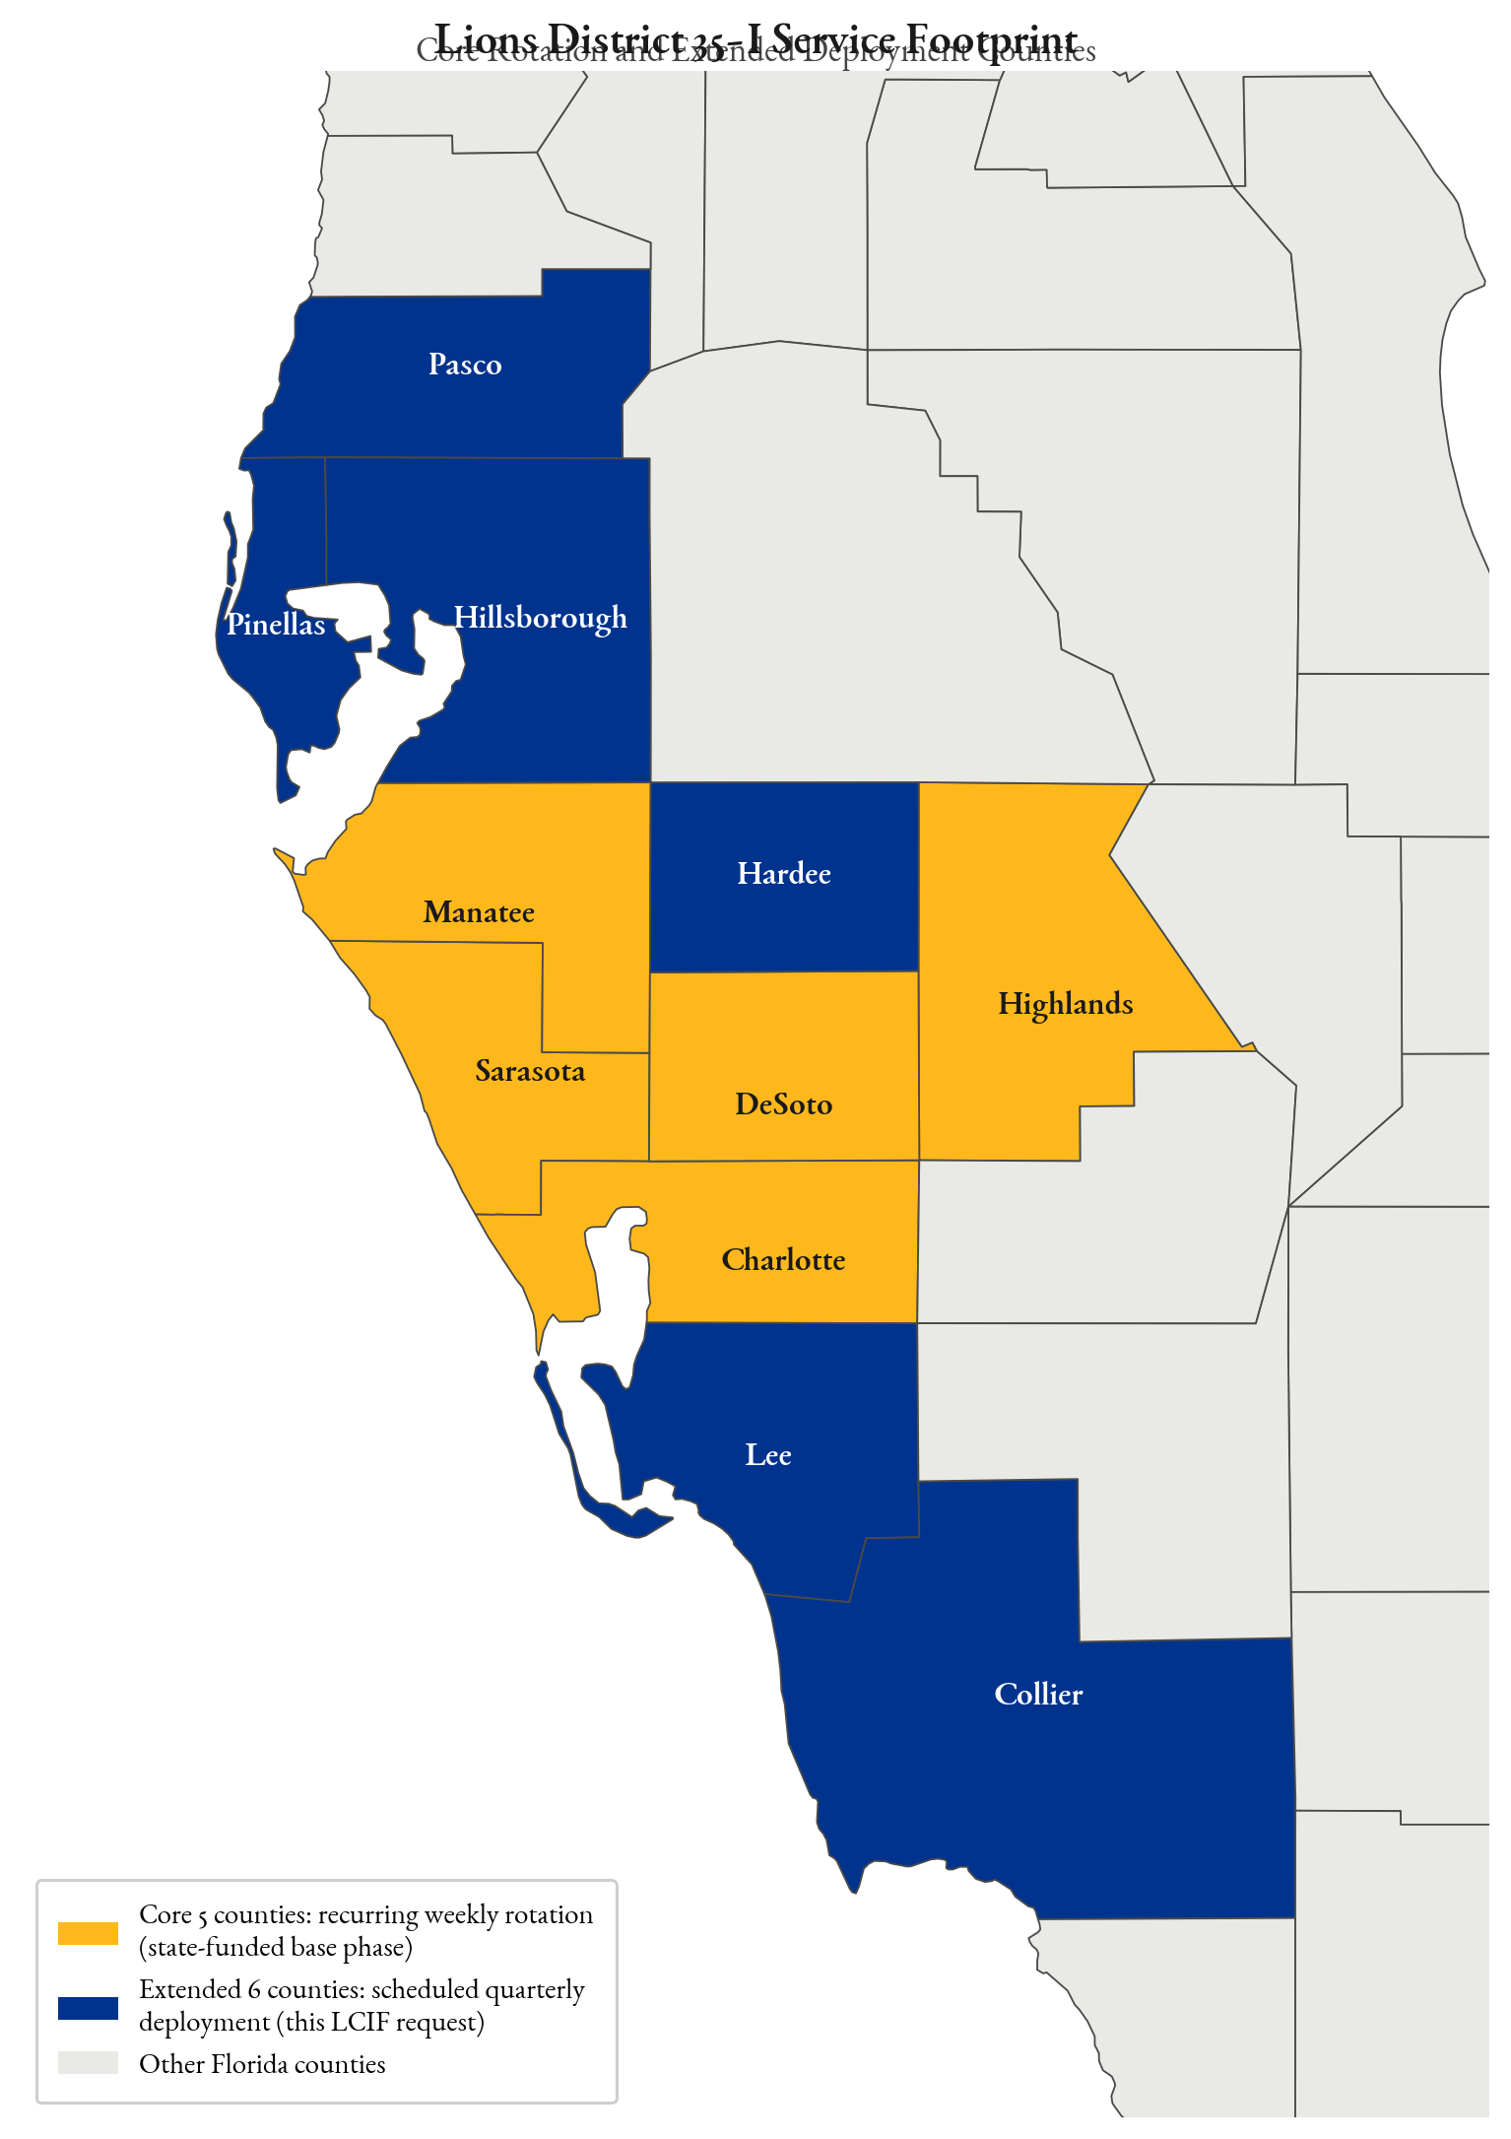
Gold: the five counties already served weekly under the state appropriation. Navy: the six counties this LCIF grant would add on a scheduled quarterly rotation.
District 35-I spans twelve Florida counties. Lighthouse's accredited service region covers eleven of them, so all six project counties sit inside the district. Clubs in seven of the district's eight zones are located in those six counties — 33 of the district's 46 clubs. The one exception, Zone 6, lies entirely within Charlotte and Sarasota, which the state appropriation already serves weekly. This is district-wide business, which is why it comes to the full district for a vote rather than to a region.
The twelfth county, Polk — home to the Frostproof and Lake Wales clubs in Zone 1 — lies outside Lighthouse's accredited service region and is not a deployment county under this grant. Polk residents referred to Lighthouse are served through the organization's existing intake and referral pathways.

Why These Six Counties
Across the eleven counties of Lighthouse's service region, an estimated 241,765 residents live with vision difficulty. The state appropriation reaches 31,765 of them. The other 210,000 — roughly 87 percent — live in the six counties this grant would reach: Hillsborough, Pinellas, Lee, Pasco, Collier, and Hardee.
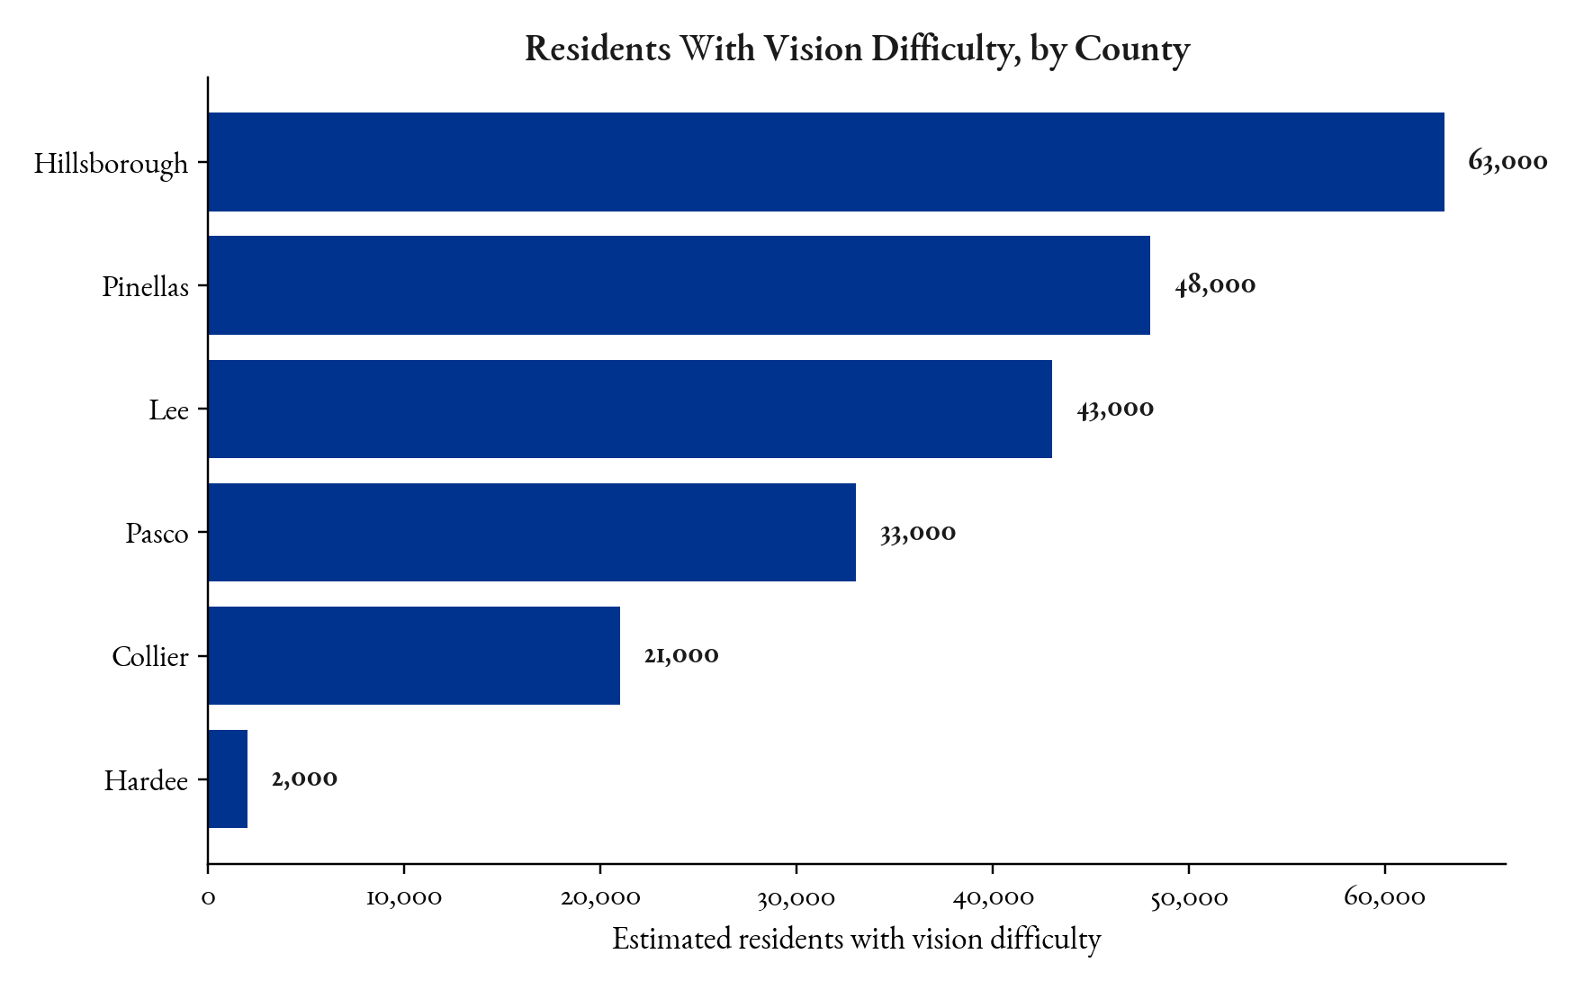 | 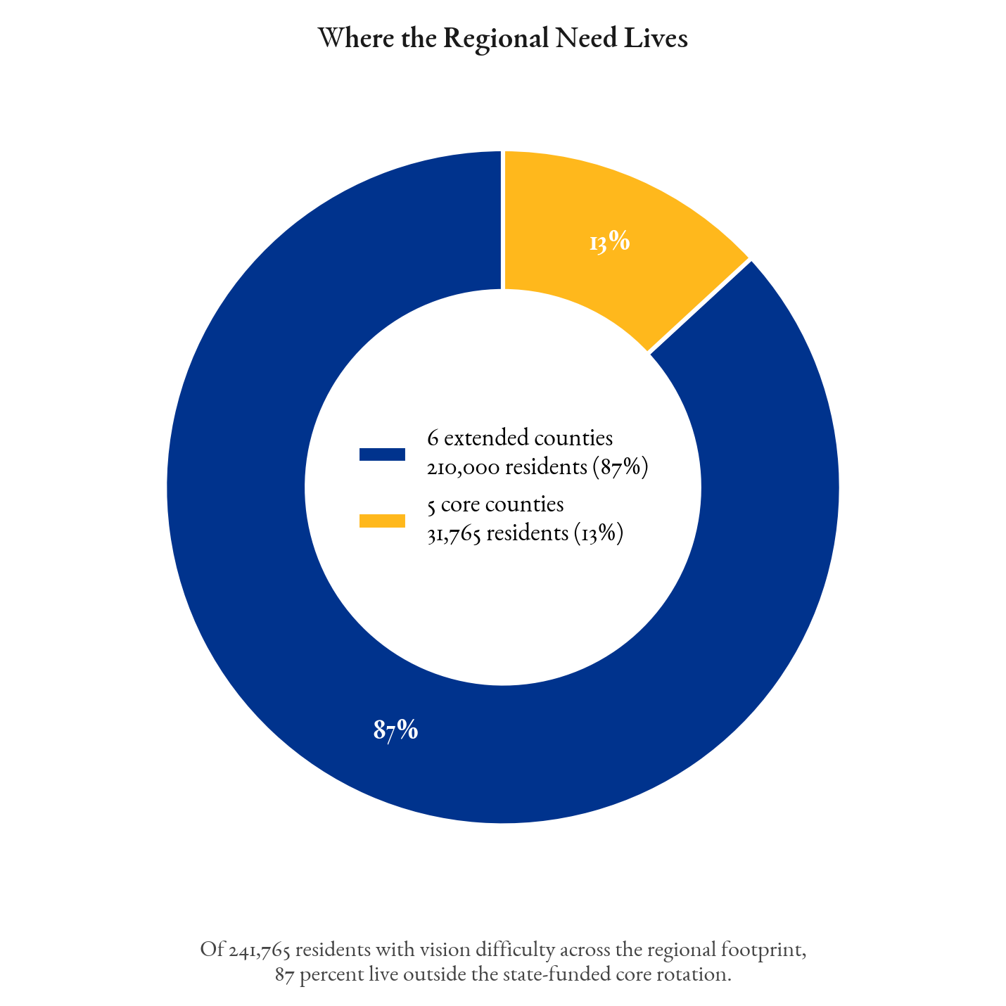
Left: estimated residents with vision difficulty in each of the six counties. Right: those six counties hold 87 percent of the regional need.
For residents in these counties, reaching accredited vision rehabilitation means a trip many cannot make. Distance, transportation, fixed incomes, and age-related mobility loss compound one another. Fixed-site service, by its nature, excludes the people least able to travel to it. Every Lion in this district already knows someone in that position.

What Hosting Asks of a Club
This is the question a club president will ask first, so it is answered directly. A host club does not fund the service, staff it, or supply the equipment. Lighthouse brings the unit, the rehabilitation professionals, and the technology. The club provides a location, a date, and word of mouth.
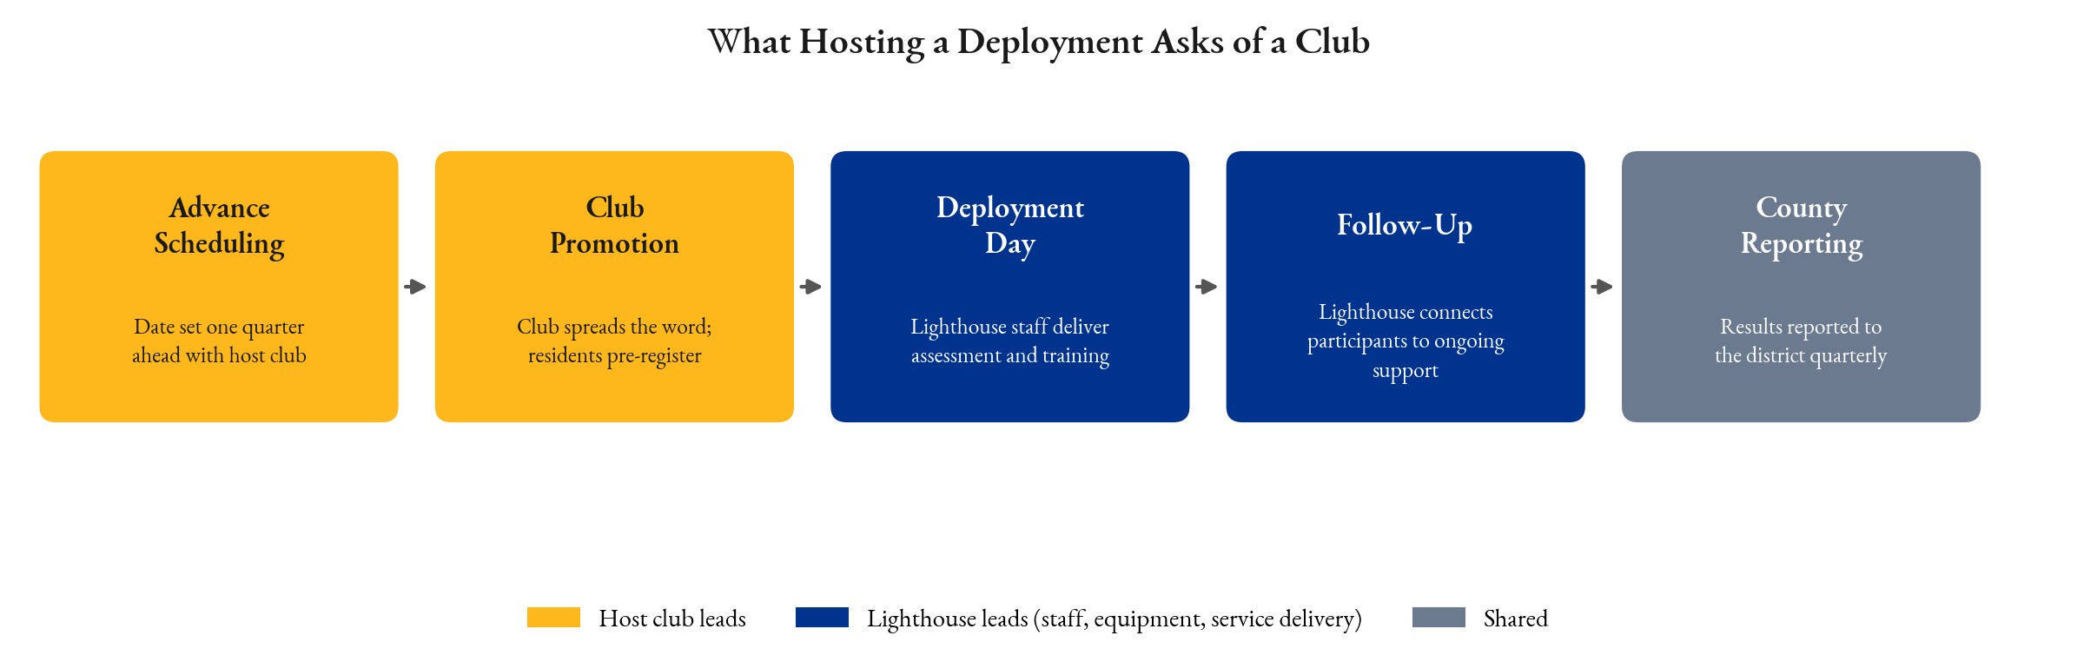
The deployment cycle. Two of the five stages are club-led, and neither requires a budget.
That distinction matters this year in particular. District 35-I created a Retention Chair position for 2026-27, held by Tim Forman, specifically to support clubs with fewer than twenty members. A small club cannot easily build a signature service project from scratch. It can host one. This gives a twelve-member club a visible, photographable, genuinely needed service day in its own community, four times a year, with no fundraising required to make it happen.

Who Lighthouse Is
Lighthouse Vision Loss Center has served Southwest Florida for more than forty years and is the region's only nationally accredited provider of comprehensive vision rehabilitation. The district is not being asked to back an untested idea.
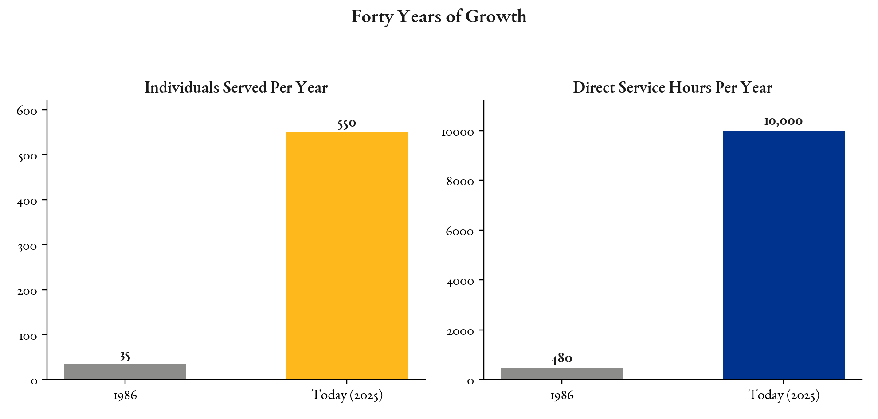
Individuals served and direct service hours, 1986 to today.
- The Assistive Technology Training Program nearly tripled its monthly output in under eighteen months, from 127 to a peak of 377 training hours per month.
- Active enrollment in that program more than doubled to 94 participants, with 87 successful training closures across the thirteen most recent reported months.
- The $848,000 state appropriation for the vehicle is already signed into law in the FY2026-27 General Appropriations Act. The district is being asked to complete a project, not to start one.

What the District Gets in Year One
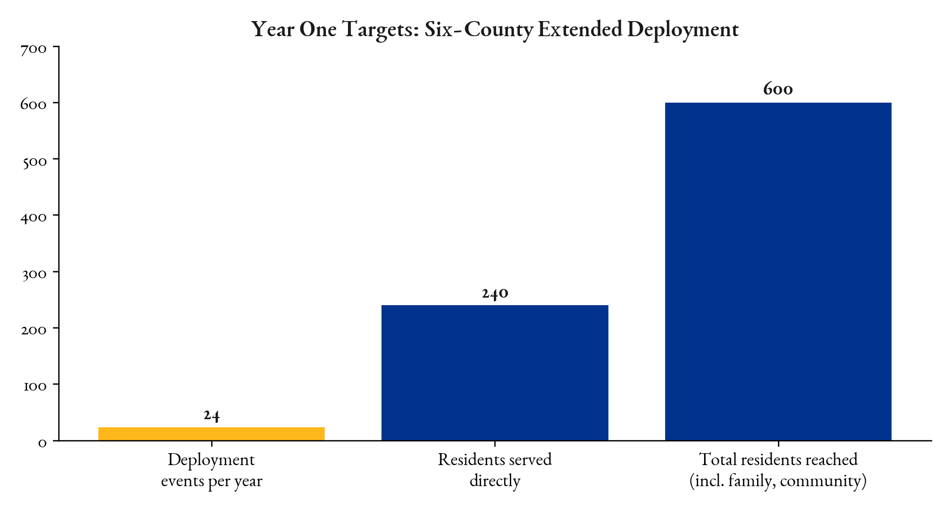
Year One targets across the six counties: 24 scheduled deployment events, 240 residents served directly, 600 residents reached in total.
- Four service days per county, twenty-four across the district, every one of them a Lions-hosted event.
- A recurring host site in each county, coordinated with the local club and published on a twelve-month advance calendar.
- County-level reporting back to the district, reviewed quarterly — clubs see their own county's numbers, not just a regional total.
- Referral pathways established with healthcare providers, Area Agencies on Aging, and community partners in each county.

Recognition for Lions and LCIF
- A permanent plaque on the unit reading “This project made possible through the cooperation of Lions International and its foundation, Lions Clubs International Foundation,” mounted at the assistive-technology station this grant funds.
- Every deployment promoted as a Lions-hosted event, naming the host club by name in scheduling and community materials.
- Lions and LCIF recognized in Lighthouse's website, annual report, and program communications.

What the August 15 Vote Decides
The vote is on the district's sponsorship of the application and the size of the district's cash match. LCIF's rules tie the two together: the grant is capped at twice the Lions cash commitment, the match must be new cash raised for this project, and at least half of it must be collected and shown on a bank statement before LCIF's board reviews the application.
LCIF Grant | Total Project Budget | Lions Cash Needed | Banked Before LCIF Board Review
$32,000 | $64,000 | $17,000 | $16,000
$60,000 | $120,000 | $30,000 | $30,000
$100,000 | $200,000 | $50,000 | $50,000
$150,000 | $300,000 | $75,000 | $75,000
Illustrative tiers. The actual ask is set by whatever the district commits and can bank; the grant scales with it. Figures per the working LCIF application draft, subject to change before submission.
Spread across the clubs of a full district, the cash match is a reachable number. What it buys is an $848,000 vehicle, already funded by the state, extended into six more counties, with the district's name on it permanently.

Leadership Roles in the Grant
An LCIF Matching Grant is completed within two years of approval, so this project runs past a single Lionistic year. The district's succession is what makes that workable.
- District Governor Beverly Flynn — applicant signatory and grant administrator; responsible for disbursement, proper use, and final reporting.
- First Vice District Governor Drew Ogden and Second Vice District Governor Christine Timmons-Malone — continuity of administration as the project period extends beyond the 2026-27 year.
- Zone chairs in Zones 1, 2, 3, 4, 5, 7, and 8 — host club identification and coordination in the six project counties, which contain clubs in all seven of those zones.
- Club presidents and secretaries — host site confirmation, advance promotion, and day-of volunteer support.

What Lighthouse Needs After the Vote
- The district's cash commitment amount and expected collection date, so the application can be sized correctly.
- Certification of the application by district cabinet resolution, with a copy of the meeting minutes.
- District Governor Flynn's signature on the LCIF endorsement page.
- A bank statement evidencing at least half the committed cash match, collected before the application goes to the LCIF board.
Sources: LCIF Matching Grant working draft, Mobile Education Center business plan, and Charlotte/DeSoto outreach plan (Lighthouse Vision Loss Center, July 2026); District 35-I leadership roster for the 2026-27 Lionistic year (district35i.com and the July 2026 district newsletter); District 35-I club, zone, and county composition verified against the official Multiple District 35 club roster at lionsmd35.com/district-i; county boundaries from the U.S. Census Bureau. Contact: Jason Rhoades, PhD, Business Development Director, Lighthouse Vision Loss Center.

