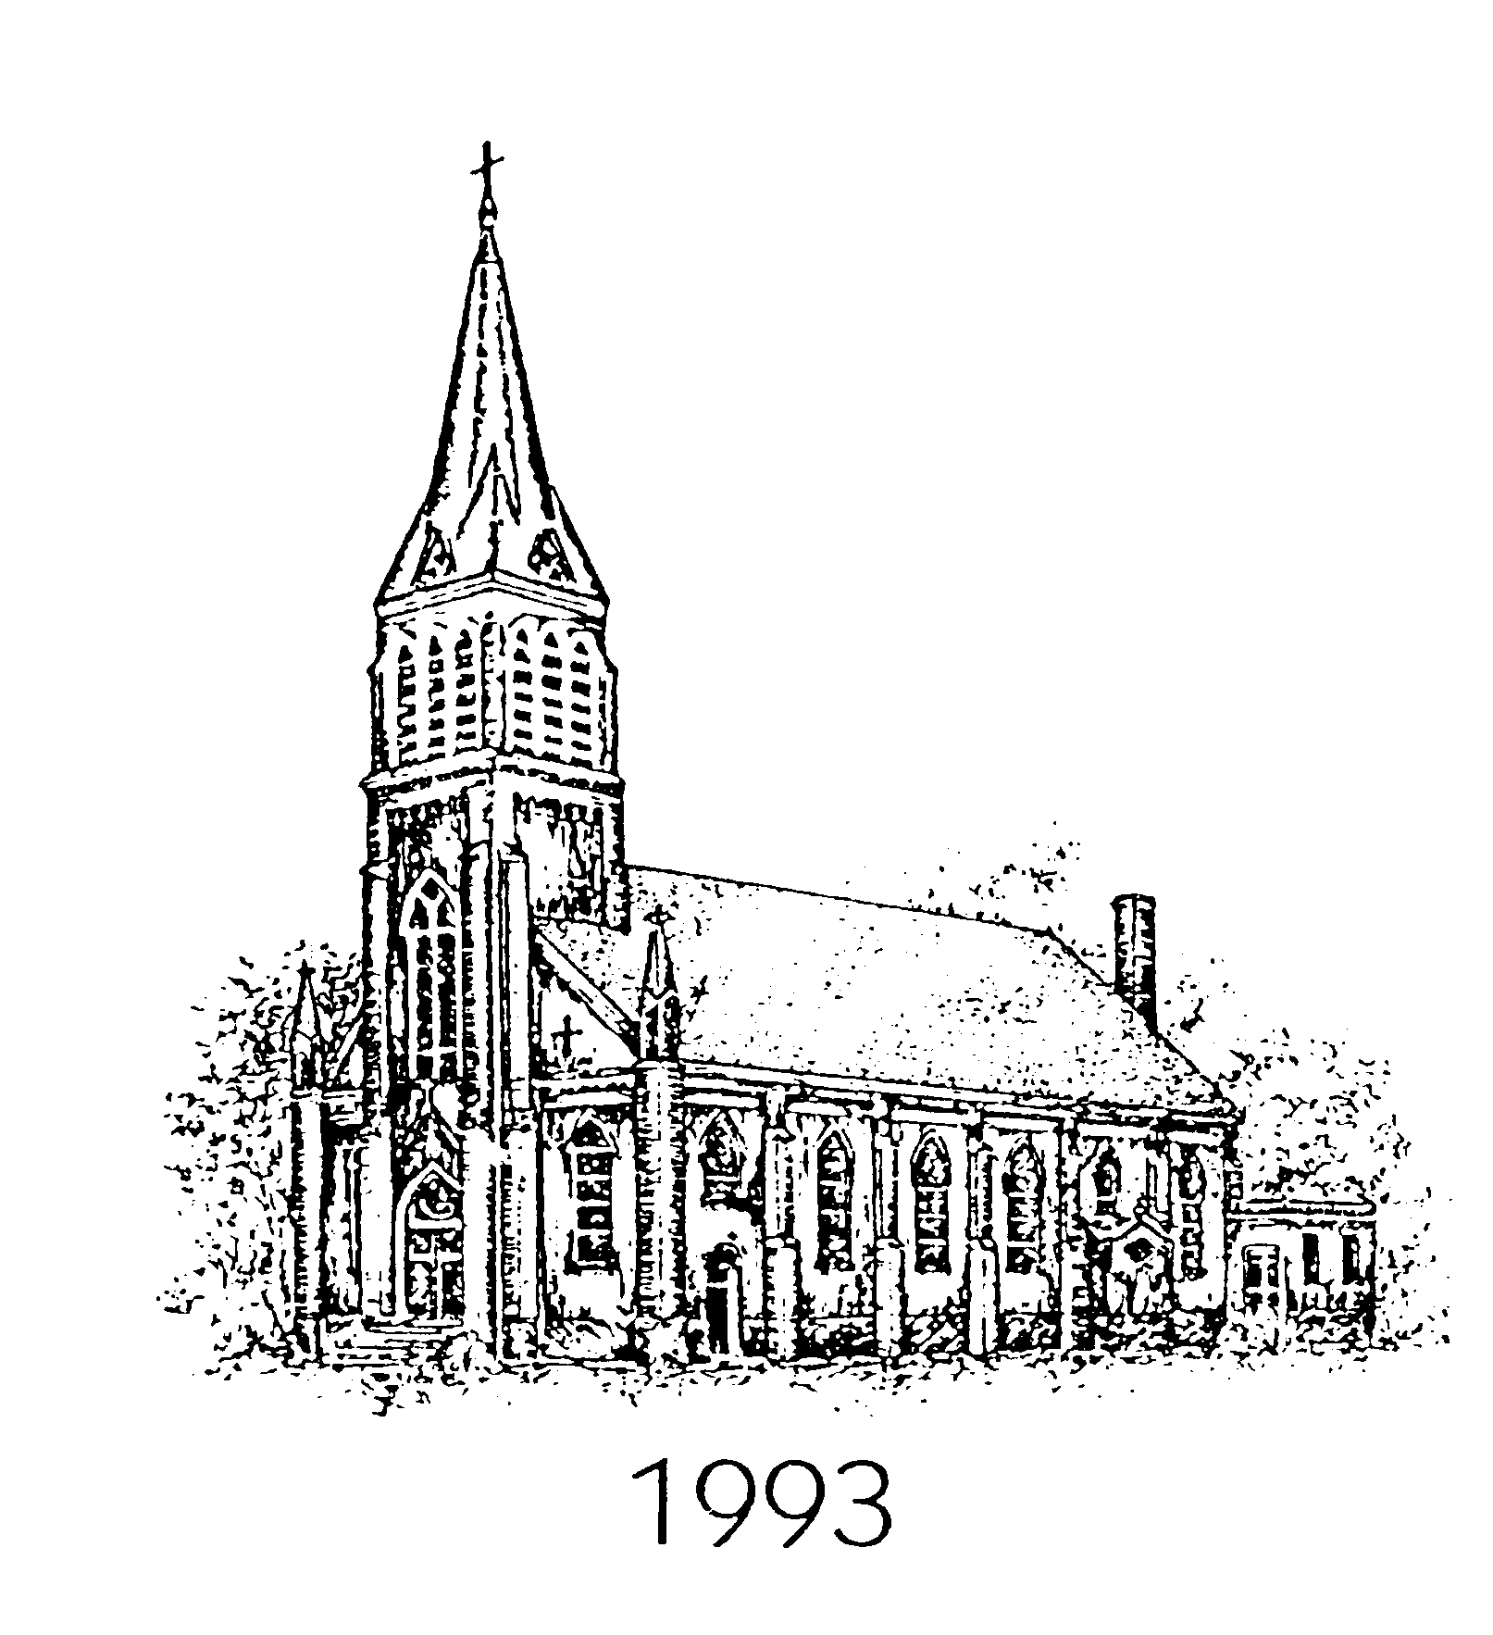

SAINT MICHAEL’S ANNUAL JULY 4
BOSTON BUTT/DEACON STEVE RIBS
PREORDER SALE

We are proud to offer our BBQ Boston Butts that will be prepared by the St. Michael’s Church, complete with a container of BBQ sauce. $45 per butt
Deacon Steve Ribs $25 per slab

To reserve your Boston Butt, please fill out the form below and deliver to the church office or drop it in the collection with payment. With questions, please call the Church Office at 256-764-1885 or Carolyn Eck at 256-436-2045

NO PREORDERS AFTER WEDNESDAY June 23 , 3:00PM
$50.00 PER BOSTON BUTT at the WINDOW on July 4
RIBS ARE PREORDER ONLY
Pre-Sale orders must be picked up from 6-8AM at the St. Michael’s Meat Stand on July 4

------------------------------------------------------------------------------------------------------------------

YES! I would like to reserve _________ (#) Boston Butt! (s) ($45 each). Total $______________

Yes, I would like to reserve __________(#) Slab of Ribs ($25 per slab} Total $______________
Enclosed is my grand total payment for $_________________

Checks Payable to Saint Michael’s Catholic Church

Name______________________________________________ Phone_______________________________________

