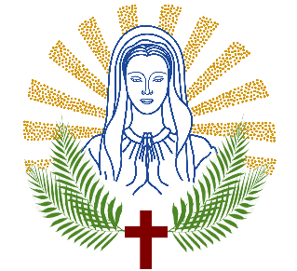

MARY MOTHER OF MARTYRS PARISH
ST. MARY & ST. STEPHEN PROTOMARTYR
CATHOLIC CHURCH

RELIGIOUS EDUCATION
SACRAMENTAL PROGRAM: 2026-2027

First Communion Year 1: 
First Communion Year 2: 
Program B - First Communion: 
Pre-Confirmation Year 1: 
Confirmation Year 2: 

Child’s Name: __________________________________________________________

Place of Birth: ___________________________________________________________
City/State

Date of Birth: _______________________ Age (right now):______________________
MM/DD/YYYY

Home Address: __________________________________________________________

Father’s Name: ___________________________________ Religion: _____________
First Last

Phone Number: _____________________ Email Address: _______________________

Mother’s Name: __________________________________ Religion: ______________
First Maiden

Phone Number: _____________________ Email Address: _______________________

Parents Marital Status:

Married: Civilly  Sacramentally (church) 

Separated: 

Divorced: 

Emergency Contact: other than Father or Mother

Name : _______________________________________________________________
First Last

Relationship: ___________________________________________________________

Phone Number: _________________________________________________________

Medical Information:
*This helps our catechists know your child better.*

Allergies: ______________________________________________________________

ADHD/ADD/etc:__________________________________________________________

School Information:

School Name: ____________________________________________________

Grade/Year level: ________________________ District:_________________________

I, the undersigned, have read and understood the requirements and conditions for enrolling my child(ren) in this program. I will ensure their full compliance.

Signature: __________________________________ Date: ______________________
Parent/Guardian
FEES:
$200 for one child
$300 for two children
$350 for three children

$_____________ Total

I, _________________________________ authorize that photographs in which my son/daughter may appear can be published on the parish website and social media if deemed necessary.

Copies of birth, baptism, & first communion (if applicable) must be turned in upon registration.
Fees must be paid in FULL upon registration.

For Office Use Only:

Payment Date: ________________________ Total Amount: _____________________

 Check #_________________  Cash #: ______________  Online  Zelle
Copies of Certificates:
Birth Baptism Communion.

 Card/Kiosk Payment

