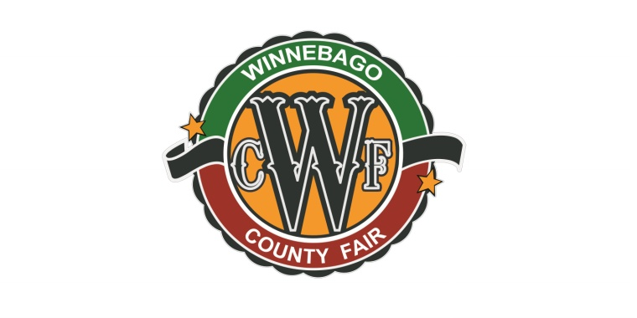
Dear valued member of the community,
The Winnebago County Fair runs July 16th to the 20th in 2025. We have a very motivated fair board, including 7 new members eager to serve in a variety of ways. We have made many improvements to the fair in recent years and we want to keep that forward momentum. We cannot achieve our goals without the continued support of our community. Thank you for partnering with us to put on a great fair!
We took a huge leap of faith last year on the Exhibit Hall renovation project and we had it ready just in time for fair. People were amazed with how it turned out! If you have not contributed in the past, we would greatly appreciate consideration of giving towards our entertainment or Exhibit Hall funds. Please take some time to look through this packet and please do not hesitate to call us with questions. We can arrange to meet you in person as well.
The annual fair fundraiser is set for Saturday, March 1st at 5:30 pm. For the first time, it will be held in the fairgrounds Exhibit Hall. We will have the traditional silent and live auctions, great food, entertainment, and cash bar. This location and format will make it a very fun and interactive atmosphere! Most of the sponsor levels have fundraiser tickets included so please get your sponsorship in to claim those in time for a great evening!
Lastly, we never forget what the fair is all about. A county fair is not a fair without youth and their projects. Be supportive of our local 4-H and FFA chapters. Our county youth enrollment numbers are up, especially clover kids, so the future is bright! Consider helping a youth with a project that you are knowledgeable about, who may not otherwise have the knowledge to take on and complete the project.
Thank you for supporting the Winnebago County Fair!
Sincerely,
Winnebago County Fairboard

Contact us:
Tom Thompson: 515-538-0163, four.t.farms@hotmail.com
TJ Hanson: 641-590-5288
Meggon Jacobs: 847-708-3208
Mike Hanson: 641-590-0561, hillsidefarm4000@gmail.com
Sam Dugan: 641-251-1107, sam.j.dugan@gmail.com
Winnebago County Fair Sponsorship 2025
2025 Winnebago County Fair Events
March 1st- Annual Fair Fundraiser in Fairgrounds Exhibit Hall
July 16th - Fair Queen & Lil Miss & Mister Coronation
July 17th-20th – Grace Good Cirque
July 17th - Peter Bloedel Perpetual Variety Show
July 17th- Rad Zoo
July 17th-19th- Doyle Carving Niche, Chainsaw Artist
July 18th-20th - Petting Zoo
Grandstand
July 17th- Antique Tractor and Pick-up Pull
July 18th- ATV Rodeo
July 19th- Tuff Trucks
July 20th - Demolition Derby

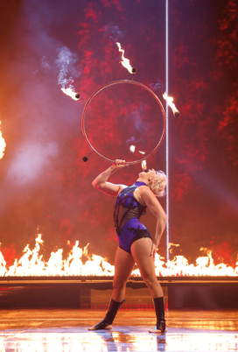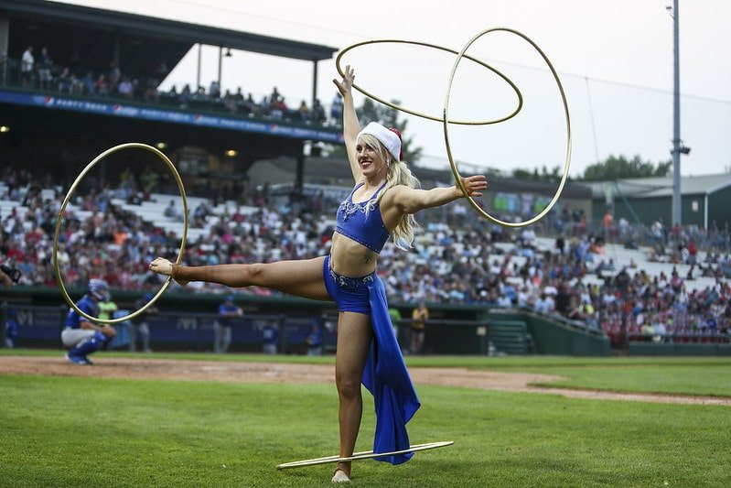
2025 Highlight: Grace Good!

General Sponsorship Levels
Supreme Sponsor- $2,000 +
- 24 Grandstand event tickets…..$320 value
  - 8 ATV Rodeo, 8 Tuff trucks, and 8 Demo Derby tickets (Tractor Pull is free will at the gate)
    - Or swap tickets for up to 8 livestock trophy sponsorships. (2 tickets = one $30 trophy)
- 10 Fair fundraiser tickets, $200 value
- Exhibit Hall fund option (see page 4)
- Banner provided by fair displayed in grandstand (see page 5 for example)
- Name announced at grandstand events
- Name on sponsor posters throughout fair and on our website, plus recognition on social media
- Name/logo on mailer sent to all county residents prior to fair. (We will need your logo by June)
Champion Sponsor- $1,500-$1,999
- 18 Grandstand event tickets…..$240 value
  - 6 ATV Rodeo, 6 Tuff Trucks, and 6 Demo Derby tickets (Tractor Pull is free will at the gate)
    - Or swap tickets for up to 6 livestock trophy sponsorships. (2 tickets= one $30 trophy)
- 6 Fair fundraiser tickets, $120 value
- Exhibit Hall fund option (see page 4)
- Banner provided by fair displayed in grandstand (see page 5 for example)
- Name announced at grandstand events
- Name on sponsor posters throughout fair and on our website, plus recognition on social media
- Name/logo on mailer sent to all county residents prior to fair. (We will need your logo by June)
Purple Ribbon Sponsor- $1,000-$1,499
- 12 Grandstand event tickets…..$ 100 value
  - 4 ATV Rodeo, 2 Tuff Trucks, and 2 Demo Derby tickets (Tractor Pull is free will at the gate)
  - 4 fundraiser tickets….$80 value
- Exhibit Hall fund option (see page 4)
- Banner provided by fair displayed in grandstand (see page 5 for example)
- Name announced at grandstand events
- Name on sponsor posters throughout fair and on our website, plus recognition on social media
Blue Ribbon Sponsor- $500-$999
- 4 Grandstand event tickets…..$50 value
  - 2 ATV Rodeo, 2 Demo or Tuff Trucks tickets
  - 2 Fundraiser meal tickets…..$40
- Exhibit Hall fund option (see page 4)
- Display your banner at the fair
- Name announced at grandstand events
- Name on sponsor posters throughout fair and on our website, plus recognition on social media
Red Ribbon Sponsor- Under $500
- Name on large sponsor posters throughout fair and on our website
Call Tom Thompson to discuss being a title sponsor of a specific grounds or grandstand event!

Exhibit Hall Fund Option
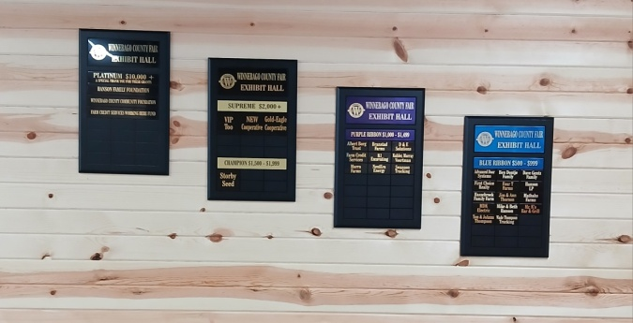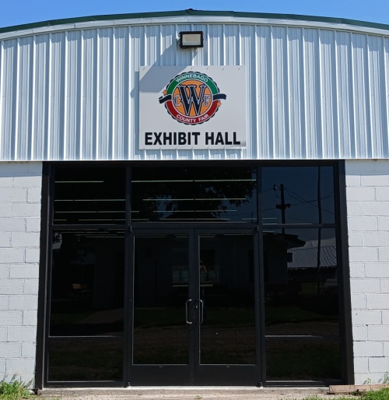
Would you or your business prefer to donate towards a capital improvement project?
100% of the money will go towards the Exhibit Hall. For this option you will not receive grandstand tickets, however, you will still receive spring fundraiser tickets and the same recognition as a sponsor with the added benefit of your name permanently posted on these beautiful plaques!
Contributions of $500 and up will receive recognition on one of the plaques. If you contributed to the project previously, this year’s amount will be added to it and recognized at the appropriate level.
This project has been a massive undertaking and we still have some things to complete to make it a perfect venue, not only for the fair, but many other uses!
Platinum Level: $10,000 plus
Supreme Level: $2,000 to $9,999
Champion Level: $1,500 to $2,499
Purple Level: $1,000 to $1,499
Blue Level: $500 to $999

Winnebago County Fair Sponsorship Agreement
Thompson, Iowa * July 16-20th, 2025

Business Name___________________________________________________________
Business Address__________________________________________________________
___________________________________________________________
Contact Person___________________________________________________________
Contact Phone Number___________________________________________________
Contact Email____________________________________________________________
Sponsorship Pledge $______________________________________________________
Sponsorship Level_________________________________________________________
Exhibit Hall Fund option? Please circle: YES (all $ go toward Exhibit Hall project)
Please circle: Check included Send Invoice
Let us know if you have an auction item to donate for the fundraiser March 1st!

Sponsor Signature_________________________________________ Date____________________
Winnebago County Fair Association
PO Box 293
Thompson, IA 50478
Example Banner (included for $1,000 and up sponsors)
