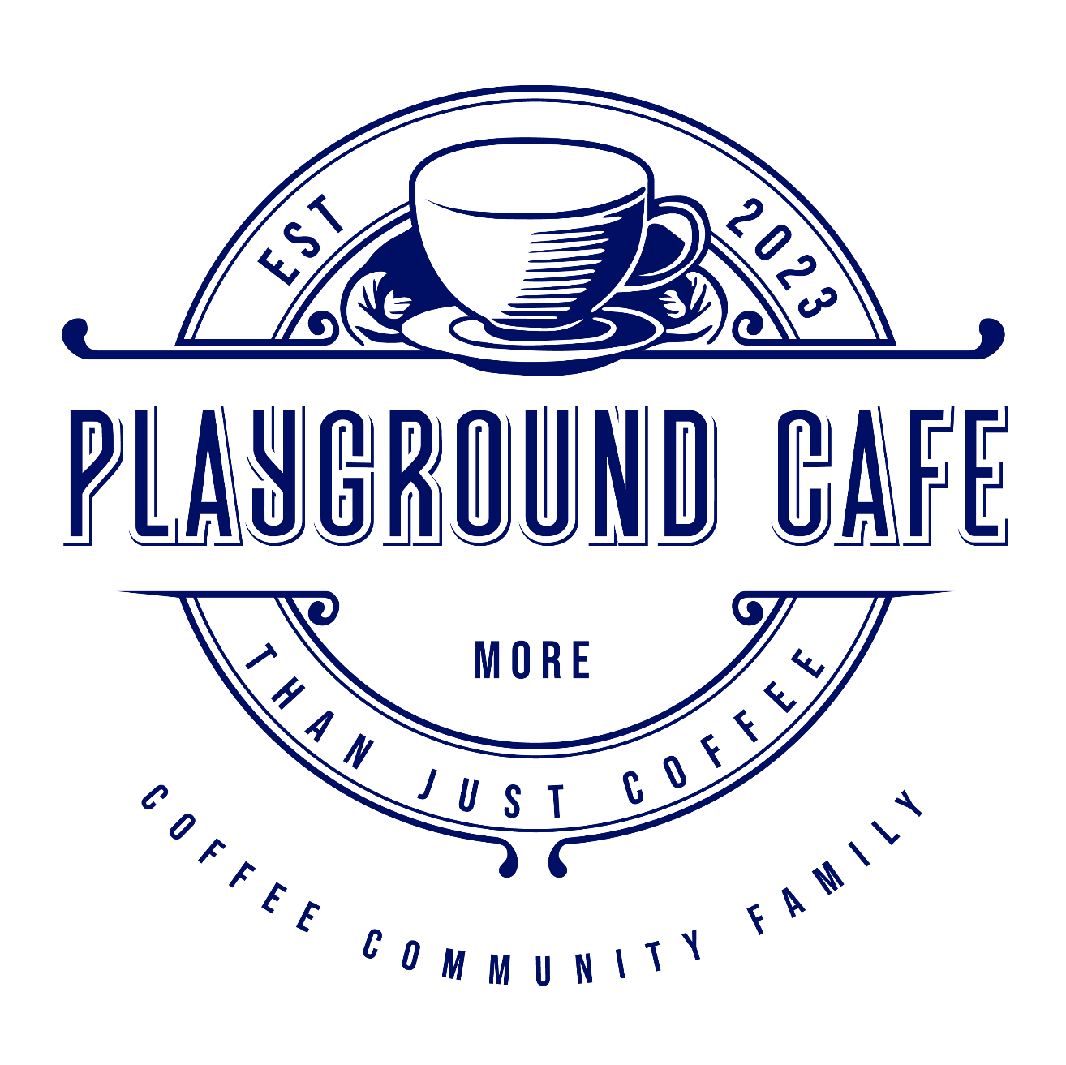
Playground Café and Bar  playgroundcafebar www.playgroundcafe.com.au

10% Surcharge applies on Sunday’s and Public Holidays

  - Kids Menu

Cheese toastie / 7
White sandwich bread, swiss cheese, toasted to golden prefection

Kids Pancakes / 10
2 kids size fluffy house made pancakes served with strawberries and maple syrup.
Add: Nutella: +$2.00 Add: scoop ice cream: +$2.00

Scrambled Eggs on Toast / 9
Kids size serving of scrambled egss served on white sandwich bread served with tomato sauce.

Chicken Nuggets & Chips / 12
6 Chicken nuggets, chips and tomato sauce

Fish & Chips / 12
2 battered fish pieces, served with chips and tomato sauce

  - ALL DAY BREAKFAST
Banana Bread / 7  served with butter.  Add: Ricotta & Honey +$4  Sourdough Toast / 7  White / Soy Linseed / Dark Rye  Gluten Free +$2  Wild berry jam / Peanut butter / Vegemite  Raisin toast / 8.50  served with butter  Toasted Granola / 18  Toasted granola, fresh seasonal fruit, honey, shaved coconut and vanilla yoghurt Gluten Free Granola +$2  Cheese Toastie / 9  Sourdough filled with Swiss cheese and toasted to golden perfection  Add: Ham +$3  Add: Tomato +$2  Gluten Free Bread: +$2  Bacon & Egg Roll / 13  Bacon, fried egg, Swiss cheese with BBQ sauce  Sharkies Burger / 17.50  Bacon, fried egg, hash brown, avocado, American cheese, BBQ sauce & aioli  Brekky Burrito / 19.50  2 soft fried eggs, bacon, hash brown, American cheese, BBQ sauce and aioli in a toasted tortilla With scrambled Egg +$2  B.L.A.T / 16.50  Bacon, Lettuce, Avocado, Tomato and aioli on toasted sourdough  Chilli & Feta Scrambled Eggs / 20  Soft-scrambled eggs folded with chilli sambal and crumbled Dodoni feta, topped with fresh herbs, served on toasted sourdough | Halloumi Stack / 24  Sourdough topped with sliced avocado, grilled halloumi, roast tomato, bacon and 2 poached eggs  M.A.F.S Brekky / 23  Sourdough topped with roasted mushrooms, smashed avocado, feta, sauteed spinach, 2 poached eggs and finished with a drizzle of black truffle oil  Smashed Avo on Toast / 24  Toasted sourdough topped with smashed avocado, cherry tomatoes, sliced radish, crumbled Dodoni feta, dukkha, accompanied by two poached eggs and finished with a smear of beetroot hummus  Corn & Zucchini Fritters / 23  Zucchini, corn, shallots, coriander and dill fritters served with sambal oelek, labneh, avocado and 2 poached eggs  Sir Benedict  2 poached eggs on sourdough, wilted spinach and hollandaise sauce  w/ bacon or leg ham / 24  w/ smoked salmon / 25  Ricotta Pancakes / 23  3 Fluffy house-made ricotta pancakes served with berry compote, fresh berries, maple syrup and vanilla infused ricotta  Eggs Your Way on toast / 14  - 2x Poached / 2x Fried / Scrambled (+2)  Add sides to build a Brekky:  - 1 Hash Brown / Extra toast /3  - Extra egg / Greek Feta / Roast tomato / Avocado /4  - Hash brown x2 / Halloumi / Roasted mushrooms / spinach /5  - Chorizo / Bacon /6  - Smoked Salmon /7

  - LUNCH (Served from 11am)

Beef Burger / 23
Wagyu beef patty, caramelised onion, tomato, lettuce, pickles, American cheese, chef’s special sauce. Served with fries. Add: Bacon $3.00

Grilled Chicken Burger / 23
Grilled Chicken breast, bacon, iceberg lettuce, Swiss cheese, fresh tomato, garlic aioli, served with fries.

Playground Grilled Chicken Sandwich / 21
Tender and juicy marinated grilled chicken, avocado, mixed greens, smoky romesco and garlic aioli sauce on thick sliced toasted sourdough.

Fish n Chips / 22
Battered flathead with chips. Served with a dill tartare sauce

Fish Tacos / 18
3x soft tacos of battered fish, avocado, pico de gallo and chilli aioli

Warm Japanese Bowl / 25
Fresh chicken infused with our chefs own rich Japanese flavours, warm brown rice, grated carrot, pickled cucumber, pickled ginger, dried wakame seaweed, avocado, all finished with a good helping of house made chili aioli and topped with finely chopped spring onion, sesame seeds and a soft fried egg.

Classic Caesar Salad / 22
Crisp cos lettuce tossed with creamy Caesar dressing, parmesan cheese, and garlic herb croutons. Topped with tender marinated grilled chicken, crispy bacon and finished with a soft-boiled egg and a sprinkle of cracked black pepper.

Bowl of Chips / 8
Crunchy steak house chips served with tomato sauce.

- HOT DRINKS  Flat White / latte / cappuccino / piccolo / macchiato / espresso / ristretto / long black / hot chocolate / 4.50  Mocha / 5.50  Babycino / 2.50  Batch Brew / 6.00  Sticky Chai / 6.00  Dirty Chai / 7.00  Turmeric Latte / 5.00  Matcha Latte / 5.00  Barista Breakfast / 12.00  Ristretto, Cold brew or batch brew and a Flat white  TEA / 5.50  English Breakfast / Earl Gray / Green / Chamomile / Peppermint / Lemongrass & Ginger  Extras: $1 each  Large, extra shot, Decaf, Soy, Almond, Oat, Macadamia, Lactose Free, Caramel, Vanilla, Hazelnut  - FRESH JUICES  Orange – Australian Valencia oranges / 9  Green – Celery, green apple, pear, spinach, lemon & ginger / 10  Sublime Pine – Pineapple, pear, apple & mint / 10  Watermelon – Watermelon, apple, strawberry & lemon / 10  Apple Juice / 8  Kids Juice - Apple or Orange / 6 | - COLD DRINKS  Cold Brew / 6  Iced Long Black / 6  Iced Latte / 6.50  Iced Matcha Latte / 6.50  Add: Strawberry +$1.50  Iced Chai Latte / 7  Iced Coffee/Chocolate/Mocha / 8.50  Served with ice cream and cream  Milkshakes Kids 5.50 I Adults 7.50  (Vanilla / Strawberry / Chocolate / Caramel / Banana) +$1 Alternate milk  Thick shakes Kids 7.50 I Adults 9.50  (Vanilla / Strawberry / Chocolate / Caramel / Banana) +$1 Alternate milk  330ml Soft Drink / 4.50  Classic Coke / No Sugar Coke / Fanta / Sprite / Lemon Lime Bitters  Mount Franklin Still / Sparkling Water / 4.50  - SMOOTHIES  Big 5 / 11.00  Pineapple, mango, kiwi, strawberry and apple  Coco Loco / 11.00  Coconut, pineapple, mango and mint  Mixed Berry / 11.00  Blackberry, raspberry, strawberry, yoghurt  Pash & Shoot / 11.00  Passionfruit, pineapple and mango  Banana / 11.00  Banana, yoghurt, milk, honey and cinnamon  +$1 Alternate milk

- SOFT SERVE ACAI  Bowl Sizes:  Small / 8  Medium / 12  Large / 16  All Bowls come standard with granola, banana & strawberries.  Want to make it your own? Why not add on a few tasteful extras:  Peanut butter / Biscoff / Nutella / Honey: $1.50 each  Blueberries / Passion fruit / Gluten Free Granola: $1.00 Each | 