Campaign – Social Share Kit – Resource Library
Content | Imagery
Did you know?  The 2024 Point-in-Time Count found that 421 people in Sault Ste. Marie are experiencing homelessness a powerful reminder that safe, stable housing is still out of reach for many in our community.  No one in Sault Ste. Marie should have to wonder where they will sleep tonight.  United Way Sault Ste. Marie & Algoma District is committed to lifting people from poverty to possibility and tackling unignorable issues like homelessness.  https://socialservices-ssmd.ca/wp-content/uploads/2025/08/PIT-Count-2024-infographic.pdf | 
Poverty forces individuals and families to make impossible choices, like whether to put food on the table or pay rent. Your donation to the United Way can make a life-changing impact for an individual or family that is struggling right here at home. | 
1 in 4 seniors live alone in poverty. Help us ensure the immediate needs of low-income community members are met by donating today. | 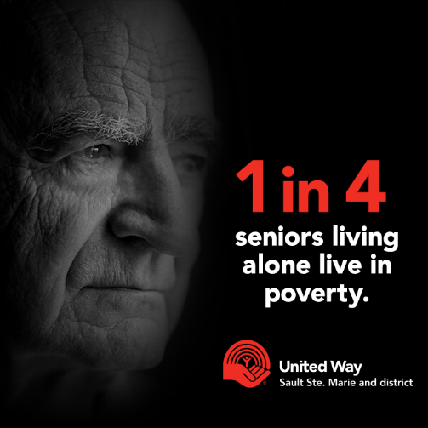
Below is a story about a client who accessed our Community Volunteer Income Tax Program.  A daughter of a senior widower called the UW office for help with her father John, who has the beginning stages of Alzheimer’s and is losing his house due to back property taxes owed. He hadn’t done his taxes since his wife passed and was not receiving all his income. The United Way Staff member helped him with his taxes and talked to the City of SSM to ask them to wait on his house; through getting his taxes he received enough to pay off his property taxes and help with other bills. Now he is able to keep his house and receive the support he needs from his family.  *Name and photo changed to protect client’s identity* | 
Did you know?  Children and youth in Algoma are waiting over a year—about 370 days—for counselling and therapy services. That’s far too long for young people who need help now.  Every child deserves quick access to care and a path to healing.  United Way Sault Ste. Marie & Algoma District is committed to lifting people from poverty to possibility. | 
Families should not have to choose whether to pay their utility bill or put food on the table. This is where your support can be vital to those who are struggling right here in our community. | 
A donation of $150 can provide a person with lessons teaching them problem solving and communication skills to help them keep and find employment.  United Way is committed to helping everyone in our community find stable, long-term employment. | 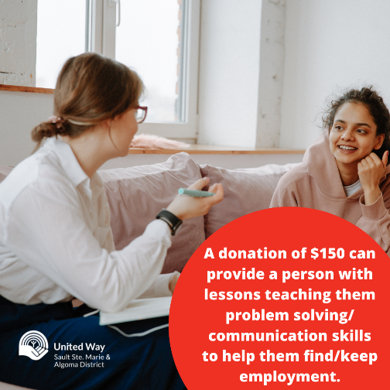
$2, $5, $10 or any amount you can give will make a meaningful difference for an individual or family living in poverty. Small contributions can have a big impact! When people come together, we can accomplish so much more than we ever could alone. | 
You have the power to make an impact on the health and wellbeing of our entire community.  Start today by donating to the United Way. For the price of your morning coffee you can change someone’s life who is struggling with homelessness. | 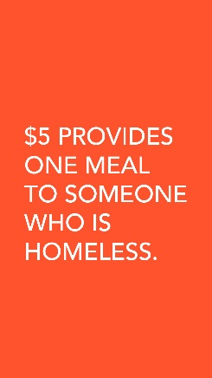
United Way is here to reduce local poverty through 3 main pillars: Helping Kids Be All That Kids Can Be, From Poverty to Possibility, and Building Strong Communities.  Donate today so we can further our reach in the community and continue to support people in reaching their full potential. | 
Read Sarah’s story! Sarah accessed our Bursary Program through Sault College.  “My parents could not afford to send me to college and as a young mom I was unable to work. But, that didn’t stop me from chasing my dream. The Options Navigator program helped make my dream come true. The worker spoke to one of his connections in the community and became aware of the United Way Bursary Program at Sault College. I applied and was accepted. I was connected to an opportunity I didn’t know I had available to me. It changed my whole life.” – Sarah.  Stories just like Sarah’s happen every day. Positive change is spreading throughout our community. Are you ready to help us change lives? | 

