Advanced Indoor Air Purification System for Microbiological and VOC Reduction

Description: The ZPA 500 is an Advanced Indoor Air Purification System based on Photocatalytic Oxidation Technology (PCO) that is effective for the inactivation of indoor airborne microbes as well as the destruction of VOC (volatile organic compounds)
contaminants. The ZPA 500 is designed to destroy objectionable odors, toxic vapors, and inactivate infectious microorganisms in indoor air. The ZPA 500 is safe to use, as it does not emit any harmful products or ozone. The destruction of contaminants occurs inside the unit. The ZPA 500 is easy to operate and maintain requiring only yearly replacement of lamps and photocatalytic modules. The ZPA 500 will effectively purify the air in rooms up to 4,000 square feet. For smaller rooms, the ZPA 200 may be a more cost-effective solution.
The ZPA 500 is effective on a variety of hazardous and objectionable indoor airborne contaminants including the most common such as:

- Bacteria, Virus, and Mold Spores
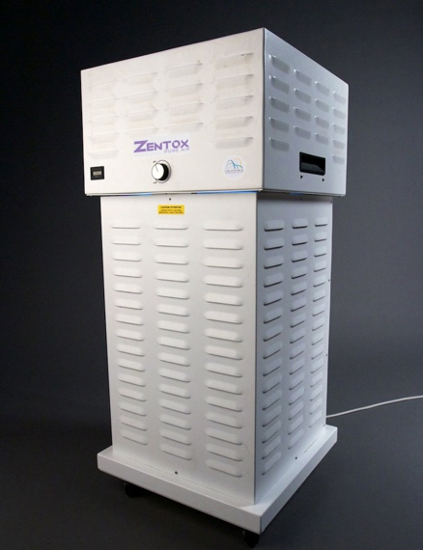
- Ammonia
- Cleaning Solvents
- Paint odor
- Hydrogen Sulfide
- Urine and Fecal odors
- Cooking odors
- Musty odors
- Carbon Monoxide
- Formaldehyde

The ZPA 500 is ideally suited for purification of indoor air in:
- Hospitals
- Schools
- Office Buildings
- Medical Offices
ZPA 500
Advanced Indoor Air Purification System
The ZPA 500 is set on wheels
- Laboratories
- Food Processing Plants
- Restaurants
- Nursing Home

Specifications:

Dimensions: Width ………………… 18 inches Depth ………………… 18 inches Height 38 inches

Weight: 45 pounds

Power Requirement: 110VAC, 5 Amps, 180 Watts

Air Flow (Variable Speed Fan): 500 scfm max.

The Zentox Pure Air Advanced Purification System is covered by the following U.S. Patents: # 5,766,455; 5,834,069.

For more information contact:
Jack Soost, Indoor Air Quality Professional
Jack Soost Associates, Inc.
Authorized Zentox Air Purifier Distributor
533 Red Maple Way, Lancaster, PA 17603
Phone: (717) 449-0833 FAX: (877) 392-8878
E-mail: jack.soost@mac.com
Web: www.JackSoostAssoc.com

Manufactured by: Zentox Corporation 600 Elm Ct.
Hopewell, VA 23860
804-668-5644


